Les Anses d'Arlet, Martinique, France
A postcard-perfect French-Caribbean fishing village where a red-domed church aligns perfectly with a wooden pier — and sea turtles graze just offshore.
⚓ Tender (no pier) · 🕒 Typical call: 5–7 hrs · 💶 Euro (€) — cash recommended · 🗣️ French (little English spoken)
✍️ MY DAY IN PORT (FILL IN)
Ship / Date
In port | arrive ______ · all aboard ______
Booked excursion
Notes / meeting point
GETTING ASHORE
- Docking: Tender — anchor in bay, land at village quay
- Walk to center: Immediate — tender drops you on the beach
- Best For: Snorkeling, sea turtles, French-Creole dining
- Don't Miss: Anse Dufour for near-guaranteed turtle encounters
GETTING AROUND
- 🚕 Taxi: €46–€94+ — Government-regulated taxis must be arranged in advance — there is no taxi rank at the dock. To Trois-Îlets runs around €
- 📱 Rideshare: ❌ not available
TOP THINGS TO DO
- Sea Turtle Snorkel at Anse Dufour — Green sea turtles graze on seagrass in waist-deep water at Anse Dufour — arguably the most reliable turtle encounter in the…
- Town Beach & Church Pier Walk — Swim or snorkel off the main Anse d'Arlet beach, then walk the iconic wooden pier for the classic photo of the pier aligned with…
- Volcanic Black Sand: Anse Noire — A dramatic pitch-black volcanic beach accessed by stone steps, sitting side-by-side with golden-sand Anse Dufour — a geological…
- Grande Anse Beach Club Day — A longer crescent of golden sand 2.5 km north of the village with lively beachfront bars and restaurants, including Ti Sable…
- Scuba Diving the Town Reef — Clear water and healthy coral just offshore from the village.
BEST WALKS
- Village to Church Pier Loop: 0.5 km · 15 min · Easy — Walk from the tender landing along the beach to the wooden pier, stroll to the end for the classic…
- Village to Grande Anse: 2.5 km one-way · 35 min · Hilly — A scenic but steep walk north over the headland to Grande Anse beach.
WEATHER · DAYLIGHT · MONEY
Month | High °F | Low °F | Rainy days
May | 83 | 76 | 21
Jul | 83 | 76 | 25
Sep | 85 | 76 | 24
Daylight: May 5:36AM–6:24PM · Jul 5:42AM–6:37PM · Sep 5:52AM–6:05PM
cruiseports.org/les-anses-darlet · Confirm terminal & all-aboard time with your ship

Les Anses d'Arlet, Martinique, France — Port Map
Red = walkable sights · Amber = excursions farther out · P = cruise terminal
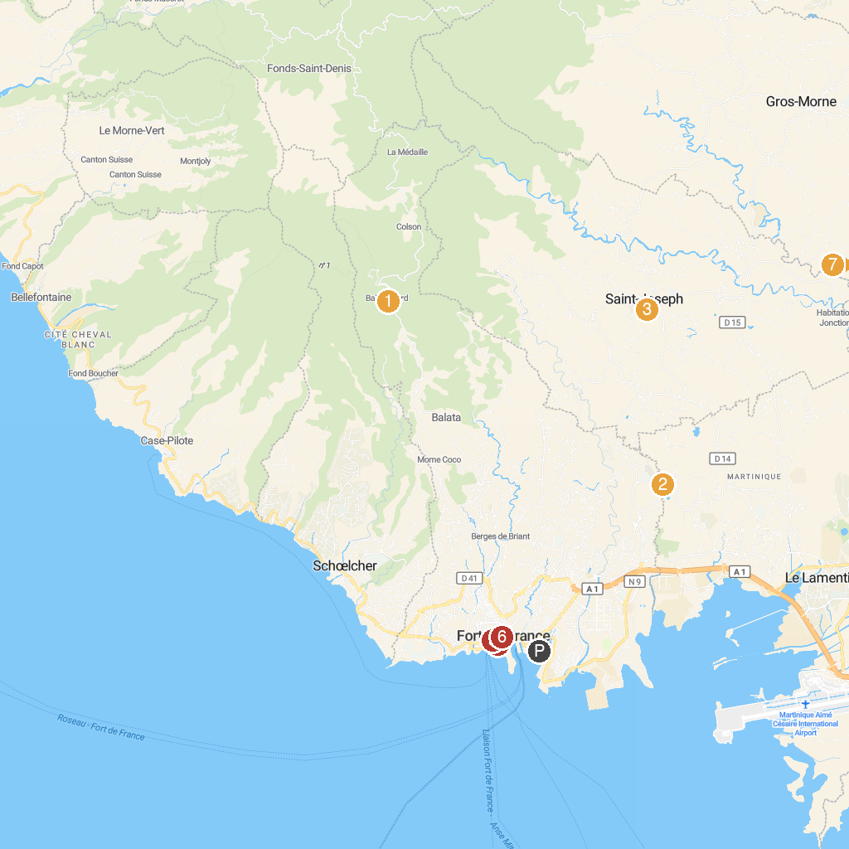
MAP KEY
1. Jardin de Balata | 5. St. Louis Catholic Cathedral
2. La Favorite Distillery | 6. Museum of the Banana
3. Église catholique Saint-Joseph à Saint-Joseph | 7. Bibliothèque Schœlcher
4. Departmental Museum of Archaeology and Prehistory of Martinique | 8. Bel’Balad
P. Cruise port / terminal
Map © MapTiler © OpenStreetMap contributors · cruiseports.org

