Les Andelys, Normandy, France
A dramatic bend in the Seine, ruled by the jagged silhouette of Château Gaillard — Richard the Lionheart's fortress built in a single year. This twin-village gem rewards walkers who go uphill.
⚓ Docked (riverside pier) · 🕒 Typical call: 6-8 hrs · 💶 Euro (€) · 🗣️ French
✍️ MY DAY IN PORT (FILL IN)
Ship / Date
In port | arrive ______ · all aboard ______
Booked excursion
Notes / meeting point
GETTING ASHORE
- Docking: Alongside pier at Quai de Seine, Petit-Andely — no tender
- Walk to center: 1-5 min to Petit-Andely; 20-25 min to Grand-Andely
- Best For: Medieval history, panoramic river views, Normandy food & cider
- Don't Miss: Château Gaillard ruins — steep but spectacular
GETTING AROUND
- 🚕 Taxi: €10–€20 (short in-town trips) — Local taxis serve the area; useful for mobility-limited visitors or reaching the château. Book via Uber app or ask at th
- 📱 Rideshare: ✅ Uber
TOP THINGS TO DO
- Château Gaillard: Richard's Fortress — Climb to the dramatic 12th-century ruins of Château Gaillard, begun by Richard the Lionheart in 1196 and famously raised in a…
- Collégiale Notre-Dame & Grand-Andely — Walk inland to Grand-Andely's magnificent Gothic collegiate church (13th–17th c.) with stunning 16th-century stained glass and a…
- Église Saint-Sauveur & Riverside Petit-Andely — Steps from the dock, the early-13th-century Saint-Sauveur church (built c.
- Norman Lunch at La Chaîne d'Or — An 18th-century inn right on the riverbank near the dock, La Chaîne d'Or is the classic lunch choice in Petit-Andely.
- Seine Valley Panorama Walk — Combine the riverside promenade of Petit-Andely with the château climb for a half-day loop.
BEST WALKS
- Riverside to Grand-Andely: 2.5 km | Flat | ~30 min one way — Start at the ship's gangway on Quai de Seine and stroll flat along the riverbank to Petit-Andely's…
- Château Gaillard Climb: 1.5 km | Steep | ~20 min up — From the dock, head into Petit-Andely and follow signs uphill through the old town to the château.
WEATHER · DAYLIGHT · MONEY
Month | High °F | Low °F | Rainy days
May | 64 | 48 | 12
Jul | 75 | 59 | 8
Sep | 70 | 54 | 9
Daylight: May 6:11AM–9:30PM · Jul 6:05AM–9:54PM · Sep 7:31AM–8:06PM
cruiseports.org/les-andelys · Confirm terminal & all-aboard time with your ship

Les Andelys, Normandy, France — Port Map
Red = walkable sights · Amber = excursions farther out · P = cruise terminal
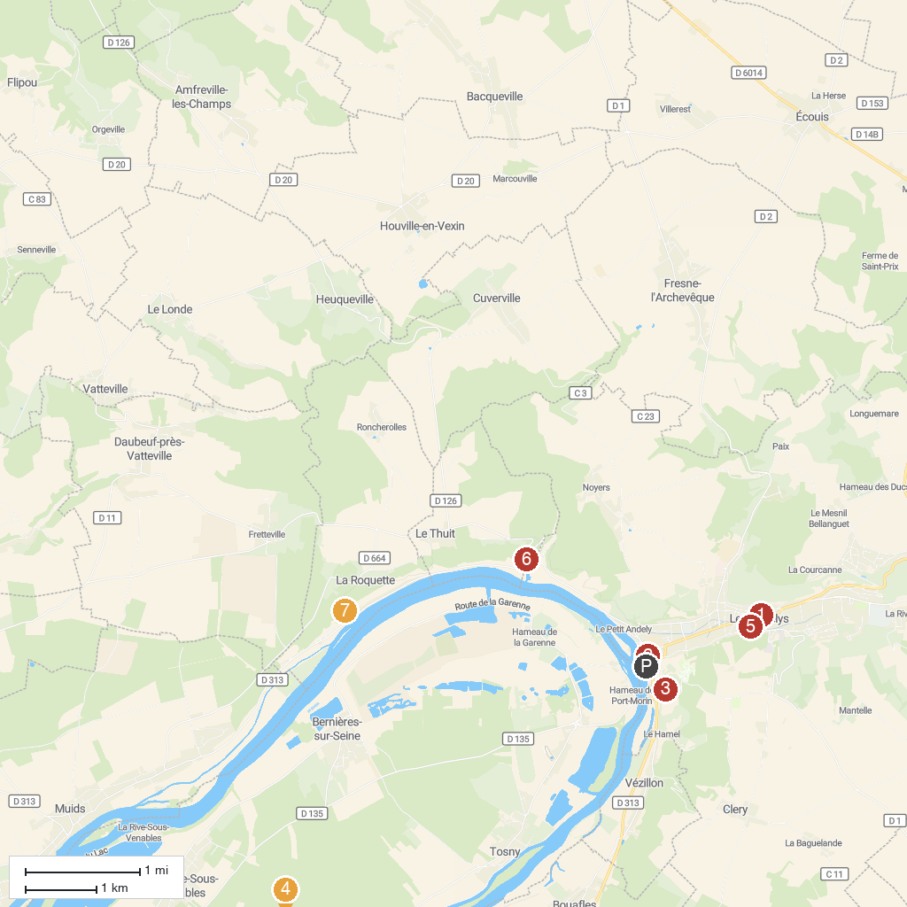
MAP KEY
1. Collégiale Notre-Dame | 5. Museum Nicolas Poussin
2. St. Savior Church of Petit-Andely | 6. Panorama du Thuit
3. Château Gaillard | 7. Monument Notre-Dame de Belle Garde
4. Château de Gaillon
P. Cruise port / terminal
Map © MapTiler © OpenStreetMap contributors · cruiseports.org

