Lerwick, Shetland Islands, Scotland
The remote capital of Britain's most northerly archipelago, Lerwick blends Norse roots with Scottish grit — puffin colonies, Iron Age brochs, and world-class knitwear all within a half-day's reach.
⚓ Pier or Tender (ship-size dependent) · 🕒 Typical call: 7–10 hrs · 💷 British Pound (GBP) · 🗣️ English (local Shetlandic dialect)
✍️ MY DAY IN PORT (FILL IN)
Ship / Date
In port | arrive ______ · all aboard ______
Booked excursion
Notes / meeting point
GETTING ASHORE
- Docking: Larger cruise ships dock at Holmsgarth or Mair's Pier (about 1.5 miles north of town; shuttle usually provided). Smaller ships may berth at Victoria Pier in the town center, and ships that can't get a berth anchor in Bressay Sound and tender to Victoria Pier.
- Walk to center: 0 min from Victoria Pier (berth or tender); 25–30 min walk or shuttle from Holmsgarth.
- Best For: History, wildlife, Shetland knitwear, and Viking heritage.
- Don't Miss: Shetland Museum (free), Fort Charlotte, and Jarlshof if you can get transport south.
GETTING AROUND
- 🚕 Taxi: ~£5–£8 — Several local taxi firms serve Lerwick (Lerwick Taxis, Sandy's Taxis, Allied Taxis). The ride from Holmsgarth to town is
- 📱 Rideshare: ❌ not available
- 🚌 Hop-on hop-off: ✅ Robertsons Coaches
TOP THINGS TO DO
- Jarlshof Prehistoric & Norse Settlement — One of Europe's most remarkable archaeological sites, about 25 miles south near Sumburgh Head.
- Sumburgh Head & Puffin Colony — The southern tip of Shetland mainland hosts nesting puffins (May–early August), gannets, guillemots, and razorbills just meters…
- Mousa Broch Boat Trip — A passenger ferry from Sandsayre Pier near Sandwick (about 13 miles / 20 min south of Lerwick) takes you to the uninhabited Isle…
- Up Helly Aa Exhibition & Town Walk — The Up Helly Aa fire festival (January) is Shetland's most famous event — but from May to September the Galley Shed exhibition…
- St Ninian's Isle Tombolo — About 17 miles southwest of Lerwick, the largest active sand tombolo in Britain connects a small island to the Shetland mainland.
BEST WALKS
- Lerwick Old Town & Fort Charlotte: 1.5 miles · 45–60 min · Easy — From Victoria Pier, head up to Commercial Street (the flagstone high street) and browse Shetland…
- Clickimin Broch: 1.5 miles each way · 30 min · Easy — A flat walk west from the town center leads to Clickimin Broch, a remarkably well-preserved Bronze…
WEATHER · DAYLIGHT · MONEY
Month | High °F | Low °F | Rainy days
May | 50 | 44 | 14
Jul | 58 | 52 | 17
Sep | 56 | 51 | 16
Daylight: May 4:25AM–9:37PM · Jul 4:07AM–10:12PM · Sep 6:33AM–7:24PM
cruiseports.org/lerwick · Confirm terminal & all-aboard time with your ship

Lerwick, Shetland Islands, Scotland — Port Map
Red = walkable sights · Amber = excursions farther out · P = cruise terminal
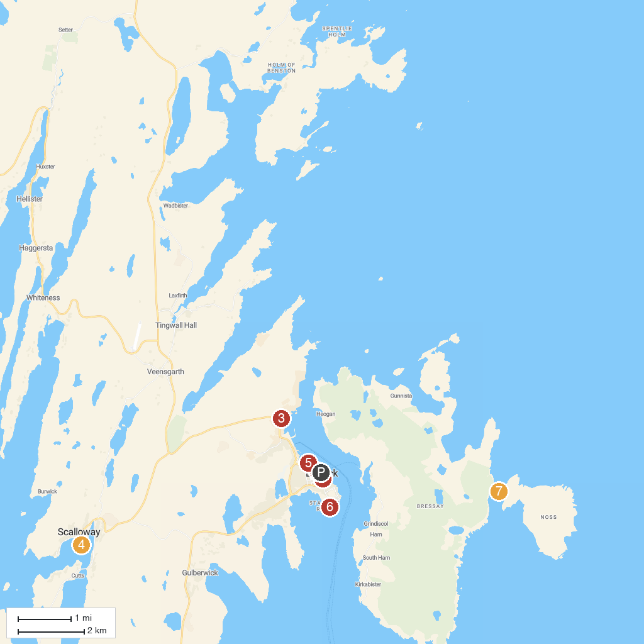
MAP KEY
1. Seabirds-and-Seals - THE ORIGINAL & NO.1 NOSS BOAT - EST 1992 | 5. Shetland Museum & Archives
2. Fort Charlotte | 6. The Knab
3. Shetland Textile Museum | 7. Noss National Nature Reserve
4. Scalloway Castle
P. Cruise port / terminal
Map © MapTiler © OpenStreetMap contributors · cruiseports.org

