Leros Island, Dodecanese, Greece
One of Greece's best-kept secrets, Leros combines a striking Italian Art Deco port town, a Byzantine hilltop castle, and authentic fishing-village beaches — all with barely a tourist in sight.
⚓ Docked at Lakki (most ships) · 🕒 Typical call: 6–8 hrs · 💶 Currency: Euro (€) · 🗣️ Language: Greek (English widely spoken)
✍️ MY DAY IN PORT (FILL IN)
Ship / Date
In port | arrive ______ · all aboard ______
Booked excursion
Notes / meeting point
GETTING ASHORE
- Docking: Most ships dock at Lakki commercial pier; small/expedition ships may tender to Agia Marina
- Walk to Center: 5–10 min flat walk from Lakki pier to Lakki town; Agia Marina is steps from its tender dock
- Best For: WWII history, Italian architecture, authentic Greek beaches, wreck diving
- Don't Miss: Agios Isidoros chapel on the sea causeway and the castle views over Panteli bay
GETTING AROUND
- 🚕 Taxi: €5–€12 — Taxis meet ferries at Lakki port; rank also in Platanos village. From Lakki to Platanos ~€12 (10 min); from Agia Marina
- 📱 Rideshare: ❌ not available
TOP THINGS TO DO
- Battle of Leros WWII Tunnel Museum — Walk through genuine Italian-built wartime tunnels packed with recovered guns, uniforms, aircraft wreckage, and the story of the…
- Castle of Panteli (Kastro) — An 11th-century Byzantine fortress crowning the island's central ridge, with sweeping 360° views over the bays of Panteli and…
- Lakki Rationalist Architecture Walk — Mussolini transformed Lakki into a model Italian naval town in the 1930s — the result is a hauntingly beautiful, almost deserted…
- Panteli & Vromolithos Beach Afternoon — Twin bays side by side, fringed by pine trees and lined with fish tavernas where you can eat grilled octopus and red mullet with…
- Wreck Diving in Lakki Bay — The intense WWII sea battles left dozens of warplanes and warships on the seabed of Leros's deep bays, making this one of the…
BEST WALKS
- Lakki Waterfront to Rationalist Town Center: 1 km · Flat · 15–20 min — From the cruise pier, walk the wide promenade past the marina and into Lakki town.
- Agia Marina to Platanos to Castle: 1.5 km one-way · Steep · 30–40 min up — From the Agia Marina tender dock, wind uphill through the narrow lanes of Platanos — the…
- Agios Isidoros Chapel Causeway: Short walk · Easy · ~15 min — Walk the narrow stone causeway stretching out to sea to reach the tiny Agios Isidoros chapel…
WEATHER · DAYLIGHT · MONEY
Month | High °F | Low °F | Rainy days
May | 75 | 62 | 3
Jul | 86 | 72 | 1
Sep | 81 | 68 | 2
Daylight: May 5:15AM–7:35PM · Jul 5:05AM–7:50PM · Sep 5:55AM–6:45PM
cruiseports.org/leros-island · Confirm terminal & all-aboard time with your ship

Leros Island, Dodecanese, Greece — Port Map
Red = walkable sights · Amber = excursions farther out · P = cruise terminal
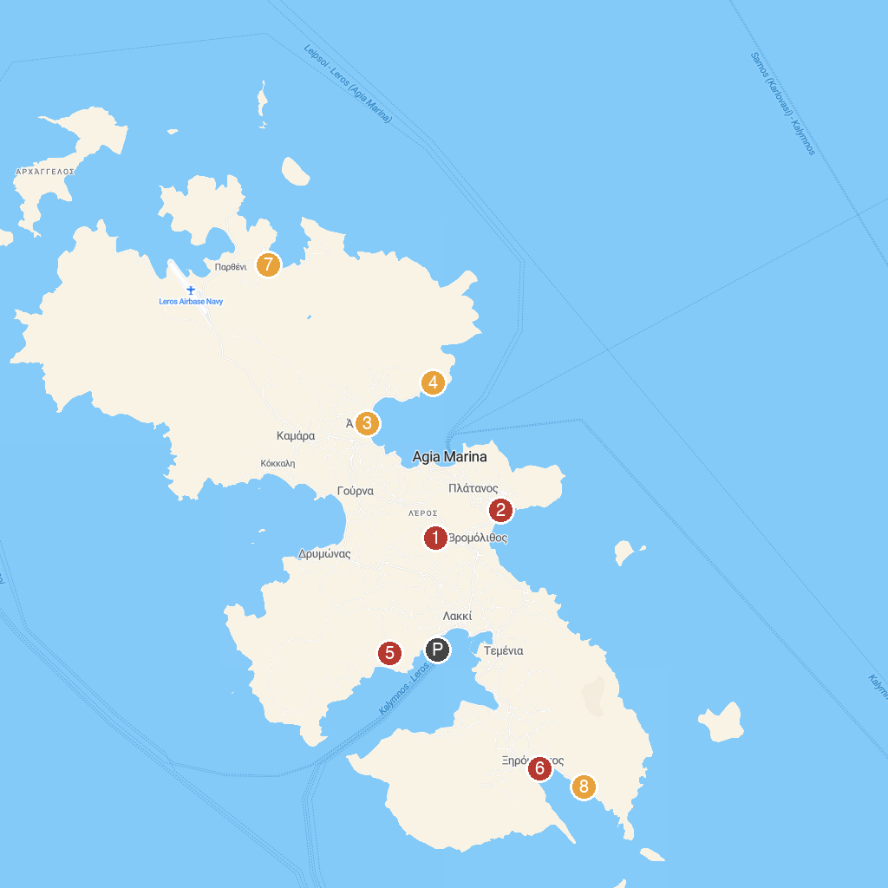
MAP KEY
1. DEPOSITO DI GUERRA | 5. Leros War Museum
2. Panteli Beach | 6. Xirokampos Beach
3. Bellenis Tower | 7. Blefoutis beach
4. Dyo Liskaria | 8. Panaghia Kavouradena
P. Cruise port / terminal
Map © MapTiler © OpenStreetMap contributors · cruiseports.org

