Lemnos Island, Aegean, Greece
One of the Aegean's best-kept secrets: wild deer roam a Byzantine castle, ancient sand dunes ripple across volcanic land, and the wine here dates back to Homer.
⚓ Tender port (most ships) · 🕒 Typical call: 7-9 hrs · 💶 Currency: Euro (€) · 🗣️ Language: Greek · 🦌 Wildlife: Castle deer
✍️ MY DAY IN PORT (FILL IN)
Ship / Date
In port | arrive ______ · all aboard ______
Booked excursion
Notes / meeting point
GETTING ASHORE
- Docking: Tender for large ships; small vessels may dock at Myrina pier
- Walk to center: 2-5 min from tender dock to Myrina main street
- Best For: Authentic Greek island, beaches, archaeology, local food & wine
- Don't Miss: Wild deer at Myrina Castle and the sand dunes (Ammothines)
GETTING AROUND
- 🚕 Taxi: €5–€15 in-town; €30–€50+ for island tours — Taxis wait near the main square in Myrina. Short in-town fares are low; negotiate or confirm metered rates for longer is
TOP THINGS TO DO
- Myrina Castle & the Wild Deer — Climb the Byzantine-Venetian fortress perched on a rocky peninsula above the harbor.
- Ammothines Sand Dunes — Known as the 'Sahara of Greece,' these rolling golden dunes surrounded by wild olive trees and thyme are widely considered…
- Poliochni — Europe's Oldest City — Dating to around 4000 BC, Poliochni is believed to be the oldest organized settlement in Europe, predating Troy.
- Hephaistia Theater & Cave of Philoctetes — The ancient city of Hephaistia features a beautifully restored Greek theater.
- Beach Day at Plati or Riha Nera — Plati Beach (10-min taxi) is a premium stretch of fine sand with beach bars and water sports.
BEST WALKS
- Harbor to Castle Loop: ~2 km | 45-60 min | Moderate (steep climb to castle) — From the tender dock, walk through the harbor area and up to the Myrina Castle.
- Waterfront Stroll — Tourkikos to Romeikos Gialos: ~1 km | 20 min | Easy (flat) — Walk from the busy fishing harbor (Tourkikos Gialos) with its tavernas along the waterfront, then…
WEATHER · DAYLIGHT · MONEY
Month | High °F | Low °F | Rainy days
May | 71 | 60 | 5
Jul | 84 | 73 | 2
Sep | 77 | 68 | 4
Daylight: May 6:05AM–8:27PM · Jul 6:04AM–8:46PM · Sep 7:01AM–7:28PM
cruiseports.org/lemnos-island · Confirm terminal & all-aboard time with your ship

Lemnos Island, Aegean, Greece — Port Map
Red = walkable sights · Amber = excursions farther out · P = cruise terminal
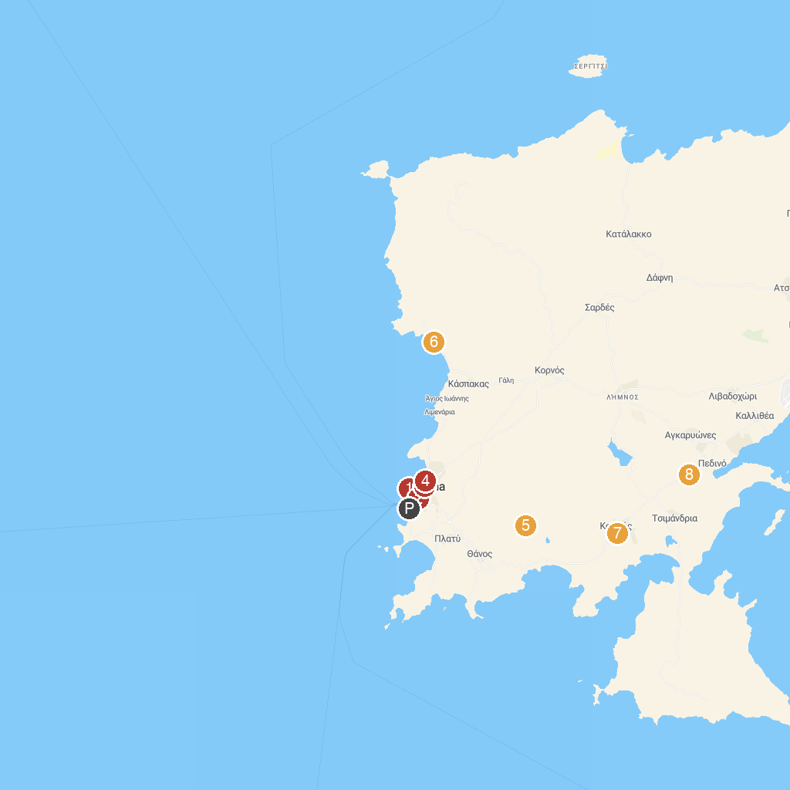
MAP KEY
1. Κάστρο Μύρινας | 5. Panagia Kakaviotissa
2. Old Harbor Myrina | 6. ΠΑΡΑΛΙΑ ΑΓΙΟΣ ΙΩΑΝΝΗΣ
3. plateia ktel | 7. Ανεμόμυλοι Αγίου Αθανασίου
4. Archeological Museum of Lemnos | 8. Folklore Museum Portianou
P. Cruise port / terminal
Map © MapTiler © OpenStreetMap contributors · cruiseports.org

