Lembar, Lombok, Indonesia
Gateway to Lombok's untouched beaches and living Sasak culture. Unlike tourist-heavy Bali next door, Lombok moves at its own unhurried pace — mosques outnumber temples and the chilies are fiercer.
⚓ Pier (Gili Mas Terminal) — large ships; tender for smaller vessels · 🕒 Typical call: 8-10 hrs · 💵 Indonesian Rupiah (IDR) — cash essential · 🗣️ Indonesian / Sasak — English at tourist spots · 🌴 Indian Ocean
✍️ MY DAY IN PORT (FILL IN)
Ship / Date
In port | arrive ______ · all aboard ______
Booked excursion
Notes / meeting point
GETTING ASHORE
- Docking: Gili Mas deep-water pier (large ships); tender at Lembar Harbor (smaller vessels)
- Walk to center: Nothing walkable from port — transport required to reach towns or beaches
- Best For: Beach lovers, culture seekers, foodies after spicy Sasak cuisine
- Don't Miss: Ayam Taliwang (Lombok's iconic spicy grilled chicken)
GETTING AROUND
- 🚕 Taxi: IDR 90,000–110,000 (~$6–7 USD) — Blue Bird taxis offer metered rides to Mataram city center (~21 km, 25–45 min). Insist on the meter or pre-negotiate; dr
TOP THINGS TO DO
- Selong Belanak Beach — Arguably one of Asia's most beautiful beaches: a wide crescent of soft white sand with shallow turquoise water.
- Sasak Village (Sade or Ende) — Living examples of indigenous Sasak culture.
- Taman Narmada Park — Built in 1727 by a Balinese king as a miniature replica of Mount Rinjani and its crater lake, complete with royal swimming pools…
- Southwest Gilis Snorkeling (Gili Nanggu & Gili Kedis) — The 'secret Gilis' — uninhabited sandbar islands with pristine coral reefs, sea turtles, and crystal-clear water.
- Mataram Islamic Center & Pura Lingsar — Lombok's defining contrast in one trip: the grand Hubbul Wathan Mosque with its soaring dome and city views from the minaret…
BEST WALKS
- Ampenan Old Town Wander: ~30 min • Easy • History & Photography — Lombok's original port district retains crumbling Dutch colonial shophouses, a busy fish market…
WEATHER · DAYLIGHT · MONEY
Month | High °F | Low °F | Rainy days
May | 87 | 76 | 11
Jul | 85 | 74 | 6
Sep | 88 | 75 | 9
Daylight: May 6:20AM–6:03PM · Jul 6:32AM–6:11PM · Sep 6:09AM–6:12PM
cruiseports.org/lembar · Confirm terminal & all-aboard time with your ship

Lembar, Lombok, Indonesia — Port Map
Red = walkable sights · Amber = excursions farther out · P = cruise terminal
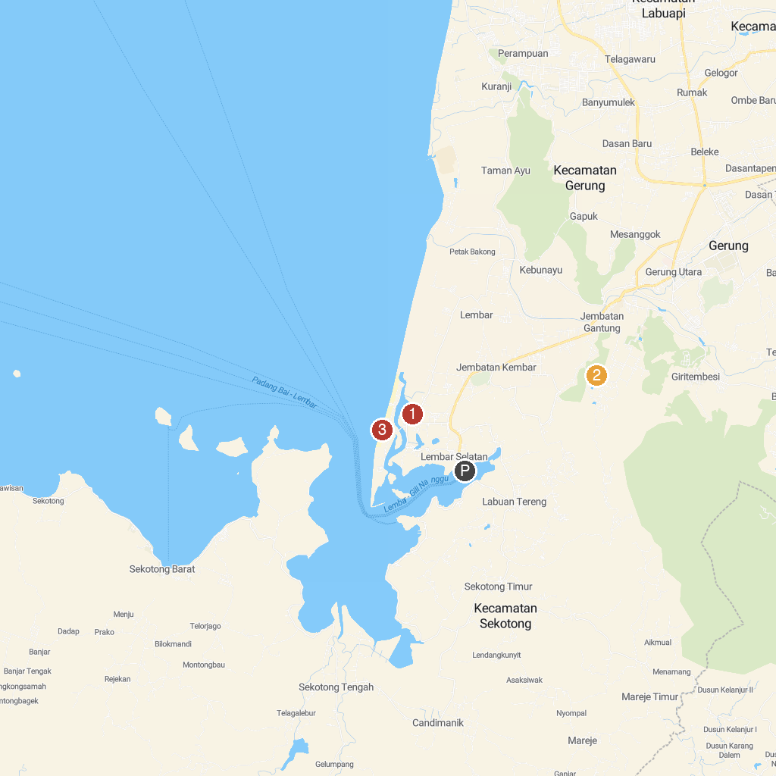
MAP KEY
1. Eco Wisata Mangrove Forest Lembar Selatan | 3. Pantai Cemare Lembar
2. Gunung Batu Idung
P. Cruise port / terminal
Map © MapTiler © OpenStreetMap contributors · cruiseports.org

