Lelystad, Flevoland, Netherlands
Lelystad sits on land that didn't exist 70 years ago — drained from the IJsselmeer and engineered into a city. Come for the replica VOC tall ship, stay for the wild horses roaming reclaimed polders.
⚓ Docked (BataviaHaven pier) · 🕒 Typical call: 7-9 hrs · 💶 Euro (€) · 🗣️ Dutch (English widely spoken) · 🚲 Flat & cycling-friendly
✍️ MY DAY IN PORT (FILL IN)
Ship / Date
In port | arrive ______ · all aboard ______
Booked excursion
Notes / meeting point
GETTING ASHORE
- Docking: Docked at BataviaHaven — river cruise ships moor directly; no tender required
- Walk to Centre: ~10 min walk or 3 km to Lelystad Centrum; Batavialand is steps from the pier
- Best For: Maritime history, aviation buffs, polder nature, outlet shopping
- Don't Miss: Batavialand's full-scale VOC ship Batavia and the Oostvaardersplassen wild horses
GETTING AROUND
- 🚕 Taxi: €18–22 — Fixed-price taxi from Bataviahaven to Lelystad Centrum Station takes about 5 minutes. Companies like Staxi offer advance
- 📱 Rideshare: ✅ Uber
TOP THINGS TO DO
- Batavialand — VOC Ship & Polder Museum — Walk the decks of a painstakingly reconstructed 17th-century VOC merchant ship, the Batavia, built by traditional craftsmen on…
- Aviodrome — National Aviation Museum — Over 100 historic aircraft and helicopters, flight simulators, a 4D theatre, and the full story of Dutch aviation from the Wright…
- Oostvaardersplassen Wild Nature Reserve — One of Europe's boldest rewilding experiments — this vast wetland reserve on the outskirts of Lelystad is home to free-roaming…
- Batavia Stad Fashion Outlet — A large designer outlet village built in the style of a Dutch town, right next to BataviaHaven.
- Nieuw Land Heritage Centre — Tells the complete story of how the Netherlands created Flevoland — draining the Zuiderzee and turning open water into productive…
BEST WALKS
- BataviaHaven Waterfront Loop: ~1.5 km · 20 min · Easy — A gentle loop around the historic harbour taking in the moored tall ships, the Batavialand…
- Harbour to Lelystad Centrum: ~3 km · 35 min · Easy — Walk or cycle into the city centre along flat polder roads and dedicated cycle paths.
WEATHER · DAYLIGHT · MONEY
Month | High °F | Low °F | Rainy days
May | 63 | 49 | 12
Jul | 71 | 59 | 15
Sep | 67 | 54 | 11
Daylight: May 5:42AM–9:27PM · Jul 5:34AM–9:53PM · Sep 7:12AM–7:52PM
cruiseports.org/lelystad · Confirm terminal & all-aboard time with your ship

Lelystad, Flevoland, Netherlands — Port Map
Red = walkable sights · Amber = excursions farther out · P = cruise terminal
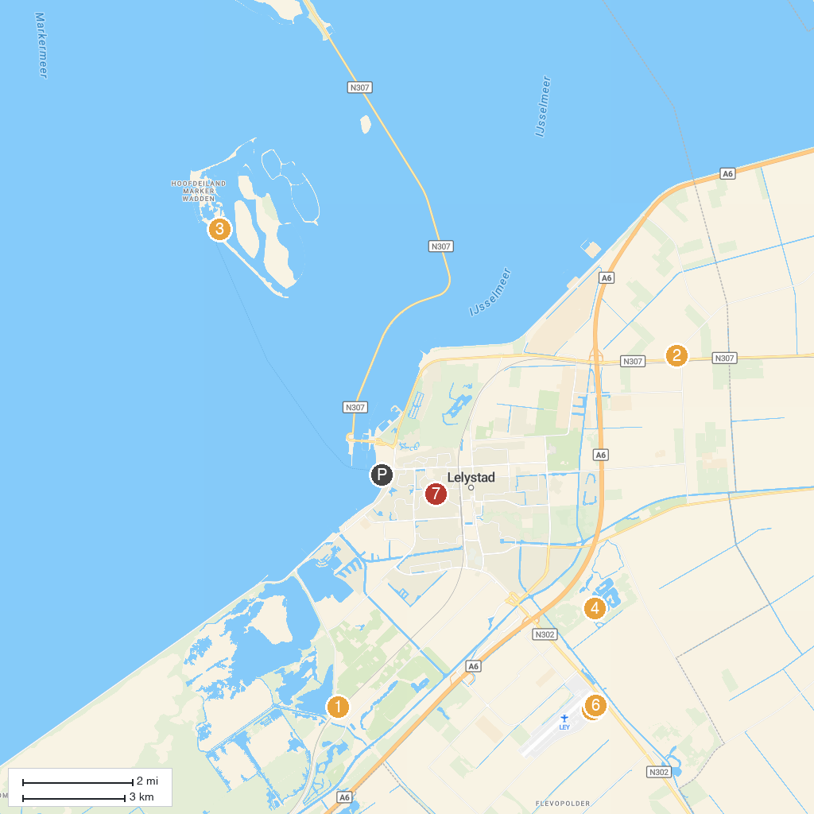
MAP KEY
1. Oostvaardersplassen | 5. Natuurpark Lelystad
2. Observatorium, Robert Morris | 6. Foundation Space Museum
3. Marker Wadden | 7. Luchtvaartmuseum Aviodrome
4. Dronten Mechanical Heritage Center | 8. Bultpark
P. Cruise port / terminal
Map © MapTiler © OpenStreetMap contributors · cruiseports.org

