Lelepa Island, Efate, Vanuatu
A sacred, community-owned island off Efate where ancient caves, brilliant coral reefs, and unhurried village life haven't changed in centuries — reached by tender into one of the Pacific's most sheltered harbours.
⚓ Tender port (no pier) · 🕒 Typical call: 6-8 hrs · 💵 Vanuatu Vatu (VUV) / AUD accepted · 🗣️ Bislama, English, French · 🏝️ Royal Beach Club opening 2027
✍️ MY DAY IN PORT (FILL IN)
Ship / Date
In port | arrive ______ · all aboard ______
Booked excursion
Notes / meeting point
GETTING ASHORE
- Docking: Tender only — ships anchor in Havannah Harbour; tender to island beach
- Walk to centre: Sandy paths only; no roads or vehicles; Fels Cave ~10 min from beach
- Best For: Culture, snorkelling, UNESCO history, authentic village visits
- Don't Miss: Fels Cave rock art (3,000-year-old carvings inside a sacred limestone cavern)
GETTING AROUND
- 🚕 Taxi: Varies by distance — Taxis and shared minivans (buses) operate in Port Vila on nearby Efate island, not on Lelepa itself. Local apps Island T
TOP THINGS TO DO
- Fels Cave & Chief Roi Mata's Domain — A guided walk to Fels Cave, where rock art up to 3,000 years old covers the walls.
- Snorkelling the Giant Clam Sanctuary — The community protects a shallow marine reserve just offshore where giant clams, sea turtles, clownfish, and coral gardens thrive.
- Natapao Village Visit — Walk through Natapao, the island's main village on its southern edge, and meet locals — children may sing, elders demonstrate…
- Mt. Tifit Ridge Walk — A short but rewarding climb toward Mt.
- Beach Day & Traditional Beachside Lunch — Most full-day tours include a beachside BBQ lunch of grilled fish, chicken, taro, and fresh tropical fruit.
BEST WALKS
- Beach Landing to Fels Cave: ~1 km | 10-15 min | Easy-Moderate — From the beach landing area, a sandy track leads through light jungle toward the southwest side of…
- Village Loop — Natapao: ~0.8 km loop | 30 min | Easy — A short circular walk from the beach through Natapao village, past the community school and…
WEATHER · DAYLIGHT · MONEY
Month | High °F | Low °F | Rainy days
May | 79 | 73 | 9
Jul | 77 | 71 | 6
Sep | 78 | 71 | 8
Daylight: May 6:04AM–5:22PM · Jul 6:18AM–5:28PM · Sep 5:43AM–5:42PM
cruiseports.org/lelepa-island-vanuatu · Confirm terminal & all-aboard time with your ship

Lelepa Island, Efate, Vanuatu — Port Map
Red = walkable sights · Amber = excursions farther out · P = cruise terminal
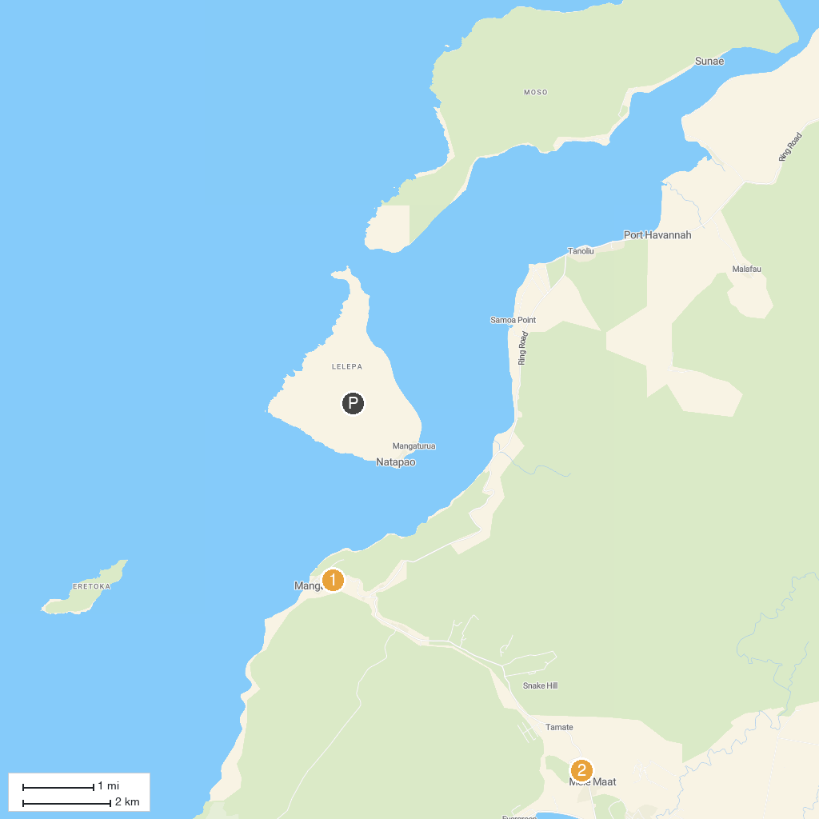
MAP KEY
1. Roawia Turtle & Snorkelling Tours | 2. Mele Cascades Waterfall Entrance Desk
P. Cruise port / terminal
Map © MapTiler © OpenStreetMap contributors · cruiseports.org

