Leknes-Gravdal, Lofoten Islands, Norway
Gravdal port is brutally honest about itself — an industrial quay with nothing to walk to. But rent a car or join a tour and you're minutes from Lofoten's jaw-dropping white-sand beaches, dramatic peaks, and Europe's largest Viking longhouse.
⚓ Pier or Tender (ship-size dependent) · 🕒 Typical call: 7–10 hrs · 💵 Norwegian Krone (NOK) — cards accepted everywhere · 🗣️ Norwegian / English widely spoken · 🚗 Car rental essential for independent exploration
✍️ MY DAY IN PORT (FILL IN)
Ship / Date
In port | arrive ______ · all aboard ______
Booked excursion
Notes / meeting point
GETTING ASHORE
- Docking: Pier for ships ≤230 m; larger ships tender to Gravdal harbour pontoon
- Walk to center: Gravdal village: 10–15 min; Leknes town: 4 km (45 min, not recommended)
- Best For: Beaches, hiking, Viking history, Arctic photography
- Don't Miss: Haukland Beach (Europe's most beautiful) and Lofotr Viking Museum
GETTING AROUND
- 🚕 Taxi: NOK 250 (~$23) to Leknes center — Taxi rank directly at Gravdal pier. Fares to Leknes sentrum run around NOK 250; surcharges apply evenings and weekends.
- 📱 Rideshare: ❌ not available
TOP THINGS TO DO
- Haukland & Uttakleiv Beaches — Two of Lofoten's most iconic beaches sit back-to-back connected by a tunnel.
- Lofotr Viking Museum (Borg) — The largest reconstructed Viking longhouse ever discovered, 15 km north of Leknes.
- Nusfjord Historic Fishing Village — One of Norway's oldest and best-preserved fishing villages.
- Hiking Holandsmelen or Offerøyfjellet — Holandsmelen is a moderate 2–3 hour hike yielding 360° views of the coast and beaches.
- Ramberg & Skagsanden Beaches — Wide white-sand beaches on the south coast backed by dramatic peaks.
BEST WALKS
- Pier to Buksnes Church: 1.5 km each way · 20 min · Easy · Free — A flat walk from the pier into Gravdal village leads to the striking red Buksnes Church (1905)…
WEATHER · DAYLIGHT · MONEY
Month | High °F | Low °F | Rainy days
May | 46 | 39 | 14
Jul | 59 | 51 | 11
Sep | 53 | 48 | 15
Daylight: Sep 6:22AM–7:36PM
cruiseports.org/leknes-gravdal · Confirm terminal & all-aboard time with your ship

Leknes-Gravdal, Lofoten Islands, Norway — Port Map
Red = walkable sights · Amber = excursions farther out · P = cruise terminal
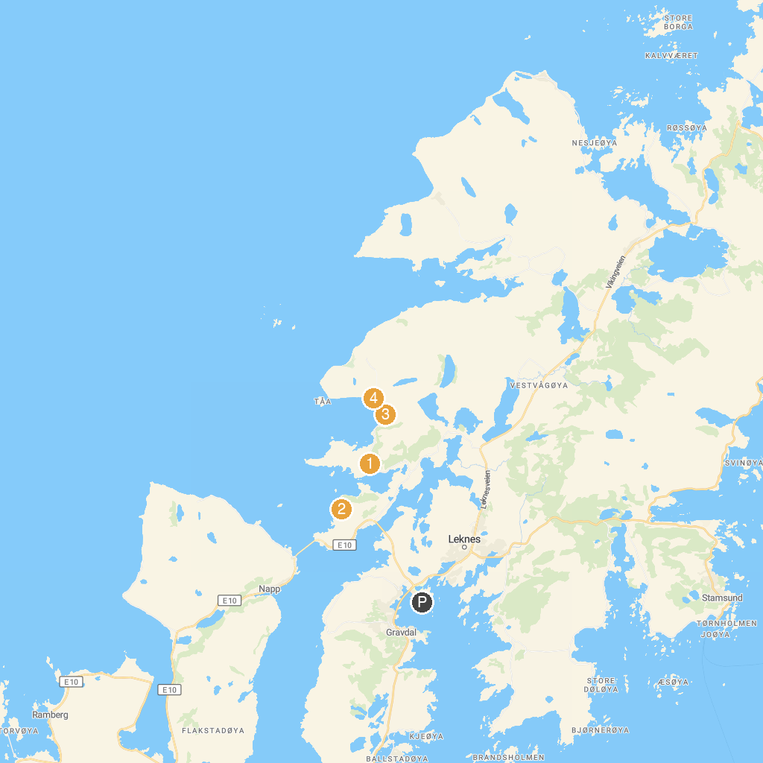
MAP KEY
1. Holandsmelen Parking | 3. Vik Strand
2. Offersøykammen | 4. Haukland Beach
P. Cruise port / terminal
Map © MapTiler © OpenStreetMap contributors · cruiseports.org

