Leirvik, Stord, Norway
Step off the gangway straight into a thriving Norwegian town — no bus required. Stord island packs fjord views, sandy beaches, and a slice of industrial history into one compact, crowd-free day.
⚓ Pier (Sunnhordlandskaien) · 🕒 Typical call: 6-8 hrs · 💵 NOK — cards accepted everywhere · 🗣️ Norwegian (English widely spoken)
✍️ MY DAY IN PORT (FILL IN)
Ship / Date
In port | arrive ______ · all aboard ______
Booked excursion
Notes / meeting point
GETTING ASHORE
- Docking: Pier — Sunnhordlandskaien, town center
- Walk to center: 0-2 min from gangway
- Best For: Hiking, fjord scenery, uncrowded Norway
- Don't Miss: Sunnhordland Open-Air Museum & Kattnakken views
GETTING AROUND
- 🚕 Taxi: NOK 80–150 (~–14 USD) — A taxi rank is located near the quay for trips to outlying areas of Stord or nearby attractions. Fares in Norway are met
TOP THINGS TO DO
- Hike Mount Kattnakken (724 m) — Stord's highest peak offers 360-degree views over the Hardangerfjord, surrounding islands, and the Folgefonna Glacier.
- Sunnhordland Open-Air Museum — Eleven historic wooden buildings dating from the 16th–20th centuries set in Vidsteenparken, a 10-minute uphill walk from the pier.
- Litlabø Mining Village — An open-air mine museum 8 km from port — sulfur and pyrite were extracted here from 1865 to 1968.
- Fitjarøyane Archipelago Boat Tour — Often called 'miniature Lofoten,' hundreds of islands and reefs at the north end of Stord make for a spectacular boat or kayak…
- Sponavikjo Beach Walk — A sheltered sandy beach on smooth coastal rocks, 20 minutes on foot south of the pier.
BEST WALKS
- Town Center & Waterfront Stroll: 1-2 hrs · Flat · Free — From the pier walk Borggata, Leirvik's pedestrian street, past bakeries and shops, then loop back…
- Vidsteenparken & Sunnhordland Museum: 1-2 hrs · Easy uphill · Free (grounds) — Short uphill walk from the pier to the open-air museum park.
- Landåsen Forest & Lake Walk: 2-3 hrs · Easy-moderate · Free — Head uphill from town into pine forest, following gravel paths to Landåsvatnet lake and various…
WEATHER · DAYLIGHT · MONEY
Month | High °F | Low °F | Rainy days
May | 55 | 45 | 14
Jul | 64 | 54 | 18
Sep | 60 | 52 | 17
Daylight: May 5:01AM–10:08PM · Jul 4:44AM–10:42PM · Sep 7:06AM–7:58PM
cruiseports.org/leirvik · Confirm terminal & all-aboard time with your ship

Leirvik, Stord, Norway — Port Map
Red = walkable sights · Amber = excursions farther out · P = cruise terminal
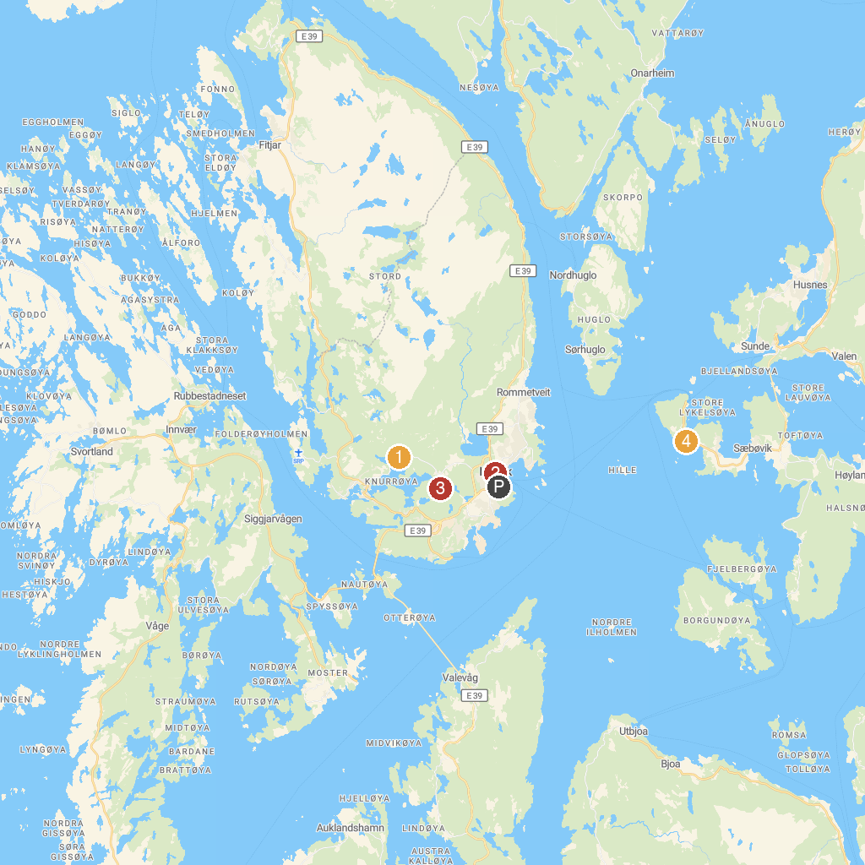
MAP KEY
1. The Mining Museum - Litlabø | 3. Eventyrskogen
2. Sunnhordlandstunet Museum - Leirvik | 4. Halsnøy kloster
P. Cruise port / terminal
Map © MapTiler © OpenStreetMap contributors · cruiseports.org

