Leiden, South Holland, Netherlands
A classic Dutch university city with 17th-century canals, wall poems, Rembrandt's hometown, and the hofjes where the Pilgrims once lived in exile before sailing to America.
⚓ Docked (river quay) · 🕒 Typical call: 6-8 hrs · 💶 Currency: Euro (€) · 🗣️ Language: Dutch (English widely spoken) · 🚲 Bike city — watch the cycle lanes
✍️ MY DAY IN PORT (FILL IN)
Ship / Date
In port | arrive ______ · all aboard ______
Booked excursion
Notes / meeting point
GETTING ASHORE
- Docking: River ships dock at canal quays near Zijlsingel; 10–15 min walk to historic center
- Walk to Center: 10–15 min flat walk from the quay
- Best For: History, culture, canal walks, Dutch art
- Don't Miss: De Burcht citadel views, Hortus Botanicus, and a broodje haring at the canal market
GETTING AROUND
- 🚕 Taxi: €15–20 — Metered taxis available (Taxicentrale Leiden, Staxi). Short city-center trips typically €15–20 for up to 4 passengers. F
- 📱 Rideshare: ✅ Uber
TOP THINGS TO DO
- Pilgrim Father Trail — The English Pilgrims lived in Leiden for 11 years before sailing on the Mayflower in 1620.
- Rembrandt's Leiden — Leiden is Rembrandt van Rijn's birthplace.
- Hortus Botanicus — Founded in 1590, this is one of the world's oldest botanical gardens — and where the very first tulip bulbs were planted in Dutch…
- National Museum of Antiquities — The Rijksmuseum van Oudheden houses a remarkable Egyptian collection, including the complete Temple of Taffeh — gifted by Egypt…
- Canal Boat Cruise — See the city from the water on a 1-hour canal boat tour.
BEST WALKS
- Historic Center Loop: 2–3 km · 1–1.5 hrs · Flat — Walk from the quay into the old city center, past the Waag (weigh house), along the Nieuwe Rijn…
- Wall Poems & Hofjes Walk: 1.5 km · 1 hr · Easy — Leiden has over 100 poems painted on building walls in their original languages.
WEATHER · DAYLIGHT · MONEY
Month | High °F | Low °F | Rainy days
May | 62 | 49 | 11
Jul | 71 | 59 | 14
Sep | 67 | 55 | 11
Daylight: May 5:47AM–9:30PM · Jul 5:39AM–9:55PM · Sep 7:17AM–7:56PM
cruiseports.org/leiden · Confirm terminal & all-aboard time with your ship

Leiden, South Holland, Netherlands — Port Map
Red = walkable sights · Amber = excursions farther out · P = cruise terminal
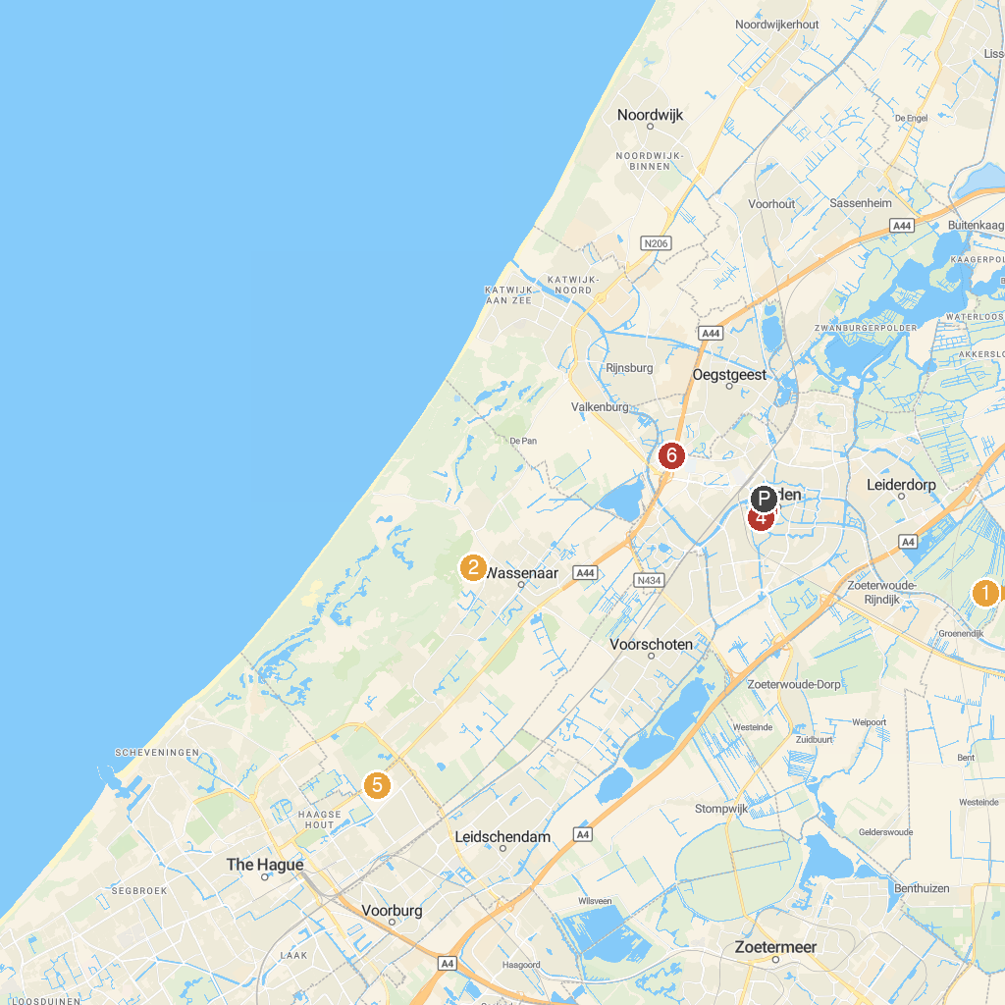
MAP KEY
1. Vogelpark Avifauna | 5. Louwman Museum
2. Duinrell | 6. Keukenhof
3. National Museum of Antiquities | 7. Corpus
4. Hortus Botanicus Leiden | 8. Madurodam
P. Cruise port / terminal
Map © MapTiler © OpenStreetMap contributors · cruiseports.org

