Lefkada Island, Ionian Islands, Greece
An Ionian gem of cliff-fringed turquoise bays and olive-draped hillsides, Lefkada rewards cruise visitors with some of Greece's most spectacular beaches — all reached by tender from the lively harbour village of Nydri.
⚓ Tender port (Nydri) · 🕒 Typical call: 7-9 hrs · 💶 Euro (€) · 🗣️ Greek
✍️ MY DAY IN PORT (FILL IN)
Ship / Date
In port | arrive ______ · all aboard ______
Booked excursion
Notes / meeting point
GETTING ASHORE
- Docking: Tender from anchorage off Nydri; tenders run continuously
- Walk to centre: 1 min — Nydri's waterfront strip is right at the tender dock
- Best For: Iconic beaches, island boat tours, kitesurfing, Greek village strolls
- Don't Miss: Porto Katsiki beach or a Nydri boat trip to Meganisi & Skorpios
GETTING AROUND
- 🚕 Taxi: €7–€36 — Metered taxis available at Lefkada Town marina and Nidri port. Short hops within Lefkada Town run ~€7; pre-booked transf
- 📱 Rideshare: ✅ Uber
TOP THINGS TO DO
- Porto Katsiki & Egremni Boat Tour — The signature Lefkada experience — a half-day boat trip from Nydri to the island's two most iconic white-cliff beaches.
- Kathisma Beach & Kitesurfing at Agios Ioannis — Head to the west coast for Kathisma, one of Greece's top beaches — paragliders land here and the surf is electric.
- Agia Mavra Castle & Lefkada Old Town — Walk or taxi to the 14th-century Venetian Agia Mavra Castle guarding the causeway, then explore Lefkada Town's colourful…
- Dimosari Waterfalls Hike — A short trail just inland from Nydri (about 3 km up the Dimosari gorge) leads through olive groves to a series of lush waterfalls…
- Meganisi & Skorpios Island Cruise — Boat tours from Nydri loop around the private Onassis island of Skorpios and the unspoilt island of Meganisi with stops for…
BEST WALKS
- Nydri Waterfront Stroll: 1.5 km loop | Easy | 20 min — From the tender landing, walk north along the harbour past tavernas, water-sports operators, and…
- Dimosari Waterfalls Trail: 4 km return | Easy-moderate | 1.5 hrs — Head inland from Nydri (the falls are about 3 km up the Dimosari gorge) and follow the signed trail…
WEATHER · DAYLIGHT · MONEY
Month | High °F | Low °F | Rainy days
May | 75 | 61 | 8
Jul | 91 | 75 | 2
Sep | 83 | 70 | 7
Daylight: May 6:25AM–8:42PM · Jul 6:24AM–9:00PM · Sep 7:18AM–7:45PM
cruiseports.org/lefkada-island · Confirm terminal & all-aboard time with your ship

Lefkada Island, Ionian Islands, Greece — Port Map
Red = walkable sights · Amber = excursions farther out · P = cruise terminal
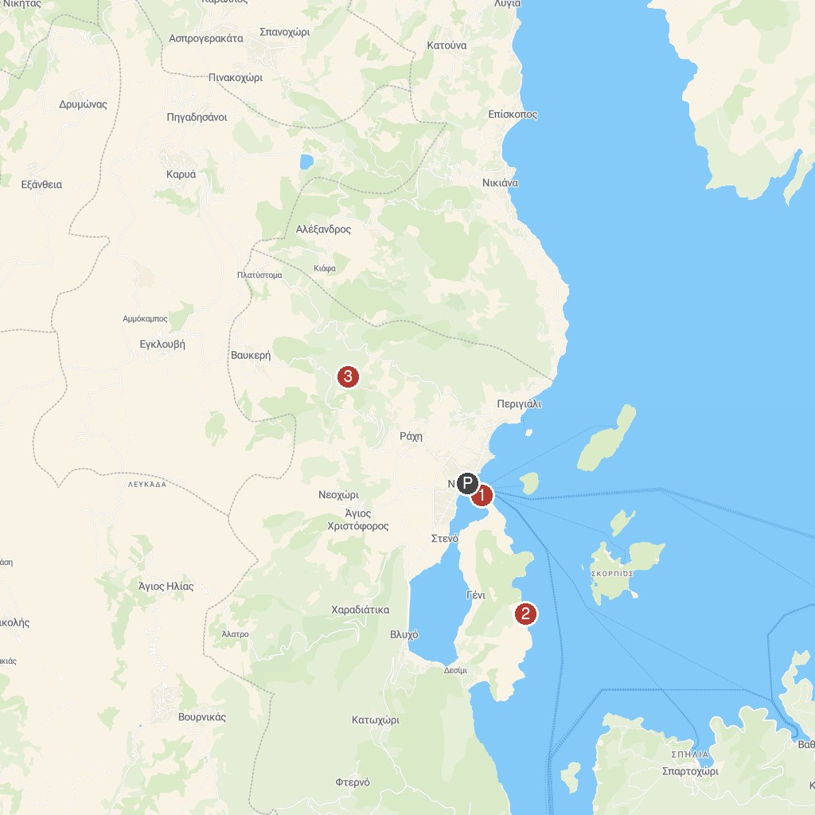
MAP KEY
1. Faneromeni Monastery | 3. Παραλία Ελλομένο
2. Ιερός Ναός Αγίας Κυριακής | 4. WATERFALLS NIDRI
P. Cruise port / terminal
Map © MapTiler © OpenStreetMap contributors · cruiseports.org

