Leer, Lower Saxony, Germany
The self-proclaimed 'Gateway to East Frisia' delivers Dutch-brick charm, a harbour full of historic ships, and the world's most devoted tea culture — all within easy walking distance of the dock.
⚓ Docked (river quay) · 🕒 Typical call: 6–8 hrs · 💶 Currency: Euro (€) · 🗣️ Language: German · 🍵 East Frisian tea capital
✍️ MY DAY IN PORT (FILL IN)
Ship / Date
In port | arrive ______ · all aboard ______
Booked excursion
Notes / meeting point
GETTING ASHORE
- Docking: River quay at Museumshafen / Freizeithafen — no tender required
- Walk to centre: 1–5 min to Altstadt from the dock
- Best For: History, architecture, culinary culture, relaxed strolling
- Don't Miss: The East Frisian tea ceremony at the Bünting Tea Museum
GETTING AROUND
- 🚕 Taxi: €6–€10 for short rides in town — Taxis are readily available in Leer with a base fare of €6 (day) or €7 (night) plus €2.30–€2.40/km. Local companies incl
TOP THINGS TO DO
- East Frisian Tea Ceremony — Visit the Bünting Tea Museum and experience the traditional Teetied ritual — Kluntje rock sugar, strong black tea, and a Wulkje…
- Altstadt Walking Tour — Wander the Dutch-influenced Old Town past Haus Samson (1570), the baroque Große Kirche, and the ornate 1894 Rathaus.
- Dyke & Riverside Cycling — East Frisia is legendary for flat, car-free cycling routes.
- Schloss Evenburg — A striking neo-Gothic moated castle in the Loga district, surrounded by a free public park.
- Miniaturland Leer — One of northern Germany's larger miniature model railways, depicting East Frisian landscapes, Berlin, and working harbour scenes…
BEST WALKS
- Museumshafen to Rathaus Loop: 1.5 km · ~25 min · Easy — Start at the Museum Harbour, walk along the Uferpromenade past historic barges, reach Haus Samson…
- Altstadt & Shopping Stroll: 2 km · ~35 min · Easy — From the dock, cross the Nessebrücke pedestrian bridge and explore Mühlenstraße (the main shopping…
WEATHER · DAYLIGHT · MONEY
Month | High °F | Low °F | Rainy days
May | 63 | 47 | 11
Jul | 71 | 58 | 15
Sep | 66 | 53 | 12
Daylight: May 5:31AM–9:23PM · Jul 5:22AM–9:49PM · Sep 7:04AM–7:45PM
cruiseports.org/leer · Confirm terminal & all-aboard time with your ship

Leer, Lower Saxony, Germany — Port Map
Red = walkable sights · Amber = excursions farther out · P = cruise terminal
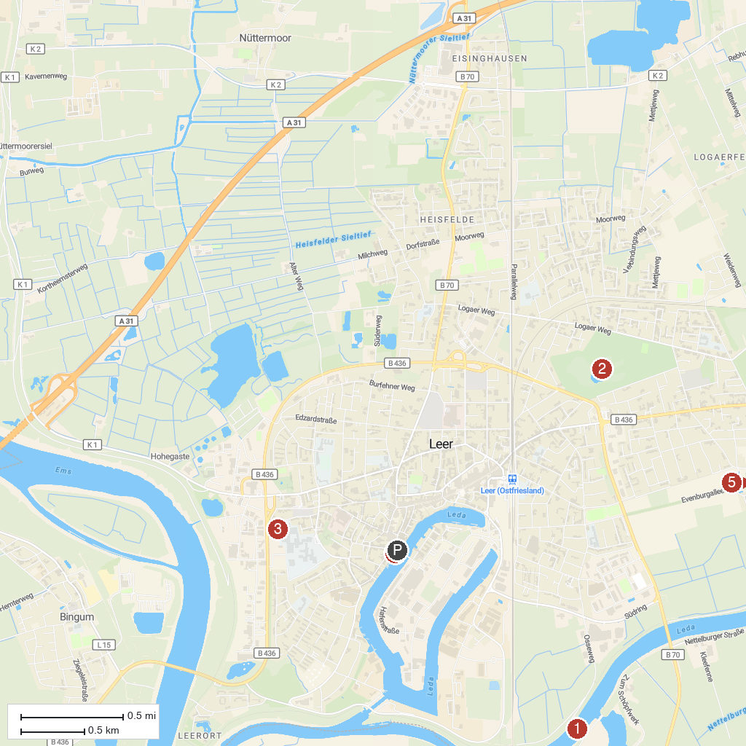
MAP KEY
1. Ledasperrwerk | 5. Villa Popken
2. Julianen Park | 6. Fehn- und Schiffahrtsmuseum Westrhauderfehn
3. Plytenberg | 7. Gut Stikelkamp
4. Museumshafen | 8. Castle Evenburg center for horticulture
P. Cruise port / terminal
Map © MapTiler © OpenStreetMap contributors · cruiseports.org

