Le Verdon-sur-Mer, Nouvelle-Aquitaine, France
At the wild tip of the Médoc Peninsula, this deep-water port is your launchpad to Bordeaux's grand boulevards, UNESCO-listed wine châteaux, and the extraordinary "Versailles of the Sea" lighthouse.
⚓ Docked (pier) · 🕒 Typical call: 8–10 hrs · 💶 Euro (€) · 🗣️ French · 🍷 Bordeaux wine country
✍️ MY DAY IN PORT (FILL IN)
Ship / Date
In port | arrive ______ · all aboard ______
Booked excursion
Notes / meeting point
GETTING ASHORE
- Docking: Alongside at deep-water Môle d'Escale terminal — no tendering
- Walk to center: Port-Médoc Marina ~25 min on foot; town center too far — use shuttle
- Best For: Wine lovers, day-trippers to Bordeaux, Cordouan lighthouse seekers
- Don't Miss: Cordouan Lighthouse UNESCO boat trip; Soulac Belle Époque villas
GETTING AROUND
- 🚕 Taxi: €17–21 — Taxi to Soulac-sur-Mer is about 7 minutes. Taxis at the port can be limited; pre-booking is recommended.
- 📱 Rideshare: ✅ Uber
TOP THINGS TO DO
- Bordeaux City Day — France's "City of Art and History" rewards a full day: the Place de la Bourse and Miroir d'Eau reflecting pool, the Gothic…
- Cordouan Lighthouse Boat Trip — Completed in 1611, the "Versailles of the Sea" is the oldest lighthouse still in operation in France and a UNESCO World Heritage…
- Médoc Wine Châteaux Tour — The Route des Châteaux (D2) winds south past legendary estates: Saint-Estèphe, Pauillac (Lafite Rothschild, Mouton Rothschild)…
- Soulac-sur-Mer & Belle Époque Villas — Just 10 km south, this seaside resort preserves over 500 ornate 19th-century villas in red brick and woodwork.
- Pointe de Grave & WWII Bunkers — Walk to the very tip of the Médoc Peninsula where the estuary meets the open ocean.
BEST WALKS
- Port-Médoc Marina Stroll: 1.5 km · Flat · ~25 min from pier — A flat walk along the road from the cruise terminal to the 800-berth Port-Médoc Marina.
- Pointe de Grave Monument Walk: 2 km loop · Easy · Flat coastal path — From the Phare de Grave, walk the coastal path to the Monument de la Libération commemorating the…
- Soulac-sur-Mer Belle Époque Circuit: 2.5 km loop · Easy · Town streets — From the Soulac shuttle drop-off, loop through the old village to admire the ornate Belle Époque…
WEATHER · DAYLIGHT · MONEY
Month | High °F | Low °F | Rainy days
May | 66 | 55 | 11
Jul | 76 | 64 | 8
Sep | 73 | 61 | 9
Daylight: May 6:33AM–9:28PM · Jul 6:30AM–9:49PM · Sep 7:43AM–8:14PM
cruiseports.org/le-verdon-sur-mer · Confirm terminal & all-aboard time with your ship

Le Verdon-sur-Mer, Nouvelle-Aquitaine, France — Port Map
Red = walkable sights · Amber = excursions farther out · P = cruise terminal
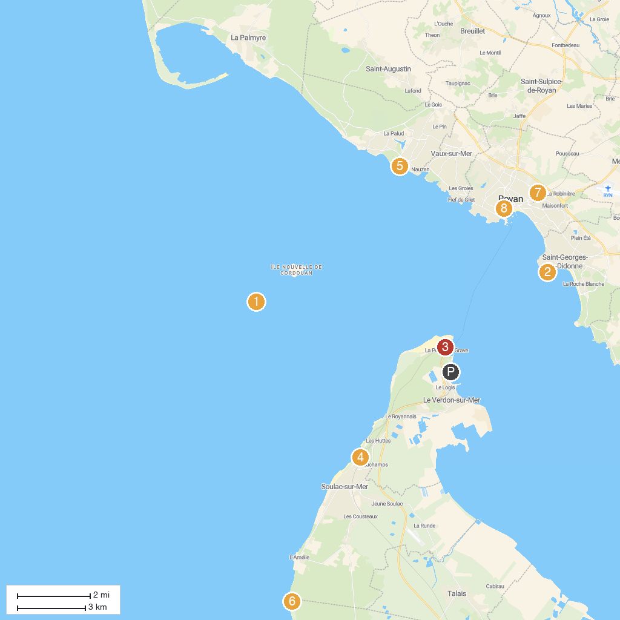
MAP KEY
1. Cordouan Lighthouse | 5. Maison des Douanes
2. Phare de Saint-Georges-de-Didonne | 6. Surf School News Vague
3. Phare de Grave | 7. Planet Exotica
4. Petit Train Touristique PGVS (Pointe Grave Le Verdon Soulac) | 8. Église Notre-Dame de Royan
P. Cruise port / terminal
Map © MapTiler © OpenStreetMap contributors · cruiseports.org

