Le Lavandou, Var, France
Le Lavandou is the softer side of the Riviera: a former fishing village with a compact harbor, sandy beaches, Provençal lanes, and the Îles d'Or shimmering offshore.
⚓ Tender port · 🕒 Typical call: 7-9 hrs · 💶 Currency: Euro · 🗣️ Language: French · 🏖️ Beach town
✍️ MY DAY IN PORT (FILL IN)
Ship / Date
In port | arrive ______ · all aboard ______
Booked excursion
Notes / meeting point
GETTING ASHORE
- Docking: Cruise ships anchor offshore near the marina and tender passengers to Quai d'Honneur
- Walk to center: The marina, town center, and Grande Plage are usually 2-5 minutes on foot from the tender landing
- Best For: Easy beach time, harbor dining, coastal walks, and relaxed Riviera scenery
- Don't Miss: Saint-Clair Beach or a short trip up to Bormes-les-Mimosas
GETTING AROUND
- 🚕 Taxi: €8 minimum — Taxis are available at the port. Minimum fare in France is around €8; local firms like Hermes VTC offer fixed rates for
- 📱 Rideshare: ✅ Uber
TOP THINGS TO DO
- Grande Plage Beach Break — Walk from the tender landing to Le Lavandou's main sandy beach for swimming, sunbeds, waterfront cafes, and an easy return to the…
- Saint-Clair Beach & Coastal Path — Follow the Sentier du Littoral east toward Saint-Clair, a sheltered cove known for clear water and a more polished Riviera feel…
- Bormes-les-Mimosas — Ride inland to one of the Var's prettiest medieval villages, with steep lanes, flowered balconies, artisan shops, and views back…
- Îles d'Or Ferry Adventure — On longer calls, passenger boats from Le Lavandou connect toward Port-Cros and other Golden Islands for national-park hikes…
- Harbor Lunch & Provençal Flavors — Stay local with seafood along Quai Gabriel Péri, market produce when stalls are open, and a glass of chilled Côtes de Provence…
BEST WALKS
- Harbor, Old Town & Grande Plage: 1.5 km | 45-60 min | Flat & easy — Start at the marina, browse the compact center and fishing-village lanes, then loop along the…
- Sentier du Littoral to Saint-Clair: 3 km return | 1.5-2 hrs | Uneven coastal path — Walk east from the port on the coastal path for sea views, rocky coves, and a reward swim at…
- Villa Théo Art Stop: 2 km return | 45-75 min | Easy to moderate — If exhibitions are open, pair a Saint-Clair direction walk with Villa Théo, the former home…
WEATHER · DAYLIGHT · MONEY
Month | High °F | Low °F | Rainy days
May | 71 | 57 | 6
Jul | 86 | 71 | 1
Sep | 78 | 65 | 6
Daylight: May 6:11AM–8:51PM · Jul 6:08AM–9:11PM · Sep 7:14AM–7:44PM
cruiseports.org/le-lavandou · Confirm terminal & all-aboard time with your ship

Le Lavandou, Var, France — Port Map
Red = walkable sights · Amber = excursions farther out · P = cruise terminal
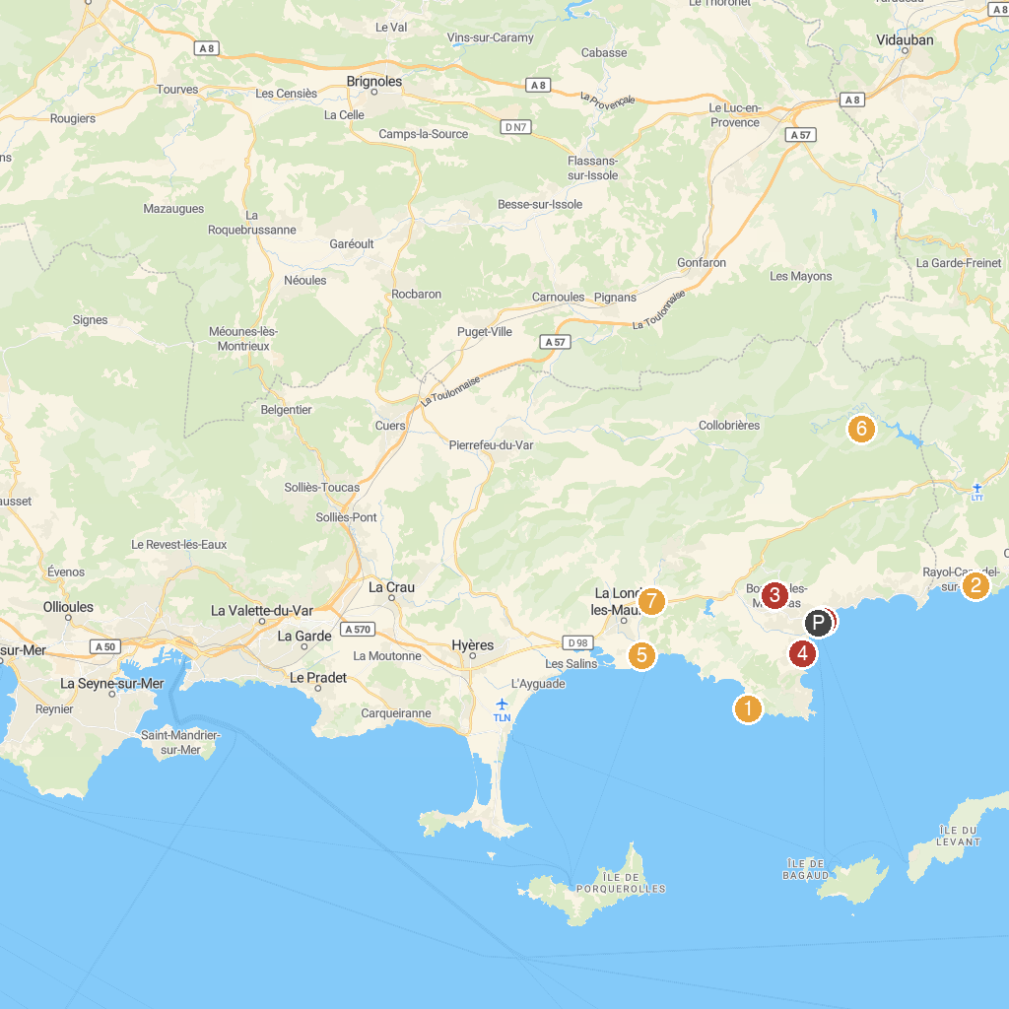
MAP KEY
1. Fort de Brégançon | 5. Aquaboum
2. Domaine du Rayol, The Mediterranean Gardens | 6. Monastère Notre-Dame de Clémence de La Verne / Moniales de Bethléem, de l'Assomption de la Vierge et de Saint-Bruno
3. MHAB-Musée d'Histoire et d'Art de Bormes | 7. Tropical Zoo
4. Beach of La Favière | 8. Jardin Du Belvédère
P. Cruise port / terminal
Map © MapTiler © OpenStreetMap contributors · cruiseports.org

