Le Havre, Normandy, France
Gateway to Paris and Normandy's storied coast. Le Havre itself is a UNESCO-listed modernist city rebuilt by Auguste Perret after WWII — worth exploring between the big excursions.
⚓ Docked (pier) · 🕒 Typical call: 8-10 hrs · 💶 Euro (EUR) · 🗣️ French
✍️ MY DAY IN PORT (FILL IN)
Ship / Date
In port | arrive ______ · all aboard ______
Booked excursion
Notes / meeting point
GETTING ASHORE
- Docking: Quai Roger Meunier cruise terminal — ships dock directly, no tender
- Walk to center: ~30 min walk or €8 taxi to the city center (Place de l'Hôtel de Ville)
- Best For: Paris day trip, D-Day beaches, Normandy scenery, Impressionist art
- Don't Miss: St. Joseph's Church tower, Étretat cliffs, or take the train to Paris
GETTING AROUND
- 🚕 Taxi: €8–€10 — Taxis from the cruise terminal to the city center cost around €8; Le Havre train station is about €10. Prices are per ta
- 📱 Rideshare: ✅ Uber, Bolt
TOP THINGS TO DO
- Paris Day Trip — Take the direct train from Gare du Havre to Paris Saint-Lazare (~2h 10min) and spend the day in the city.
- D-Day Landing Beaches — Visit Omaha Beach, the American Cemetery at Colleville-sur-Mer, and Pointe du Hoc — among the most moving sites in Europe.
- Étretat Cliffs Walk — The chalk sea cliffs at Étretat — with their famous rock arches and needles — are about 29 km northeast of Le Havre.
- Le Havre City & MuMa — The rebuilt city center is a UNESCO World Heritage Site — explore the concrete boulevards and soaring St.
- Honfleur Half-Day — The prettiest harbor town in Normandy sits 45 minutes from Le Havre.
BEST WALKS
- Perret City Center Walk: 2-3 km · Easy · 1-1.5 hrs — Walk the grand boulevards of Auguste Perret's postwar masterplan.
- Waterfront Promenade: 2 km · Easy · 45 min — Stroll the seafront promenade from the port toward the beach at Plage du Havre.
WEATHER · DAYLIGHT · MONEY
Month | High °F | Low °F | Rainy days
May | 62 | 50 | 12
Jul | 71 | 60 | 12
Sep | 68 | 57 | 12
Daylight: May 6:15AM–9:37PM · Jul 6:09AM–10:00PM · Sep 7:36AM–8:12PM
cruiseports.org/le-havre-paris · Confirm terminal & all-aboard time with your ship

Le Havre, Normandy, France — Port Map
Red = walkable sights · Amber = excursions farther out · P = cruise terminal
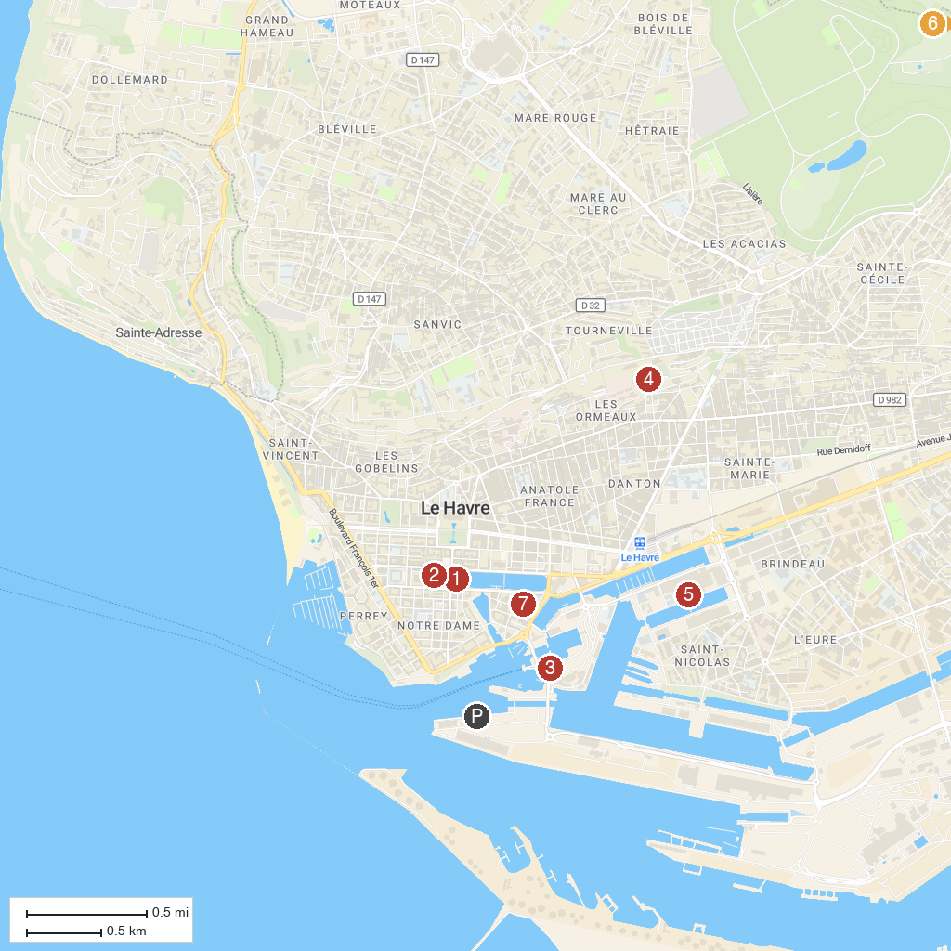
MAP KEY
1. Monuments aux morts | 5. Gulli Parc
2. Bibliothèque Oscar Niemeyer | 6. Park Rouelles (The Bouteillerie)
3. Port Center - Haropa Place | 7. Jardin du Tripot
4. Parc Hauser | 8. Museum Hotel Dubocage Belville
P. Cruise port / terminal
Map © MapTiler © OpenStreetMap contributors · cruiseports.org

