Lauterbach, Rügen, Germany
A royal Baltic harbor where you step off the gangway and straight onto a 19th-century steam train. Lauterbach opens the door to Putbus's neoclassical elegance, ancient beech forests, and the mysterious GDR-era island of Vilm.
⚓ Pier (small ships dock) · 🕒 Typical call: 8-12 hrs (overnight possible) · 💶 Euro (€) — carry cash · 🗣️ German (some English in tourist areas) · 🚂 Narrow-gauge steam train access
✍️ MY DAY IN PORT (FILL IN)
Ship / Date
In port | arrive ______ · all aboard ______
Booked excursion
Notes / meeting point
GETTING ASHORE
- Docking: Pier — Kommunalhafen / Lauterbach Mole (small & river ships only)
- Walk to Putbus: ~2.5 km (30 min) or 5 min by Rasender Roland train
- Best For: Steam train rides, royal town architecture, nature walks, Vilm Island tours
- Don't Miss: Rasender Roland steam train to Binz or Granitz Castle
GETTING AROUND
- 🚕 Taxi: €7–10 — Short taxi ride to Putbus town center (~2 km, ~2 min). Putbus is the historic spa town directly connected to Lauterbach
TOP THINGS TO DO
- Rasender Roland Steam Train Ride — Board the coal-fired Rasender Roland (Rushing Roland), a working narrow-gauge railway operating since 1895.
- Granitz Hunting Lodge — Rügen's most visited castle, built 1837–1846 for Prince Wilhelm Malte I.
- Insel Vilm Guided Boat Tour — A once-secret GDR retreat for top party officials — only 30 visitors per day are allowed on this pristine biosphere island.
- Putbus — The White City — A princely planned town of pure white neoclassical buildings radiating from a circular plaza (The Circus) with a central obelisk.
- Binz Beach & Strandkörbe — Rügen's iconic resort town with a 5 km sandy beach lined with hooded wicker beach chairs (Strandkörbe), grand Bäderarchitektur…
BEST WALKS
- Harbor to Putbus via Schlosspark: 2.5 km · 30 min · Flat, paved — Walk south along the harbor promenade, then follow the signposted path through the Putbus…
- Goor Coastal Forest Trail: 4 km loop · 1 hr · Easy, mostly flat — Head east from the harbor along the shoreline into the Goor Biosphere Reserve.
WEATHER · DAYLIGHT · MONEY
Month | High °F | Low °F | Rainy days
May | 62 | 46 | 16
Jul | 74 | 57 | 13
Sep | 66 | 51 | 11
Daylight: May 5:47AM–8:59PM · Jul 5:42AM–9:22PM · Sep 7:03AM–7:38PM
cruiseports.org/lauterbach-rugen · Confirm terminal & all-aboard time with your ship

Lauterbach, Rügen, Germany — Port Map
Red = walkable sights · Amber = excursions farther out · P = cruise terminal
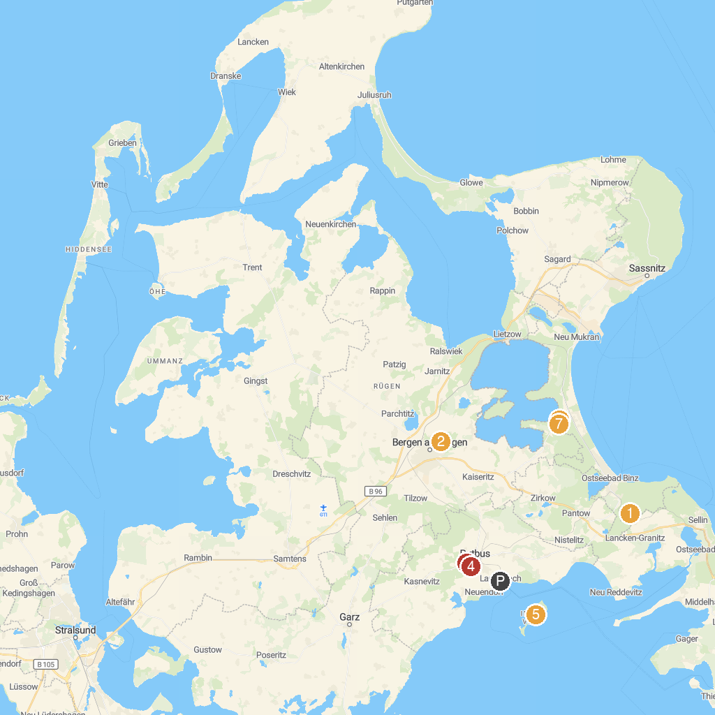
MAP KEY
1. Granitz Hunting Castle | 5. Insel Vilm
2. Inselrodelbahn | 6. Baumwipfelpfad im Naturerbe Zentrum Rügen
3. Uhren- und Musikgerätemuseum | 7. Aussichtplattform Adlerhorst - Baumwipfelpfad Rügen Naturerbezentrum Rügen
4. Schloss Park | 8. Sand sculpture festival in Binz
P. Cruise port / terminal
Map © MapTiler © OpenStreetMap contributors · cruiseports.org

