Las Palmas de Gran Canaria, Gran Canaria, Spain
The Canary Islands' biggest city pairs a spectacular urban beach with a UNESCO-worthy old town — all bathed in near-perfect Atlantic sunshine that makes every port day feel like a gift.
⚓ Docked (cruise terminal) · 🕒 Typical call: 8-10 hrs · 💶 Currency: Euro (€) · 🗣️ Language: Spanish · ☀️ Climate: 22–26 °C year-round
✍️ MY DAY IN PORT (FILL IN)
Ship / Date
In port | arrive ______ · all aboard ______
Booked excursion
Notes / meeting point
GETTING ASHORE
- Docking: Ships dock at Santa Catalina Cruise Terminal — no tendering
- Walk to centre: Las Canteras beach is ~15 min on foot; Vegueta old town is ~3 km (taxi or bus)
- Best For: Beach lovers, history buffs, city wanderers
- Don't Miss: Playa de Las Canteras and the colonial streets of Vegueta
GETTING AROUND
- 🚕 Taxi: €6–20 — Official white metered taxis wait at the terminal. Fare to Vegueta (historic old town) is roughly €6–10; longer trips ac
- 🚌 Hop-on hop-off: ✅ City Sightseeing
TOP THINGS TO DO
- Maspalomas Dunes & South Coast — Drive south to the spectacular Maspalomas sand dunes — a mini-Sahara meeting the Atlantic.
- Vegueta Old Town Walking Tour — Explore Las Palmas' historic quarter: Casa de Colón (Columbus House), the Gothic-Renaissance Cathedral, and colourful colonial…
- Roque Nublo & Central Highlands — Head into the volcanic interior to the iconic Roque Nublo monolith, Gran Canaria's highest accessible peak area.
- Playa de Las Canteras Beach Day — Las Palmas' 3 km urban beach is one of Spain's finest — protected by a natural reef, gentle waves, and a promenade lined with…
- Mercado del Puerto & Food Tour — Gran Canaria's food scene shines at the renovated Mercado del Puerto: fresh papas arrugadas, mojo sauces, local cheeses, and…
BEST WALKS
- Las Canteras Promenade Stroll: 2.5 km | ~45 min | Easy | Flat seafront — Walk from the port along Paseo de Las Canteras, past surf schools and chiringuito bars, to the…
- Vegueta Historic Quarter: 2 km loop | ~1.5 hrs | Easy | Cobblestones — From Plaza de Santa Ana, visit the Cathedral de Santa Ana, duck into Casa de Colón, and explore the…
WEATHER · DAYLIGHT · MONEY
Month | High °F | Low °F | Rainy days
May | 71 | 63 | 6
Jul | 77 | 68 | 2
Sep | 78 | 70 | 5
Daylight: May 7:11AM–8:44PM · Jul 7:15AM–8:59PM · Sep 7:47AM–8:06PM
cruiseports.org/las-palmas-de-gran-canaria · Confirm terminal & all-aboard time with your ship

Las Palmas de Gran Canaria, Gran Canaria, Spain — Port Map
Red = walkable sights · Amber = excursions farther out · P = cruise terminal
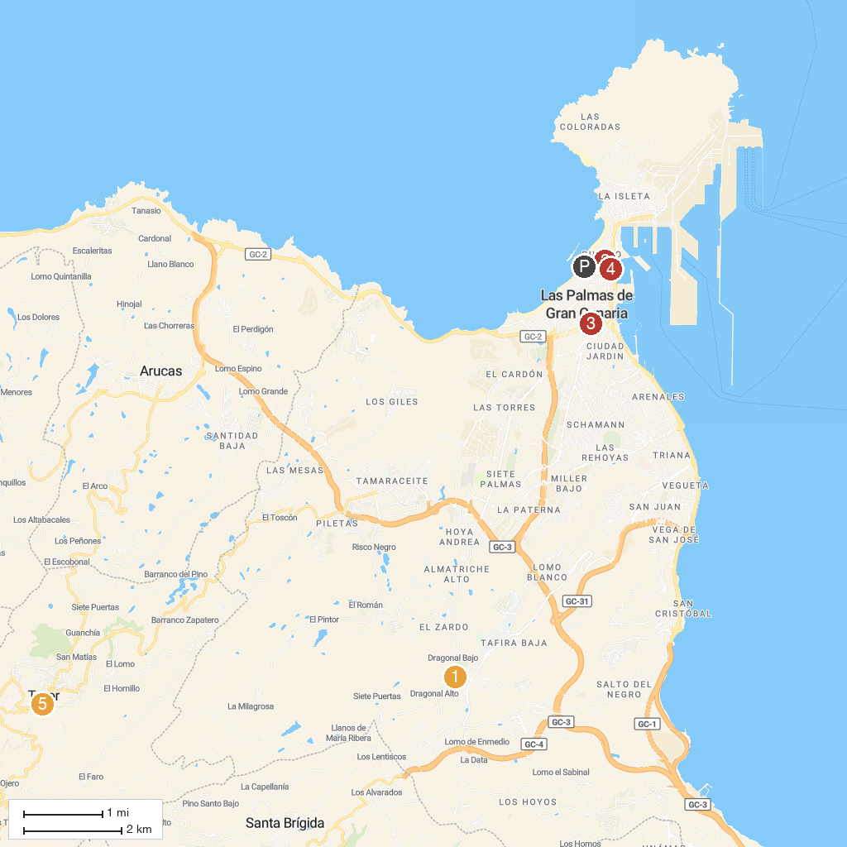
MAP KEY
1. Real Club de Golf De Las Palmas | 5. Casa de Colón
2. Jardín Botánico Viera y Clavijo | 6. Casino Las Palmas
3. Santa Catalina Park | 7. Parque de las Rehoyas
4. Estadio Insular Park | 8. Basílica de Nuestra Señora del Pino
P. Cruise port / terminal
Map © MapTiler © OpenStreetMap contributors · cruiseports.org

