Larnaca, Cyprus
One of the oldest continually inhabited cities in the world, Larnaca blends early Christian pilgrimage, Ottoman heritage, and some of the clearest water in the eastern Mediterranean — all within easy walking distance of the pier.
⚓ Pier — direct docking · 🕒 Typical call: 8-10 hrs · 💶 Currency: Euro (€) · 🗣️ Greek (English spoken widely)
✍️ MY DAY IN PORT (FILL IN)
Ship / Date
In port | arrive ______ · all aboard ______
Booked excursion
Notes / meeting point
GETTING ASHORE
- Docking: Direct pier; shuttle to promenade (~1.2 km from gate)
- Walk to center: 15 min from port gate to Phinikoudes Promenade
- Best For: History, beaches, easy walkable day, local food
- Don't Miss: Church of Saint Lazarus crypt and the Larnaca Salt Lake
GETTING AROUND
- 🚕 Taxi: €3–€5 — The cruise port is just 0–2 km from the city center and Finikoudes Beach promenade. Metered taxis charge ~€3 base plus €
- 📱 Rideshare: ✅ Bolt
TOP THINGS TO DO
- Church of Saint Lazarus & the Old Town — Descend into the 9th-century Byzantine crypt where Lazarus is believed to be buried, admire the gilded iconostasis, then wander…
- Larnaca Medieval Castle & Pierides Museum — The 14th-century harbor fort offers rooftop sea views (€2.50), while the nearby Pierides Museum — Cyprus's oldest private…
- Larnaca Salt Lake & Hala Sultan Tekke — Four interconnected salt lakes host thousands of pink flamingos in winter and spring; in summer the salt crust turns brilliant…
- Zenobia Wreck Dive or Glass-Bottom Boat — The MS Zenobia, a ferry that sank in 1980 just offshore, is rated one of the top 10 wreck dives in the world.
- Phinikoudes & Mackenzie Beaches — Phinikoudes Beach runs right along the promenade — calm, shallow, and lined with sun-loungers.
BEST WALKS
- Phinikoudes Promenade to Saint Lazarus Church: 2.5 km round trip · 45 min · Easy — Start at the palm-lined Phinikoudes seafront, walk past the cafes and the Larnaca Medieval Castle…
- Salt Lake & Hala Sultan Tekke Loop: Best by taxi (5 km from port) · Easy walking on site · 1-2 hrs — Take a taxi to the Larnaca Salt Lake viewpoint, walk the short path along the lake edge to the Hala…
WEATHER · DAYLIGHT · MONEY
Month | High °F | Low °F | Rainy days
May | 81 | 65 | 4
Jul | 93 | 76 | 0
Sep | 89 | 73 | 1
Daylight: May 5:42AM–7:41PM · Jul 5:43AM–7:59PM · Sep 6:28AM–6:52PM
cruiseports.org/larnaca · Confirm terminal & all-aboard time with your ship

Larnaca, Cyprus — Port Map
Red = walkable sights · Amber = excursions farther out · P = cruise terminal
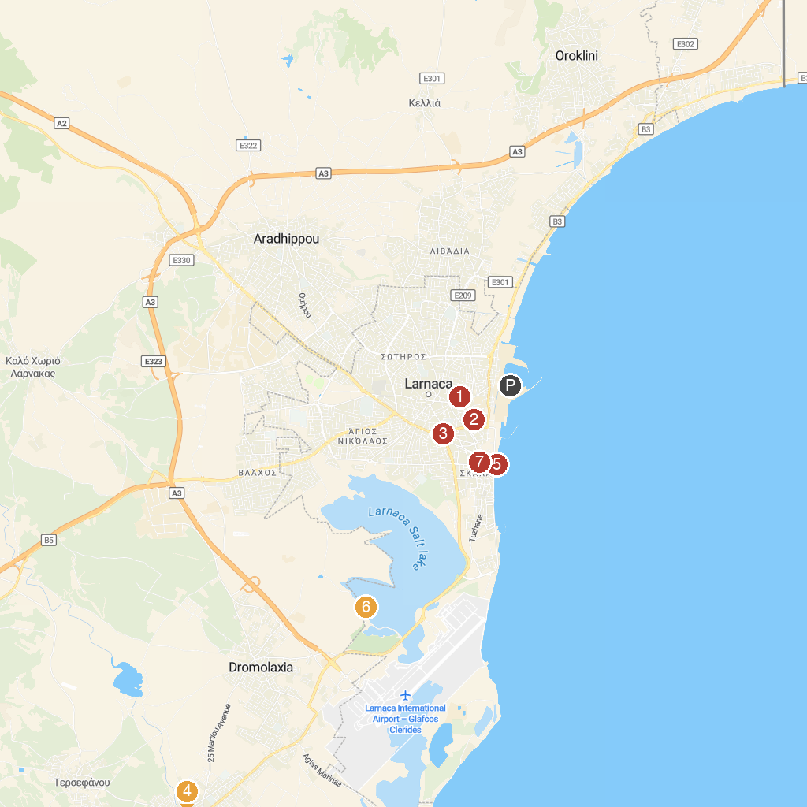
MAP KEY
1. Archaeological Site of Kition | 5. Larnaca Pier
2. Archaeological Museum of Larnaka District | 6. Hala Sultan Tekke
3. Δημοτικό Μουσείο Φυσικής Ιστορίας | 7. Holy Church of Saint Lazarus
4. Holy Church of the Virgin Mary Angeloktisti at Kiti
P. Cruise port / terminal
Map © MapTiler © OpenStreetMap contributors · cruiseports.org

