Langesund, Telemark, Norway
Norway's intimate 'Riviera' town delivers 450-million-year-old geopark rocks, WWII fort views, and the best shrimp-on-the-dock lunch in Scandinavia — all within easy walking distance of the tender pier.
⚓ Tender port · 🕒 Typical call: 6-8 hrs · 💳 Cashless — card everywhere · 🗣️ Norwegian (English widely spoken) · 🌊 Norwegian Riviera
✍️ MY DAY IN PORT (FILL IN)
Ship / Date
In port | arrive ______ · all aboard ______
Booked excursion
Notes / meeting point
GETTING ASHORE
- Docking: Tender — anchor offshore, small boats to town quay
- Walk to Center: 2 min from tender landing to town square
- Best For: Authentic coastal Norway, geology, WWII history
- Don't Miss: Fresh shrimp at the harbor & Tangen Fort views
GETTING AROUND
- 🚕 Taxi: 100–200 NOK — Local taxis (Bamble Taxi, Grenland Taxi, Telemark Taxi) are available but the short distance means most passengers simpl
TOP THINGS TO DO
- Gea Norvegica UNESCO Geopark Walk — Steinvika, on Langesund's western shore, exposes 450-million-year-old volcanic and glacial rock formations with fossil beds and…
- Tangen Fort WWII Ruins — Walk the peninsula tip to explore German WWII coastal fortifications — bunkers, cannon emplacements, and trenches — now a…
- Archipelago Island Ferry — Hop on the local Skjærgårdsbåtene commuter ferry for a scenic ride through Langesundsfjord to car-free islands like Sandøya and…
- Wrightegaarden Historic Merchant House — An 18th-century merchant estate at the heart of Langesund's cultural life, famous for hosting world-class musicians (Bob Dylan…
- Kayak the Skjærgård — Paddle through the island-studded Langesund archipelago with local guides, exploring sea caves and skerries along Norway's…
BEST WALKS
- Old Town to Tangen Fort: 4 km round trip · 1-1.5 hrs · Easy — From the tender quay, follow the harbor promenade past the white captain's houses of Smietangen…
- Town Center to Krogshavn Beach: 2.4 km round trip · 40 min · Easy — A gentle stroll from the quay through the old town to Krogshavn, Langesund's main swimming beach…
- Steinvika Geopark Loop: 2.5 km · 1 hr · Easy-moderate — Walk the coastal path west from the quay to Steinvika for the UNESCO-listed rock formations, then…
WEATHER · DAYLIGHT · MONEY
Month | High °F | Low °F | Rainy days
May | 58 | 44 | 11
Jul | 69 | 56 | 12
Sep | 61 | 51 | 12
Daylight: May 4:50AM–9:45PM · Jul 4:34AM–10:18PM · Sep 6:50AM–7:40PM
cruiseports.org/langesund · Confirm terminal & all-aboard time with your ship

Langesund, Telemark, Norway — Port Map
Red = walkable sights · Amber = excursions farther out · P = cruise terminal
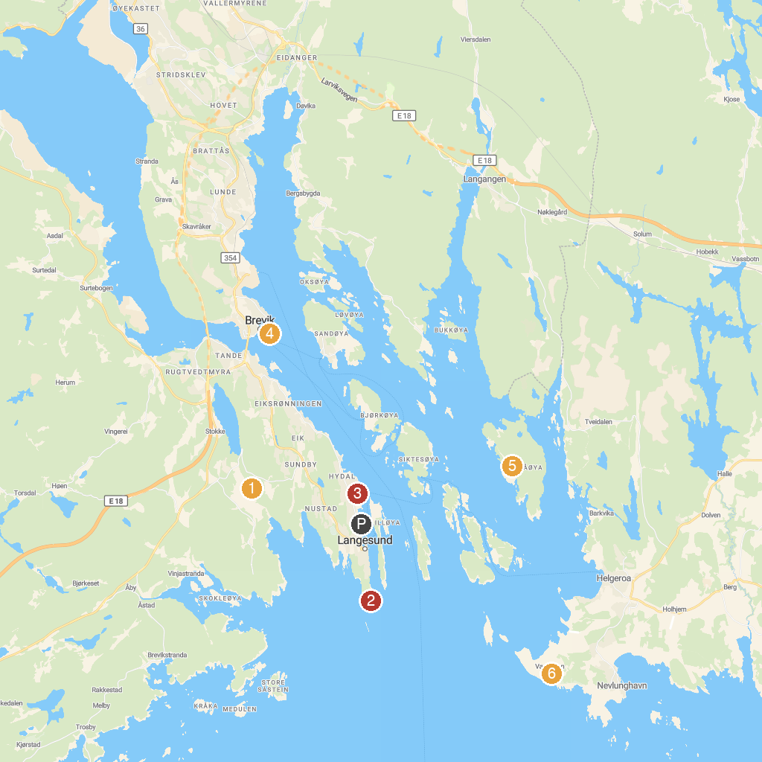
MAP KEY
1. Tangvald Nature Reserve | 4. Brevik church
2. Tangen fort | 5. Paradisbukta (Jordsbukta)
3. Badeparken | 6. Mølen Gea Norvegica Geopark
P. Cruise port / terminal
Map © MapTiler © OpenStreetMap contributors · cruiseports.org

