Lærdal, Vestland, Norway
Norway's sunniest fjord village rewards slow walkers with cobbled lanes of colourful 18th-century timber houses and a legendary salmon river — and Borgund Stave Church is just 30 km away.
⚓ Tender port · 🕒 Typical call: 6–8 hrs · 💵 Norwegian Krone (NOK) — nearly cashless · 🗣️ Norwegian (English widely understood)
✍️ MY DAY IN PORT (FILL IN)
Ship / Date
In port | arrive ______ · all aboard ______
Booked excursion
Notes / meeting point
GETTING ASHORE
- Docking: Tender — ships anchor; shuttle to Lærdalsøyri guest harbour
- Walk to centre: 2 min flat walk from tender pier to Gamle Lærdalsøyri
- Best For: Historic wooden architecture, stave church day trips, scenic fjord hiking
- Don't Miss: Borgund Stave Church (30 km) and the Lærdalselvi salmon river walk
GETTING AROUND
- 🚕 Taxi: ~100–200 NOK (~$10–20 USD) base+short ride — Local taxis are available but rarely needed given the compact town. Norwegian taxis charge ~100 NOK base plus ~14.5 NOK/
TOP THINGS TO DO
- Borgund Stave Church — Built around 1180, Borgund is the best-preserved stave church in Norway — a triple-nave masterpiece of dragon-head gables and…
- Gamle Lærdalsøyri Walking Tour — Over 160 colourful 18th- and 19th-century timber buildings line Øyragata and surrounding lanes — one of the finest intact…
- Norwegian Wild Salmon Centre — The Lærdalselvi was historically fished by European royalty and is still one of Norway's premier salmon rivers.
- Stegastein Viewpoint & Aurlandsfjellet Scenic Route — Drive the Snow Road over the mountains to Aurland and stop at the Stegastein viewpoint — a cantilevered wooden platform 650 m…
- Vindhellavegen Historic Mountain Path — Adjacent to Borgund Stave Church, this 19th-century drystone path winds up a steep mountain gorge with dramatic horseshoe bends…
BEST WALKS
- Gamle Lærdalsøyri Historic Quarter: 1–2 hrs · Flat · Free — From the tender pier walk west along the waterfront to the entrance of Gamle Lærdalsøyri and stroll…
- Salmon River & Village Loop: 45 min · Flat · Free — A short circuit along the banks of the Lærdalselvi past the Norwegian Wild Salmon Centre and back…
WEATHER · DAYLIGHT · MONEY
Month | High °F | Low °F | Rainy days
May | 57 | 44 | 16
Jul | 69 | 57 | 19
Sep | 61 | 50 | 17
Daylight: May 4:44AM–10:10PM · Jul 4:23AM–10:46PM · Sep 6:57AM–7:51PM
cruiseports.org/laerdal · Confirm terminal & all-aboard time with your ship

Lærdal, Vestland, Norway — Port Map
Red = walkable sights · Amber = excursions farther out · P = cruise terminal
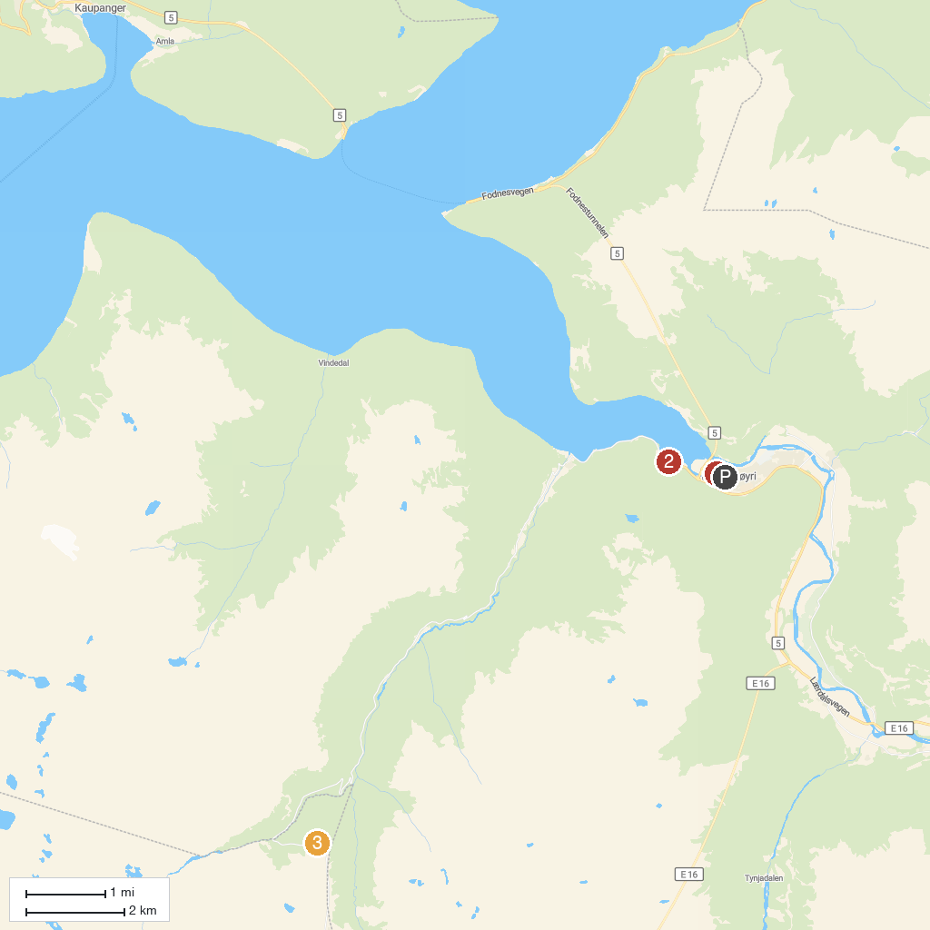
MAP KEY
1. Lærdal parkering. Gamlebyen | 3. Lærdalstunnelen
2. Aurlandsfjellet scenic route (north entry Lærdalsøyri) | 4. Vedahaugane
P. Cruise port / terminal
Map © MapTiler © OpenStreetMap contributors · cruiseports.org

