La Romana, La Altagracia, Dominican Republic
A working sugar-town turned Caribbean gateway — where a replica medieval village perches over a jungle river gorge, and the best beach day of your cruise might just be an island away.
⚓ Pier (no tendering) · 🕒 Typical call: 8–10 hrs · 💵 USD widely accepted · 🗣️ Spanish (English in tourist areas)
✍️ MY DAY IN PORT (FILL IN)
Ship / Date
In port | arrive ______ · all aboard ______
Booked excursion
Notes / meeting point
GETTING ASHORE
- Docking: Dedicated cruise pier on the Chavón River — no tendering
- Walk to center: City center ~1.5 miles; not walkable — take a taxi
- Best For: Altos de Chavón, Isla Saona beach, cigars, golf
- Don't Miss: Altos de Chavón village and amphitheater above the river gorge
GETTING AROUND
- 🚕 Taxi: $10–15 — Taxis wait just outside the port gate to the city center. Meters are rarely used — agree on the fare before you get in.
- 📱 Rideshare: ✅ Uber
TOP THINGS TO DO
- Altos de Chavón — A hand-built replica of a 16th-century Mediterranean village perched 300 feet above the Chavón River gorge.
- Isla Saona Day Trip — The crown jewel of the East National Park — a postcard-perfect tropical island with swaying palms, shallow turquoise water, and…
- Isla Catalina Snorkel — A 30-minute boat ride from the cruise pier leads to Catalina Island — white sand beach and an excellent coral wall for…
- Cueva de las Maravillas — One of the Caribbean's most significant archaeological sites — a vast cave system with hundreds of well-preserved Taino…
- Tabacalera de García Cigar Factory — One of the world's largest hand-rolled cigar factories, producing premium brands including Montecristo, Romeo y Julieta, and H.
BEST WALKS
- Terminal Grounds & Pool Wander: Flat | 10–20 min | Free — Easy loop from the gangway through the duty-free market, craft stalls, and pool terrace.
- Altos de Chavón Village Walk: Easy | 45–60 min | Entry or excursion fee — Wander the cobblestone lanes of the replica Mediterranean village — past art galleries, the St.
WEATHER · DAYLIGHT · MONEY
Month | High °F | Low °F | Rainy days
May | 86 | 75 | 14
Jul | 89 | 77 | 12
Sep | 88 | 76 | 18
Daylight: May 6:02AM–7:02PM · Jul 6:08AM–7:15PM · Sep 6:23AM–6:37PM
cruiseports.org/la-romana · Confirm terminal & all-aboard time with your ship

La Romana, La Altagracia, Dominican Republic — Port Map
Red = walkable sights · Amber = excursions farther out · P = cruise terminal
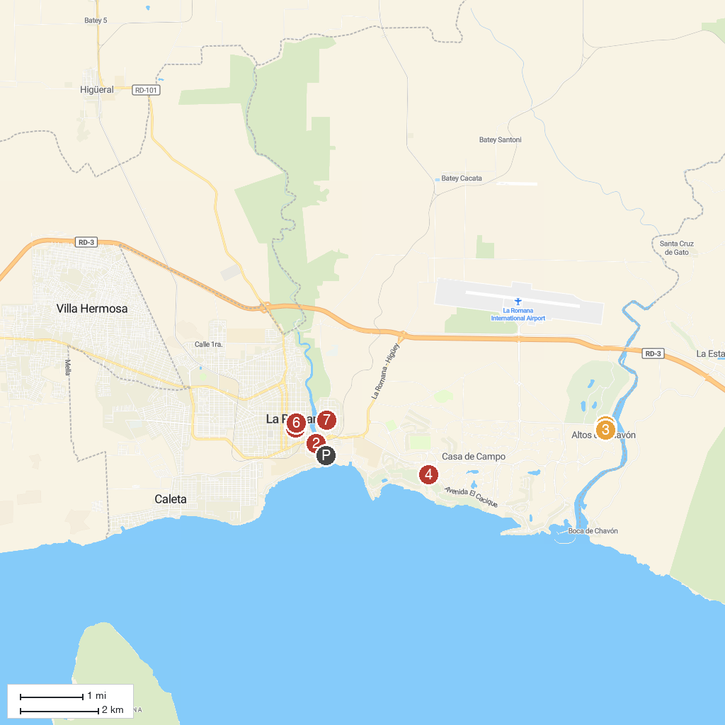
MAP KEY
1. Dye Fore Golf Course of Casa de Campo | 5. Teeth of the Dog Golf Course, Casa de Campo Resort & Villas
2. Aldea Cultural Santa Rosa de Lima | 6. Duarte Central Park
3. Altos de Chavón | 7. Parroquia Santa Rosa de Lima
4. Tanama Jungle Ranch | 8. Iglesia San Antonio de Padua
P. Cruise port / terminal
Map © MapTiler © OpenStreetMap contributors · cruiseports.org

