La Rochelle, Charente-Maritime, France
La Rochelle guards its medieval harbour with three towering sentinels and opens onto the Atlantic — a handsome port city where arcaded streets, fresh oysters, and the island escape of Île de Ré reward a day ashore.
⚓ Pier — Port de la Pallice · 🕒 Typical call: 8–10 hrs · 💶 Currency: Euro (€) · 🗣️ Language: French (English spoken in tourist areas)
✍️ MY DAY IN PORT (FILL IN)
Ship / Date
In port | arrive ______ · all aboard ______
Booked excursion
Notes / meeting point
GETTING ASHORE
- Docking: Pier at Port de la Pallice, ~6 km from city centre
- Walk to centre: Not walkable — shuttle bus or taxi (10–15 min)
- Best For: History, cycling, island day trips, fresh seafood
- Don't Miss: Climbing the three medieval towers at the Vieux Port
GETTING AROUND
- 🚕 Taxi: €15–€25 — Taxis are available at the pier but may be limited. Fares are regulated by the Charente-Maritime regional tariff; the ~6
- 📱 Rideshare: ✅ Uber, Bolt
TOP THINGS TO DO
- The Three Medieval Towers — Tour Saint-Nicolas, Tour de la Chaîne, and Tour de la Lanterne guard the harbour entrance.
- Île de Ré Day Trip — Cross the 3 km bridge to this chic flat island of salt marshes, hollyhocks, whitewashed villages, and sandy beaches.
- La Rochelle Aquarium — One of Europe's largest private aquariums, a short walk from the Vieux Port.
- Rochefort & the Hermione Frigate — A short drive south, Rochefort's Corderie Royale (royal ropeworks) and the full-scale reconstruction of the 18th-century frigate…
- Old Town Market & Seafood Lunch — The covered Central Market opens every morning with local oysters, cheeses, and produce.
BEST WALKS
- Old Port & Towers Loop: 1.5 km · 30–45 min · Flat — Start at the Grosse Horloge (medieval clock gate), walk down to the Vieux Port, loop around to the…
- Vieux Port to Aquarium Stroll: 1 km · 20 min · Flat — Walk south along the waterfront from the Vieux Port past the marina at Les Minimes toward the…
WEATHER · DAYLIGHT · MONEY
Month | High °F | Low °F | Rainy days
May | 65 | 54 | 11
Jul | 75 | 63 | 8
Sep | 72 | 59 | 8
Daylight: May 6:32AM–9:30PM · Jul 6:28AM–9:52PM · Sep 7:43AM–8:15PM
cruiseports.org/la-rochelle · Confirm terminal & all-aboard time with your ship

La Rochelle, Charente-Maritime, France — Port Map
Red = walkable sights · Amber = excursions farther out · P = cruise terminal
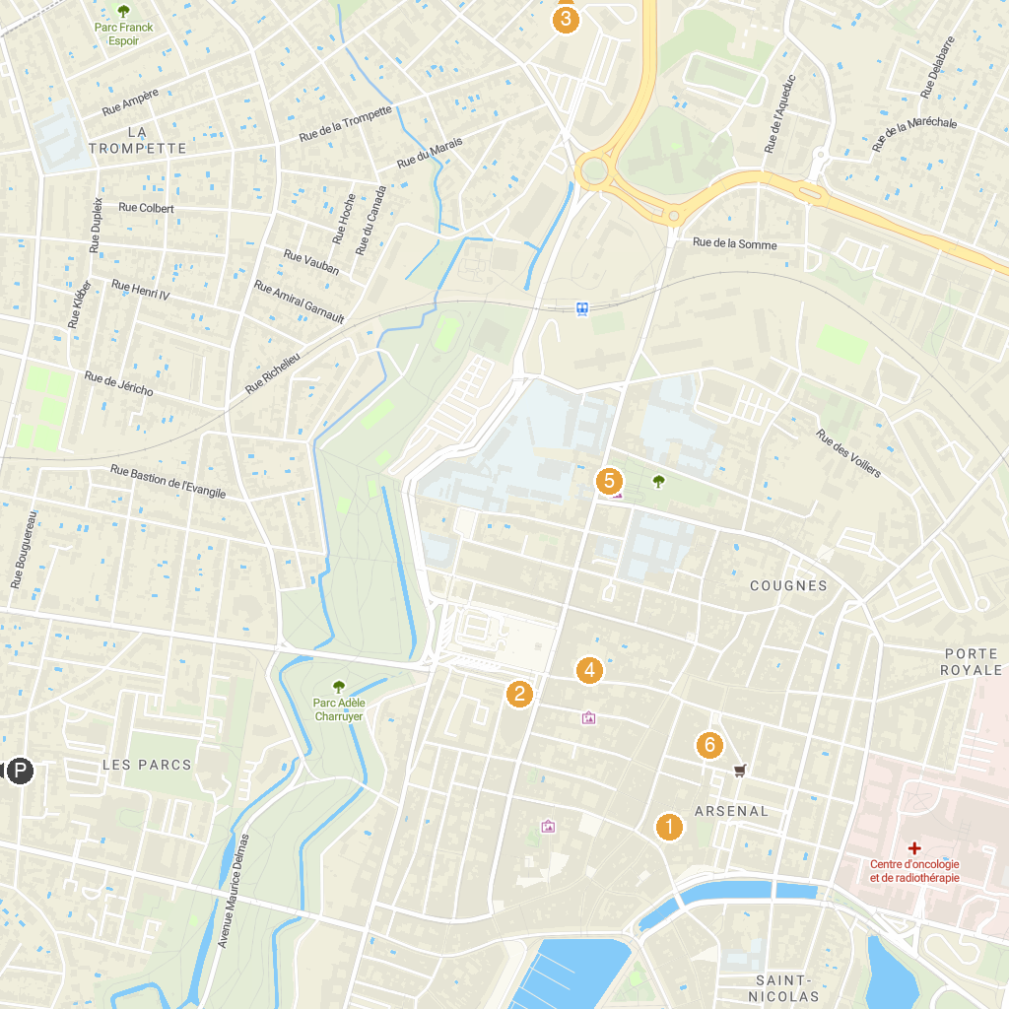
MAP KEY
1. Cloister Of The White Ladies | 4. musée des Beaux-Arts de La Rochelle
2. Saint Louis Cathedral | 5. Muséum d'Histoire naturelle de La Rochelle
3. Escape Yourself La Rochelle | 6. Bunker La Rochelle (Museum)
P. Cruise port / terminal
Map © MapTiler © OpenStreetMap contributors · cruiseports.org

