La Paz, Baja California Sur, Mexico
Jacques Cousteau called the Sea of Cortez the 'Aquarium of the World' — La Paz is your front door to it. Swim with whale sharks, snorkel with sea lions, or simply stroll the sculpture-lined Malecón as the desert sun sets over the bay.
⚓ Pier (Pichilingue, ~18 km from town) · 🕒 Typical call: 7-10 hrs · 💵 Mexican Peso (USD widely accepted) · 🗣️ Spanish (English at tourist areas)
✍️ MY DAY IN PORT (FILL IN)
Ship / Date
In port | arrive ______ · all aboard ______
Booked excursion
Notes / meeting point
GETTING ASHORE
- Docking: Pier at Puerto de Pichilingue, ~18 km (11 mi) north of downtown
- Walk to center: Not walkable — taxi 20-25 min ($20-25 USD) or cruise shuttle
- Best For: Whale sharks, snorkeling, eco-tours, pristine beaches
- Don't Miss: Playa Balandra — consistently voted Mexico's most beautiful beach
GETTING AROUND
- 🚕 Taxi: $40 one-way (up to 4 passengers) — Taxis wait at the terminal and offer a direct ride to downtown or the marina. Negotiate and confirm the fare before depa
- 📱 Rideshare: ✅ Uber, DiDi
TOP THINGS TO DO
- Swim with Whale Sharks — One of the world's best whale shark encounters, right in La Paz Bay.
- Isla Espíritu Santo Sea Lion Snorkel — This UNESCO biosphere island hosts a colony of playful California sea lions.
- Playa Balandra Day — Mexico's most photographed beach: a sheltered, waist-deep cove of turquoise water framed by the iconic mushroom rock.
- La Paz Malecón & City Walk — The 5 km waterfront boardwalk is lined with bronze sculptures (including a giant pearl and a Jacques Cousteau tribute), palm…
- Kayaking & Snorkeling near La Paz Bay — Guided kayak and snorkel tours combine paddling the sheltered bays near Pichilingue with snorkeling over reefs rich with tropical…
BEST WALKS
- Malecón Boardwalk to Cathedral: 2-3 km | Easy | 45-75 min — Start at the shuttle drop-off near the Malecón's north end and walk south along the waterfront past…
WEATHER · DAYLIGHT · MONEY
Month | High °F | Low °F | Rainy days
May | 90 | 65 | 0
Jul | 97 | 77 | 3
Sep | 93 | 78 | 8
Daylight: May 5:38AM–6:57PM · Jul 5:42AM–7:11PM · Sep 6:07AM–6:24PM
cruiseports.org/la-paz · Confirm terminal & all-aboard time with your ship

La Paz, Baja California Sur, Mexico — Port Map
Red = walkable sights · Amber = excursions farther out · P = cruise terminal
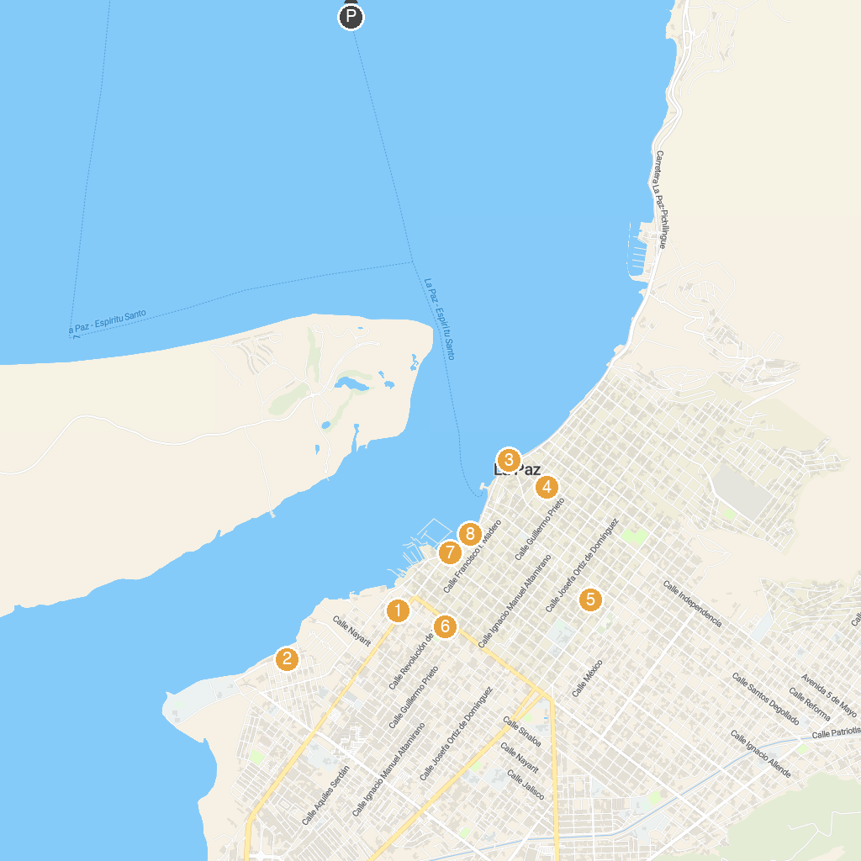
MAP KEY
1. Baja Expeditions | 5. Plaza de Los Músicos Santa Cecilia
2. Serpentario de La Paz | 6. Sanctuary of Our Lady of Guadalupe
3. Kiosco del Malecón | 7. Malecón de La Paz
4. Nuestra Señora de La Paz | 8. Escultura Paraíso del Mar
P. Cruise port / terminal
Map © MapTiler © OpenStreetMap contributors · cruiseports.org

