La Guaira, La Guaira State, Venezuela
Wedged between the Caribbean and sheer Andean cliffs, La Guaira has served as Venezuela's maritime gateway for four centuries. A quick mountain crossing brings you to sprawling Caracas — or stay coastal for colonial forts, beaches, and rum-soaked arepas.
⚓ Pier (cruise terminal) · 🕒 Typical call: 8-10 hrs · 💵 USD widely accepted · 🗣️ Spanish · ⚠️ Shore excursions strongly recommended
✍️ MY DAY IN PORT (FILL IN)
Ship / Date
In port | arrive ______ · all aboard ______
Booked excursion
Notes / meeting point
GETTING ASHORE
- Docking: Pier — Puerto de La Guaira cruise terminal, no tendering
- Walk to Center: ~20 min walk to La Guaira old town; Caracas is 45–60 min by road
- Best For: Cable car over Ávila, colonial history, Venezuelan cuisine, beach clubs
- Don't Miss: Teleférico Warairarepano cable car from Caracas to ~2,140 m Ávila summit
GETTING AROUND
- 🚕 Taxi: $50–$75 — Official taxis and pre-arranged transfers run from the cruise terminal to Caracas city center (~27–33 km, about 30 minut
TOP THINGS TO DO
- Teleférico Warairarepano — Ávila Cable Car — Ride Venezuela's most famous attraction: a modern gondola rising from Caracas to roughly 2,140 m atop Mount Ávila.
- La Guaira Colonial Walking Tour — Explore the old port quarter with its 18th-century Casa Guipuzcoana (a grand Basque trading house), cobblestone streets, and the…
- Caracas City & Simón Bolívar Sites — Visit the Casa Natal de Bolívar (birthplace of the Liberator), the National Pantheon where Bolívar is interred, and Plaza Bolívar…
- Private Beach Club Day Pass — Rather than the public beaches, excursions to secured private beach clubs along the Litoral Central offer clean facilities…
- El Hatillo Colonial Village & Shopping — This charming, secure suburb on Caracas's southern edge is Venezuela's best artisan shopping destination — colorful colonial…
BEST WALKS
- La Guaira Historic Quarter: ~1.5 km · 30–40 min · Flat — From the cruise terminal, walk into the old town along Calle Bolívar to the Casa Guipuzcoana and…
WEATHER · DAYLIGHT · MONEY
Month | High °F | Low °F | Rainy days
May | 88 | 77 | 20
Jul | 87 | 77 | 26
Sep | 88 | 78 | 26
Daylight: May 6:05AM–6:42PM · Jul 6:13AM–6:54PM · Sep 6:17AM–6:27PM
cruiseports.org/la-guaira · Confirm terminal & all-aboard time with your ship

La Guaira, La Guaira State, Venezuela — Port Map
Red = walkable sights · Amber = excursions farther out · P = cruise terminal
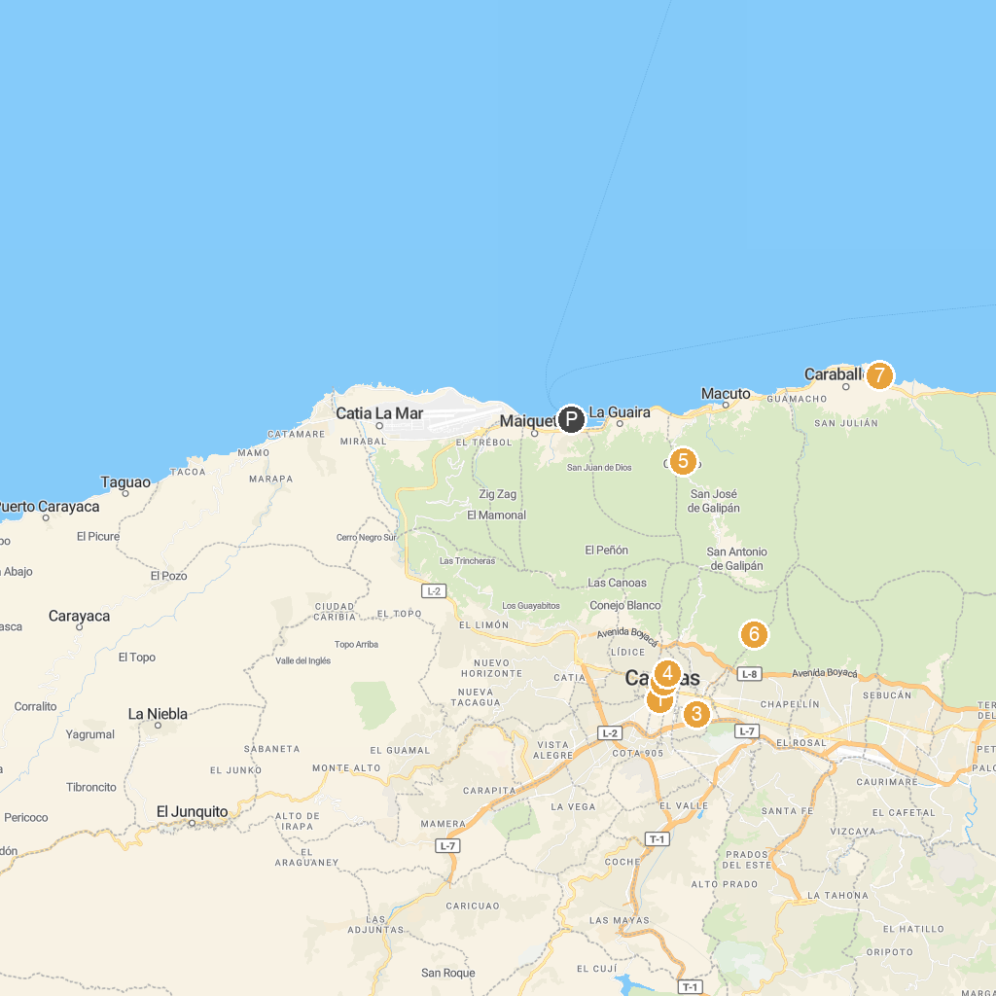
MAP KEY
1. Iglesia Católica San Francisco | 5. National Pantheon
2. Our Lady of Las Mercedes | 6. Art Ecological Museum
3. Children's Museum of Caracas | 7. P.G.P. Papelón
4. Los Caobos Park | 8. Vive Parapente La Guaira Galipan
P. Cruise port / terminal
Map © MapTiler © OpenStreetMap contributors · cruiseports.org

