La Goulette, Tunis, Tunisia
Gateway to ancient Carthage and the blue-and-white cliffside village of Sidi Bou Said, La Goulette offers one of the Mediterranean's most historically dense shore days — all within a short taxi or train ride of the pier.
⚓ Pier (direct docking) · 🕒 Typical call: 6–8 hrs · 💵 Tunisian Dinar (TND) · 🗣️ Arabic & French · 🏛️ UNESCO sites
✍️ MY DAY IN PORT (FILL IN)
Ship / Date
In port | arrive ______ · all aboard ______
Booked excursion
Notes / meeting point
GETTING ASHORE
- Docking: Direct pier — dedicated cruise terminal, no tender
- Walk to Center: La Goulette town ~10 min on foot; Carthage/Tunis require taxi or TGM train
- Best For: Roman ruins, Arab medinas, photogenic hilltop villages
- Don't Miss: Sidi Bou Said village and bambalouni (fried doughnuts) on the main street
GETTING AROUND
- 🚕 Taxi: ~15–25 TND (~$5–8 USD) — Taxis wait directly outside the cruise terminal for the 12–15 km ride to central Tunis (12–20 min). Agree on the fare be
TOP THINGS TO DO
- Ruins of Ancient Carthage — Walk among the UNESCO-listed remnants of one of antiquity's greatest cities.
- Sidi Bou Said Village — A cliffside hilltop village of uniform blue-and-white houses, bougainvillea-draped alleyways, and elaborate carved doorways…
- Tunis Medina & Souks — One of the Arab world's finest medinas — a UNESCO-listed labyrinth of covered souks selling spices, pottery, leather, and silver.
- Bardo National Museum — Housed in a 15th-century beylical palace, the Bardo holds one of the world's greatest collections of Roman mosaics — vivid floors…
- La Marsa Beach Day — If your call time allows, La Marsa is an upscale suburb 20 minutes north of the port with a clean sandy beach, seaside cafes, and…
BEST WALKS
- La Goulette Waterfront Stroll: 30–45 min · Flat · Free — Exit the cruise terminal and walk south along the seafront promenade past fish restaurants and the…
- Sidi Bou Said Village Loop: 1–1.5 hrs · Mostly flat with gentle hills · Free — From the TGM station, walk up the main cobbled street past the blue doors and jasmine sellers to…
WEATHER · DAYLIGHT · MONEY
Month | High °F | Low °F | Rainy days
May | 74 | 61 | 6
Jul | 89 | 73 | 0
Sep | 84 | 72 | 5
Daylight: May 5:11AM–7:19PM · Jul 5:11AM–7:37PM · Sep 6:01AM–6:25PM
cruiseports.org/la-goulette-tunis · Confirm terminal & all-aboard time with your ship

La Goulette, Tunis, Tunisia — Port Map
Red = walkable sights · Amber = excursions farther out · P = cruise terminal
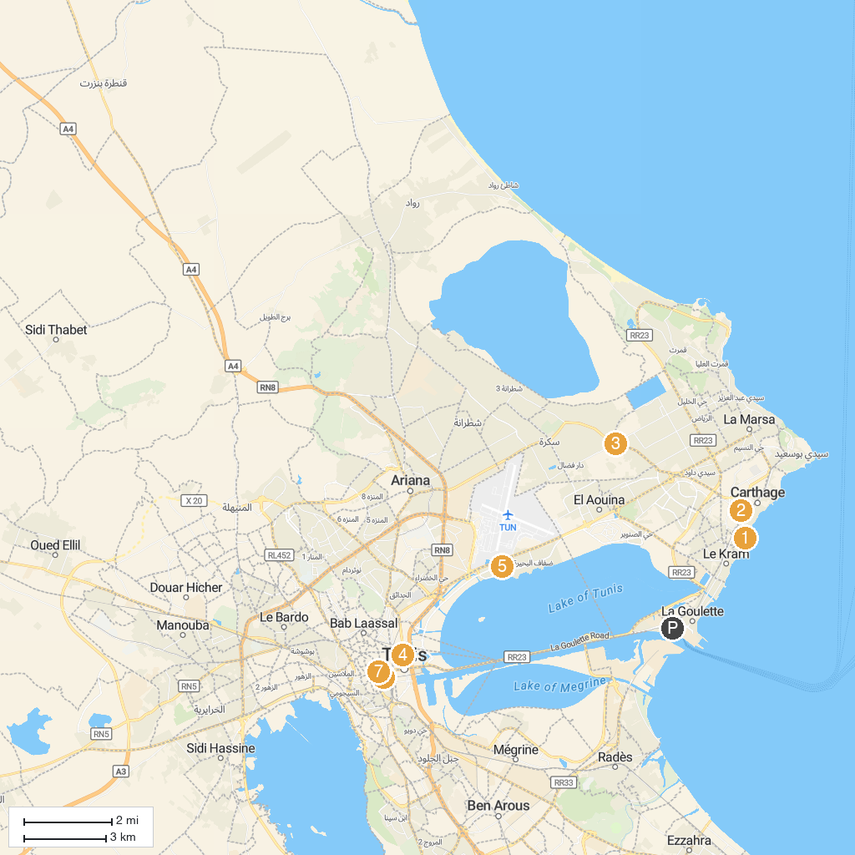
MAP KEY
1. Carthage Oceanographic Museum | 5. Currency Museum
2. Zitouna Mosque | 6. Dahdah Happy Land Entertainment Park
3. Punic Quarter of Byrsa | 7. Central Market of Tunis
4. Soukra Park | 8. Victory Square
P. Cruise port / terminal
Map © MapTiler © OpenStreetMap contributors · cruiseports.org

