La Digue, Seychelles
No roads worth driving, no high-rises, no rush — just bicycles, granite monoliths, and some of the most photographed beaches on earth. La Digue is the Seychelles at its most unspoiled.
⚓ Tender (no pier) · 🕒 Typical call: 6-8 hrs · 💵 Seychelles Rupee / USD & EUR accepted · 🗣️ Seychellois Creole, English, French · 🚲 Bicycle island
✍️ MY DAY IN PORT (FILL IN)
Ship / Date
In port | arrive ______ · all aboard ______
Booked excursion
Notes / meeting point
GETTING ASHORE
- Docking: Tender only — ships anchor off La Passe; 10–15 min tender ride to the jetty
- Walk to centre: La Passe village is 1 min from the jetty; nearest beaches 15–25 min on foot
- Best For: Beach lovers, photographers, cyclists, nature seekers
- Don't Miss: Anse Source d'Argent — regularly rated the world's most beautiful beach
GETTING AROUND
- 🚕 Taxi: SCR 150–300 (€10–€20) per short trip — Open-air mini-taxis and golf-cart style vehicles are available in very limited numbers. Useful for those who cannot cycl
- 📱 Rideshare: ❌ not available
TOP THINGS TO DO
- Anse Source d'Argent Beach — Walk or bike through L'Union Estate (paid entry ~150 SCR) to reach the iconic beach framed by sculpted pink granite boulders.
- Veuve Nature Reserve — Free forest reserve in the island's interior — the last stronghold of the critically endangered Seychelles Paradise Flycatcher.
- L'Union Estate Plantation — A working colonial plantation featuring giant Aldabra tortoises, a vanilla plot, an ox-driven coconut oil press, and one of the…
- East Coast Wild Beaches Hike — Bike across the island to Grand Anse, then hike the rocky coastal trail to Petite Anse and Anse Coco — dramatic, undeveloped…
- Snorkelling at Anse Sévère — A reef-fringed north-coast beach easily reached by a 15-minute bike ride from the pier.
BEST WALKS
- Pier to Anse Sévère (North Coast Loop): 3 km round trip • 30-40 min on foot • Flat — Head north along the seafront road from La Passe Jetty through the village and past L'Union Estate…
- La Passe Village Wander: Under 1 km • 15-20 min • Flat — A short stroll from the jetty into the colourful village centre — Creole wooden houses, souvenir…
WEATHER · DAYLIGHT · MONEY
Month | High °F | Low °F | Rainy days
May | 83 | 80 | 22
Jul | 79 | 77 | 16
Sep | 80 | 78 | 18
Daylight: May 6:15AM–6:10PM · Jul 6:26AM–6:19PM · Sep 6:09AM–6:14PM
cruiseports.org/la-digue-island-seychelles · Confirm terminal & all-aboard time with your ship

La Digue, Seychelles — Port Map
Red = walkable sights · Amber = excursions farther out · P = cruise terminal
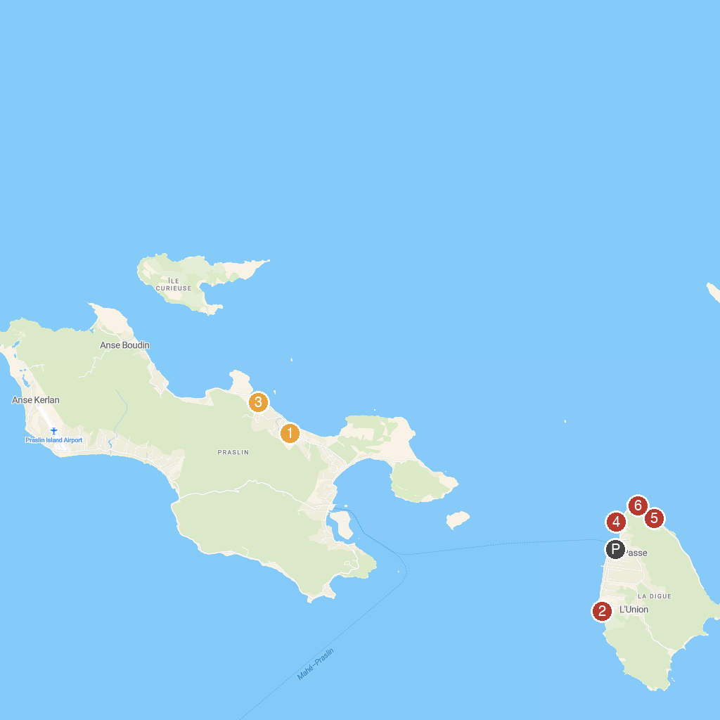
MAP KEY
1. Praslin Museum | 4. Pointe Cap Barbi
2. L’Union Estate Farm | 5. Anse Gaulettes
3. Geoli Charters - Group Tours, Private Charters & Glass Bottom Boat | 6. Anse Patates
P. Cruise port / terminal
Map © MapTiler © OpenStreetMap contributors · cruiseports.org

