La Coruña, Galicia, Spain
A Coruña is Spain's glass city — a Celtic-flavored Atlantic port where Roman history, world-class seafood, and wild beaches are all within walking distance of the dock.
⚓ Docked (pier) · 🕒 Typical call: 8-10 hrs · 💶 Euro · 🗣️ Spanish & Galician
✍️ MY DAY IN PORT (FILL IN)
Ship / Date
In port | arrive ______ · all aboard ______
Booked excursion
Notes / meeting point
GETTING ASHORE
- Docking: Muelle de Trasatlánticos — ships dock in the city center, no tender
- Walk to center: 5–10 min on foot to Plaza de María Pita
- Best For: Seafood lovers, history buffs, easy walkers
- Don't Miss: Tower of Hercules — the world's only fully preserved Roman lighthouse
GETTING AROUND
- 🚕 Taxi: €5–€15 — Taxis queue at the port; the meter starts at €4.30 (includes first 2.2 km). The short ride to Plaza de María Pita typica
- 📱 Rideshare: ✅ Bolt
TOP THINGS TO DO
- Tower of Hercules — Climb the only fully preserved Roman lighthouse in the world, built in the 1st century AD and still guiding ships today.
- Old Town & Plaza de María Pita — Wander medieval stone streets in the Ciudad Vieja, then emerge into La Coruña's grand main square.
- Galician Tapas Crawl — Hit Calle Galera, Calle Estrella, and Calle Barrera — the tapas heartland just off the main square.
- Riazor & Orzán Atlantic Beaches — Two sweeping crescent beaches on the wild western side of the peninsula, just 15–20 minutes on foot from the dock.
- Monte de San Pedro Park — A former clifftop military fort turned scenic park, with decommissioned 1930s Vickers guns, a hedge maze, and the best panoramic…
BEST WALKS
- Harbor to Old Town Loop: 2.5 km · ~45 min · flat · easy — Walk from the terminal along the marina, past the iconic glass-balconied galerías, into Plaza de…
- Coastal Promenade to the Beaches: 2 km · ~30 min · flat · easy — Walk west from the center along the Paseo Marítimo — one of Europe's longest seafront promenades…
WEATHER · DAYLIGHT · MONEY
Month | High °F | Low °F | Rainy days
May | 66 | 53 | 11
Jul | 73 | 61 | 7
Sep | 72 | 60 | 11
Daylight: May 7:09AM–9:51PM · Jul 7:07AM–10:11PM · Sep 8:13AM–8:43PM
cruiseports.org/la-coruna · Confirm terminal & all-aboard time with your ship

La Coruña, Galicia, Spain — Port Map
Red = walkable sights · Amber = excursions farther out · P = cruise terminal
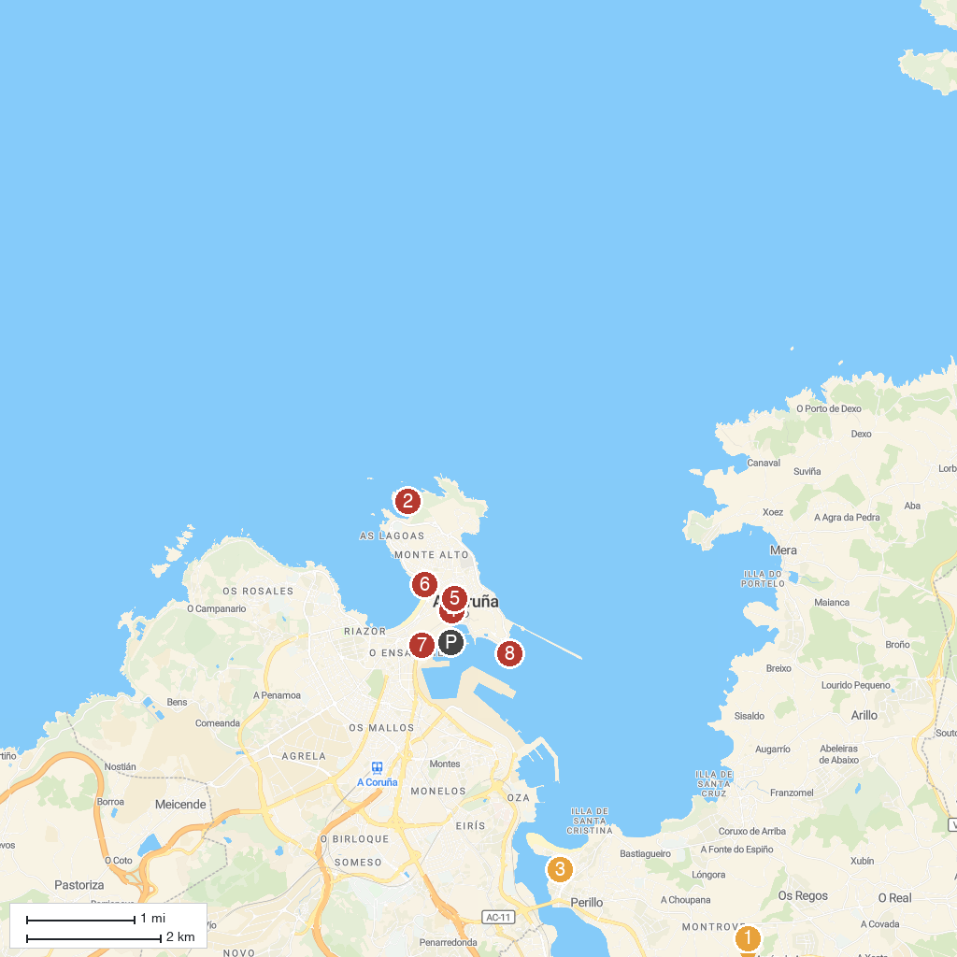
MAP KEY
1. Parroquia de Santa María de Cambre | 5. Casa Museo Casares Quiroga
2. Torre de Hércules | 6. Surfers Fountain
3. José Martí Park | 7. Gardens of Méndez Núñez
4. Church of San Nicolás | 8. Castelo de Santo Antón
P. Cruise port / terminal
Map © MapTiler © OpenStreetMap contributors · cruiseports.org

