La Ciotat, Provence, France
Where the Lumière brothers invented cinema and locals still play pétanque beside a harbor ringed with ochre cliffs — La Ciotat is the French Riviera without the glitz.
⚓ Tender port · 🕒 Typical call: 7-9 hrs · 💶 Currency: Euro (€) · 🗣️ Language: French
✍️ MY DAY IN PORT (FILL IN)
Ship / Date
In port | arrive ______ · all aboard ______
Booked excursion
Notes / meeting point
GETTING ASHORE
- Docking: Tender — ships anchor in the bay; tenders land at Vieux Port
- Walk to center: 0 min — tender drops right at the Old Port
- Best For: History, calanques, beaches, Provençal food
- Don't Miss: Eden Théâtre (world's oldest cinema) & Calanque de Figuerolles
GETTING AROUND
- 🚕 Taxi: €17–€21 — Taxis are available but not always plentiful at the pier. Pre-booking is advisable, especially for excursions to Cassis
- 📱 Rideshare: ✅ Uber
TOP THINGS TO DO
- Calanques Boat Tour — Small boats depart regularly from the Vieux Port for tours of La Ciotat's dramatic ochre-and-poudingue calanques, continuing to…
- Eden Théâtre — World's Oldest Cinema — Opened in 1889 and where the Lumière brothers screened some of history's first projected films in 1895, the beautifully restored…
- Parc du Mugel & Calanque du Mugel — A free 30-acre botanical park at the base of the Eagle's Beak cliff, with tropical plants, sweeping sea views, and a sheltered…
- Day Trip to Cassis — The elegant AOC wine village of Cassis is about 30 minutes by bus (Line M05, ~€2-4 each way) with its own stunning calanques…
- Calanque de Figuerolles Hike — A 25-minute walk from the port leads to this spectacular red-rock inlet where steep stairs descend to clear turquoise water.
BEST WALKS
- Old Port to Eden Théâtre & Old Town: 1.5 km · 20-30 min · Flat — From the tender landing at the Vieux Port, walk along the harbor promenade past the fishing boats…
- Harbour to Parc du Mugel & Calanque du Mugel: 2.5 km · 30-40 min · Gentle uphill — Head southwest from the Vieux Port along Boulevard Beaurivage to the entrance of Parc du Mugel.
- Beach Walk to Grande Plage: 1.5 km · 20 min · Flat — Walk east along the seafront boulevard from the Vieux Port past the promenade gardens to La Grande…
WEATHER · DAYLIGHT · MONEY
Month | High °F | Low °F | Rainy days
May | 69 | 57 | 6
Jul | 84 | 70 | 1
Sep | 77 | 65 | 6
Daylight: May 6:14AM–8:54PM · Jul 6:11AM–9:14PM · Sep 7:17AM–7:47PM
cruiseports.org/la-ciotat · Confirm terminal & all-aboard time with your ship

La Ciotat, Provence, France — Port Map
Red = walkable sights · Amber = excursions farther out · P = cruise terminal
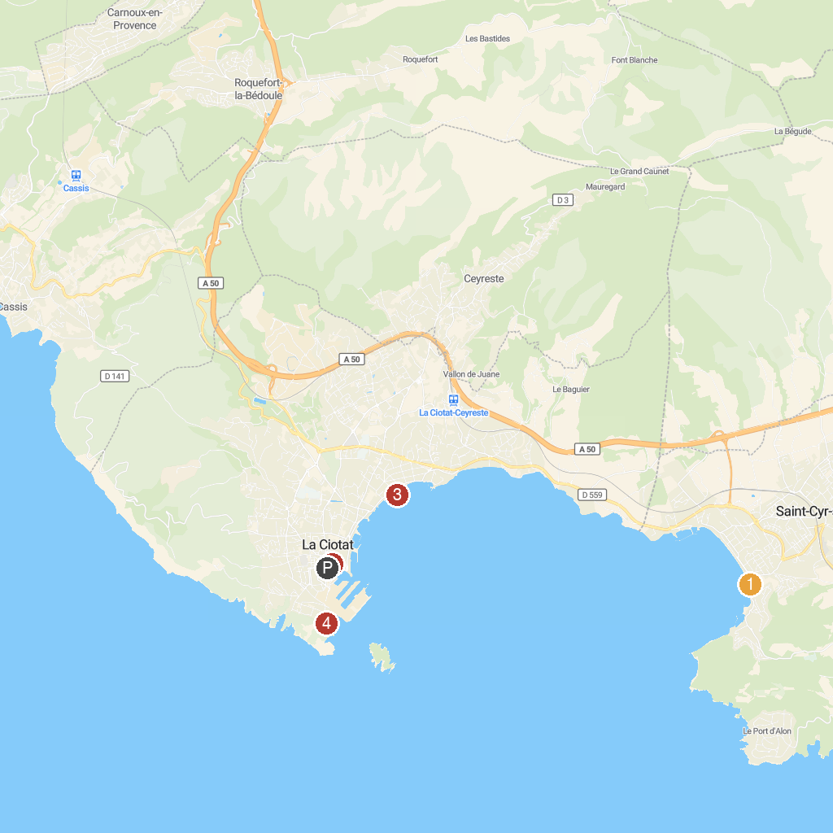
MAP KEY
1. Museum Tauroentum | 5. Museum of the Foreign Legion
2. Green Island Shuttle | 6. Parc national des Calanques
3. Plage Lumière | 7. ZOA Parc
4. Eglise Saint André | 8. Parc du Mugel
P. Cruise port / terminal
Map © MapTiler © OpenStreetMap contributors · cruiseports.org

