Kythnos Island, Cyclades, Greece
One of the Aegean's best-kept secrets, Kythnos rewards visitors with a world-famous double sandbar, healing thermal springs, and whitewashed villages where daily life still moves at its own unhurried pace.
⚓ Docked (small/mid ships) or Tender · 🕒 Typical call: 6–8 hrs · 💶 Euro (€) · 🗣️ Greek
✍️ MY DAY IN PORT (FILL IN)
Ship / Date
In port | arrive ______ · all aboard ______
Booked excursion
Notes / meeting point
GETTING ASHORE
- Docking: Merichas pier — small/mid ships dock; large ships tender
- Walk to center: 0 min — port village is at the pier
- Best For: Beaches, thermal springs, authentic Greek island life
- Don't Miss: Kolona Beach double sandbar (water taxi from port)
GETTING AROUND
- 🚕 Taxi: €4 minimum, ~€0.90/km — Taxis wait at the port of Merichas and are the most direct way to reach Chora (~8 km) or other villages. Limited fleet —
TOP THINGS TO DO
- Kolona Beach Water Taxi — The island's crown jewel — a 240 m double-sided sandbar of golden sand connecting Kythnos to the islet of Agios Loukas.
- Loutra Thermal Springs — Natural sulfur and iron hot springs flow into the sea at the village of Loutra on the northeast coast.
- Chora Village Walk — The island capital (Messaria) is a postcard Cycladic village with narrow whitewashed alleys, hilltop churches, and a small…
- Dryopida & Katafyki Cave — Dryopida is an inland village with unique tiled (not flat) rooftops — a rarity in the Cyclades.
- Apokrousi & Martinakia Beaches — Martinakia is a short 10-min walk north of the pier — shaded, sandy, and family-friendly.
BEST WALKS
- Merichas Harbor to Martinakia Beach: 0.8 km · 10–15 min · Easy · Flat coastal path — A gentle flat walk north along the coast from the port to the tamarisk-shaded cove of Martinakia…
- Chora Village Lanes: 1–2 km · 30–45 min · Easy–Moderate · Cobblestones — Once you've taken a taxi or bus to Chora, explore its whitewashed alleyways on foot.
WEATHER · DAYLIGHT · MONEY
Month | High °F | Low °F | Rainy days
May | 72 | 63 | 4
Jul | 85 | 76 | 0
Sep | 80 | 72 | 3
Daylight: May 6:13AM–8:24PM · Jul 6:13AM–8:42PM · Sep 7:04AM–7:29PM
cruiseports.org/kythnos-island · Confirm terminal & all-aboard time with your ship

Kythnos Island, Cyclades, Greece — Port Map
Red = walkable sights · Amber = excursions farther out · P = cruise terminal
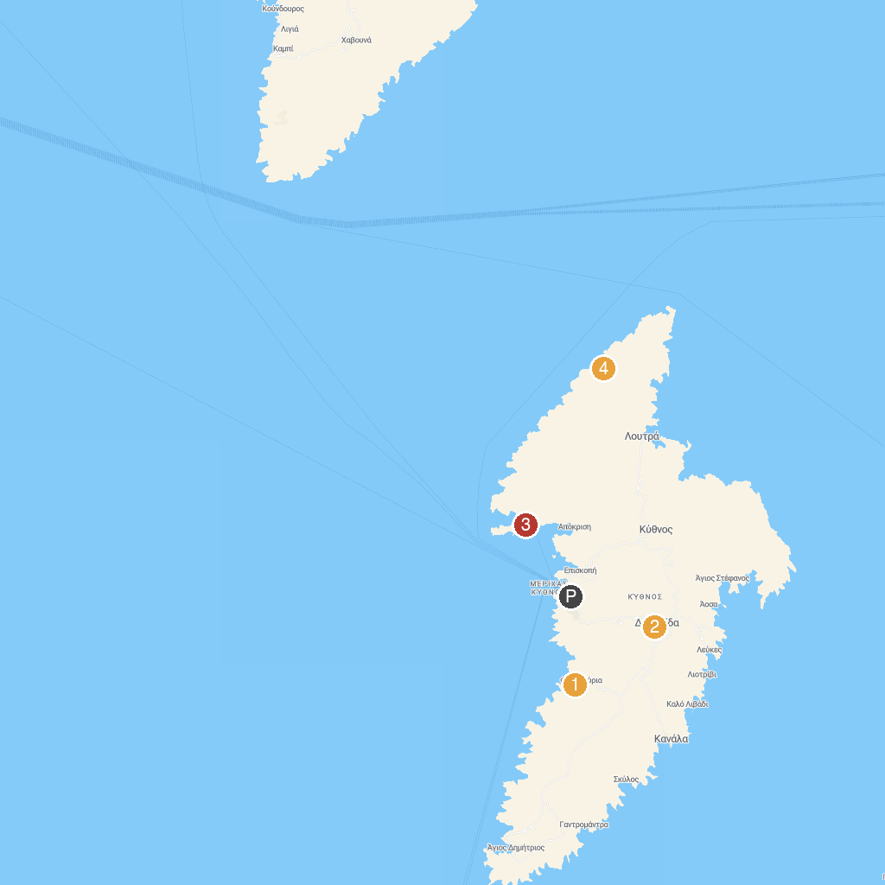
MAP KEY
1. Παναγιά Φλαμπουριανή | 3. Kolona Beach
2. Σπήλαιο Καταφύκι - Katafiki cave | 4. Oria Castle
P. Cruise port / terminal
Map © MapTiler © OpenStreetMap contributors · cruiseports.org

