Kuwait City, Kuwait
Where pearl-diving heritage meets glittering skyscrapers. Kuwait City offers an unfiltered Arabian Gulf experience — 200-year-old souqs, world-class museums, and some of the most hospitable people on the planet.
⚓ Pier (Shuwaikh Port) · 🚌 Shuttle or taxi to center · 🕒 Typical call: 8-10 hrs · 💵 Kuwaiti Dinar (KWD) · 🗣️ Arabic / English widely spoken
✍️ MY DAY IN PORT (FILL IN)
Ship / Date
In port | arrive ______ · all aboard ______
Booked excursion
Notes / meeting point
GETTING ASHORE
- Docking: Pier at Shuwaikh Port — no walking out; taxi/shuttle required
- Walk to center: ~10 km by road (15-20 min drive) — not walkable
- Best For: Souq shopping, cultural museums, Gulf architecture
- Don't Miss: Souq Al-Mubarakiya & the Grand Mosque guided tour
GETTING AROUND
- 🚕 Taxi: 6–8 KWD (~$20–26) — Metered taxis are plentiful at the port. Agree on a fare before departure; the city center is roughly 10–15 minutes away
- 📱 Rideshare: ✅ Careem, Bolt
TOP THINGS TO DO
- Souq Al-Mubarakiya — Kuwait's oldest and most atmospheric market has traded for over 200 years.
- Kuwait Towers & the Corniche — The trio of sphere-covered towers is Kuwait's most recognizable landmark.
- Grand Mosque Guided Tour — Kuwait's official state mosque (Al Masjid Al Kabir) is stunning inside and out — intricate Islamic calligraphy, ornate detailing…
- Sheikh Abdullah Al Salem Cultural Centre — One of the largest museum complexes in the world, housing four world-class museums: the Space Museum, Science Museum, Natural…
- Al Shaheed Park — Kuwait's largest urban park offers botanical gardens, walking paths, lakes, modern sculptures, and two small on-site museums.
BEST WALKS
- Kuwait Corniche to Kuwait Towers: 2 km | Easy | Flat seafront promenade — Drop off near the Scientific Center on the Gulf Road and walk the breezy Corniche south past the…
WEATHER · DAYLIGHT · MONEY
Month | High °F | Low °F | Rainy days
May | 100 | 80 | 0
Jul | 112 | 91 | 0
Sep | 106 | 85 | 0
Daylight: May 4:56AM–6:33PM · Jul 4:58AM–6:49PM · Sep 5:33AM–5:53PM
cruiseports.org/kuwait-city · Confirm terminal & all-aboard time with your ship

Kuwait City, Kuwait — Port Map
Red = walkable sights · Amber = excursions farther out · P = cruise terminal
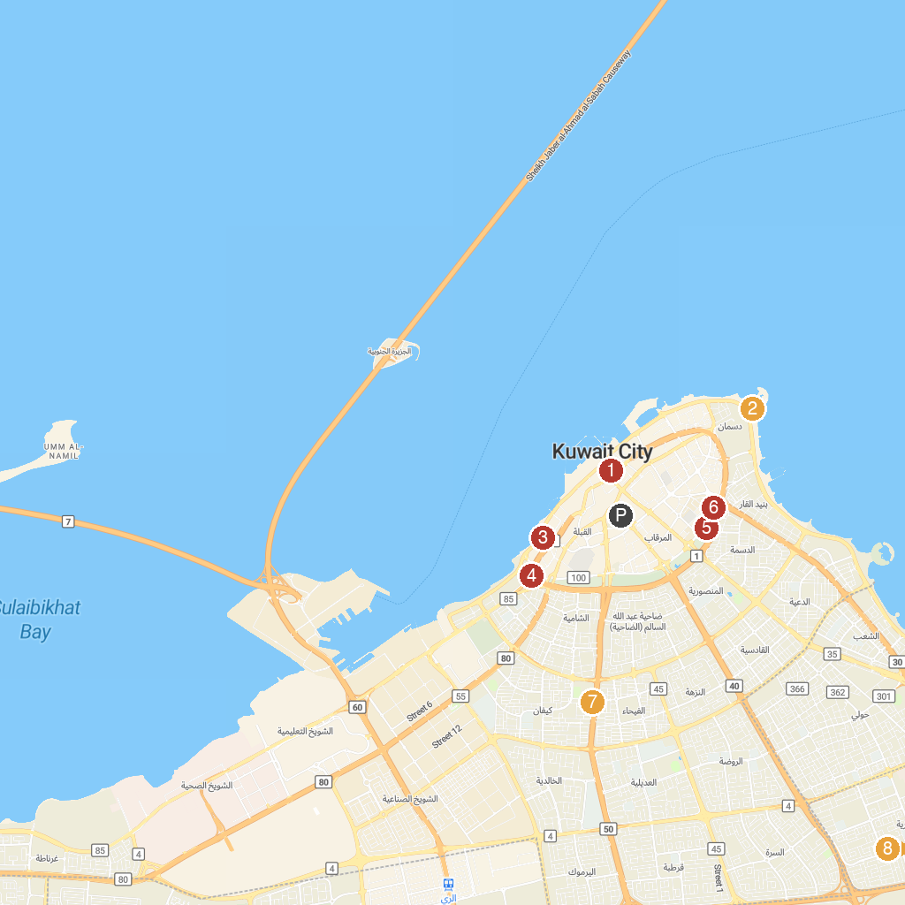
MAP KEY
1. Grand Mosque of Kuwait | 5. Al Shaheed Park
2. Kuwait Towers | 6. متحف الموطن
3. The Americani Cultural Centre - House of Islamic Antiquities | 7. مسجد العلبان
4. Sheikh Jaber Al-Ahmad Cultural Centre | 8. Tareq Rajab Museum of Islamic Calligraphy
P. Cruise port / terminal
Map © MapTiler © OpenStreetMap contributors · cruiseports.org

