Kushiro City, Hokkaido, Japan
The 'City of Mist' sits where subarctic Hokkaido meets its largest wetland — home to rare red-crowned cranes, legendary seafood markets, and a harbor sunset that stops ships in their tracks.
⚓ Pier (West Wharf No. 4 or downtown Mizube) · 🕒 Typical call: 8–10 hrs · 💴 Currency: Japanese Yen (JPY) — carry cash · 🗣️ Language: Japanese (limited English) · 🦩 Best for: Wildlife, seafood, nature
✍️ MY DAY IN PORT (FILL IN)
Ship / Date
In port | arrive ______ · all aboard ______
Booked excursion
Notes / meeting point
GETTING ASHORE
- Docking: Pier — West Wharf No. 4 (large ships) or Mizube/central dock (small ships)
- Walk to center: ~4.5 km from West Wharf; free shuttle to Fisherman's Wharf MOO (~15 min)
- Best For: Red-crowned cranes, Kushiro wetland, Washo Market katte-don, Nusamai Bridge sunset
- Don't Miss: Build your own seafood bowl (katte-don) at Washo Market
GETTING AROUND
- 🚕 Taxi: ¥2,500–¥3,000 (~$16–19 USD) — Taxis are available at the pier and take about 15 minutes to the city center. Drivers may have limited English — having
TOP THINGS TO DO
- Kushiro Shitsugen Wetland & Crane Reserve — Japan's largest wetland hosts the iconic red-crowned tancho crane year-round.
- Lake Akan & Ainu Culture — A stunning caldera lake famous for rare marimo algae balls and the lakeside Ainu Kotan village, where you can watch traditional…
- Washo Market Katte-Don & Robatayaki — Kushiro's must-do food experience.
- Nusamai Bridge & City Walk — Kushiro's most photographed landmark, adorned with four bronze statues representing the seasons.
- Kushiro City Museum & Art Museum — The City Museum covers the region's natural history and indigenous Ainu heritage.
BEST WALKS
- Fisherman's Wharf to Nusamai Bridge & Washo Market: 2.5 km loop · ~45 min · Flat — From Fisherman's Wharf MOO, stroll east along the Kushiro River waterfront to the iconic Nusamai…
- Kushiro Shitsugen Observatory Boardwalk: ~1 km boardwalk · 30 min · Easy · Requires taxi/bus to reach — Take a taxi (~25 min from city) to Kushiro Marsh Observatory (Kushiro Shitsugen Tenbodai).
WEATHER · DAYLIGHT · MONEY
Month | High °F | Low °F | Rainy days
May | 55 | 43 | 10
Jul | 67 | 59 | 11
Sep | 67 | 57 | 11
Daylight: May 3:59AM–6:38PM · Jul 3:57AM–6:59PM · Sep 5:02AM–5:32PM
cruiseports.org/kushiro-city · Confirm terminal & all-aboard time with your ship

Kushiro City, Hokkaido, Japan — Port Map
Red = walkable sights · Amber = excursions farther out · P = cruise terminal
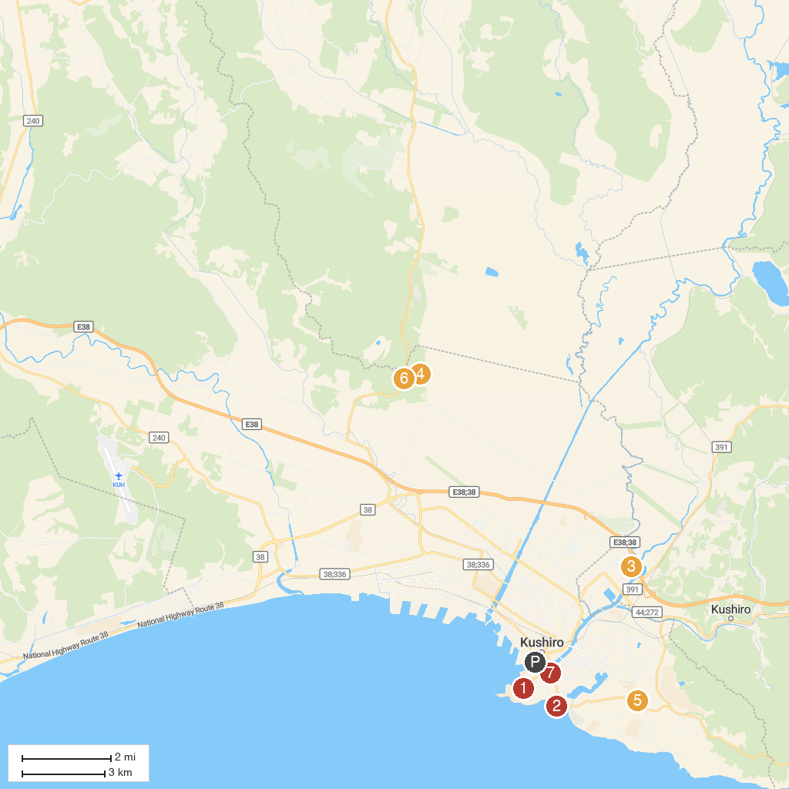
MAP KEY
1. Yonemachi Park | 5. Pacific Ocean Coal Mine Exhibition Hall
2. Chiyonoura Marine Park | 6. Kushiro Marsh Observatory
3. Kushirocho Sports Park | 7. Iwapokki suimon gate
4. Satellite view point | 8. Kushiro City Museum of Art (Kushiro-shiritsu Bijutsukan)
P. Cruise port / terminal
Map © MapTiler © OpenStreetMap contributors · cruiseports.org

