Kupang, West Timor, Indonesia
The dry, savanna-clad capital of East Nusa Tenggara blends Dutch colonial history, a Captain Bligh footnote, a cave hiding a crystalline swimming pool, and a local food scene built around wood-smoked pork.
⚓ Pier (Tenau Port — 10 km from center) · 🕒 Typical call: 7–9 hrs · 💵 Indonesian Rupiah (IDR) — cash essential · 🗣️ Bahasa Indonesia / Kupang Malay · ☀️ Hot & dry — bring sunscreen and water
✍️ MY DAY IN PORT (FILL IN)
Ship / Date
In port | arrive ______ · all aboard ______
Booked excursion
Notes / meeting point
GETTING ASHORE
- Docking: Pier at Tenau Port, ~10 km west of city center
- Walk to center: Not walkable — 10 km industrial road; take ship shuttle or taxi
- Best For: History buffs, cave swimming, authentic local culture, foodie adventurers
- Don't Miss: Crystal Cave swim, Sasando harp village, Se'i smoked pork lunch
GETTING AROUND
- 🚕 Taxi: IDR 80,000–150,000 (~–10 USD) — Taxis from Tenau Port to the city center cover roughly 10 km. Agree on fare before departing or use a metered cab.
- 📱 Rideshare: ✅ Grab, Gojek, Maxim
TOP THINGS TO DO
- Crystal Cave Swim (Gua Kristal) — Descend into a limestone cave hiding a stunning deep-blue pool of crystal-clear brackish water.
- Sasando Harp Village — Oebelo — Watch master craftsmen hand-build the Sasando, a unique bamboo-and-lontar-palm harp native to nearby Rote Island and a cultural…
- Oenesu Waterfall (Air Terjun Oenesu) — A multi-tiered waterfall in shady forest, about 35 minutes west of Tenau Port in West Kupang district, with natural limestone…
- Kupang City & Captain Bligh Walk — Explore Fort Concordia (exterior — built by the Dutch VOC in 1653 as their main base against the Portuguese on Timor), the old…
- Lasiana Beach & Lontar Palms — Kupang's most famous beach is lined with thousands of towering lontar palms.
BEST WALKS
- Old Town & Waterfront Stroll: 2–3 km • Mostly flat • 45–60 min — From Taman Nostalgia, walk south to the old Dutch colonial waterfront, past weathered trade…
WEATHER · DAYLIGHT · MONEY
Month | High °F | Low °F | Rainy days
May | 87 | 76 | 4
Jul | 86 | 73 | 1
Sep | 90 | 73 | 2
Daylight: May 5:52AM–5:31PM · Jul 6:04AM–5:38PM · Sep 5:39AM–5:41PM
cruiseports.org/kupang · Confirm terminal & all-aboard time with your ship

Kupang, West Timor, Indonesia — Port Map
Red = walkable sights · Amber = excursions farther out · P = cruise terminal
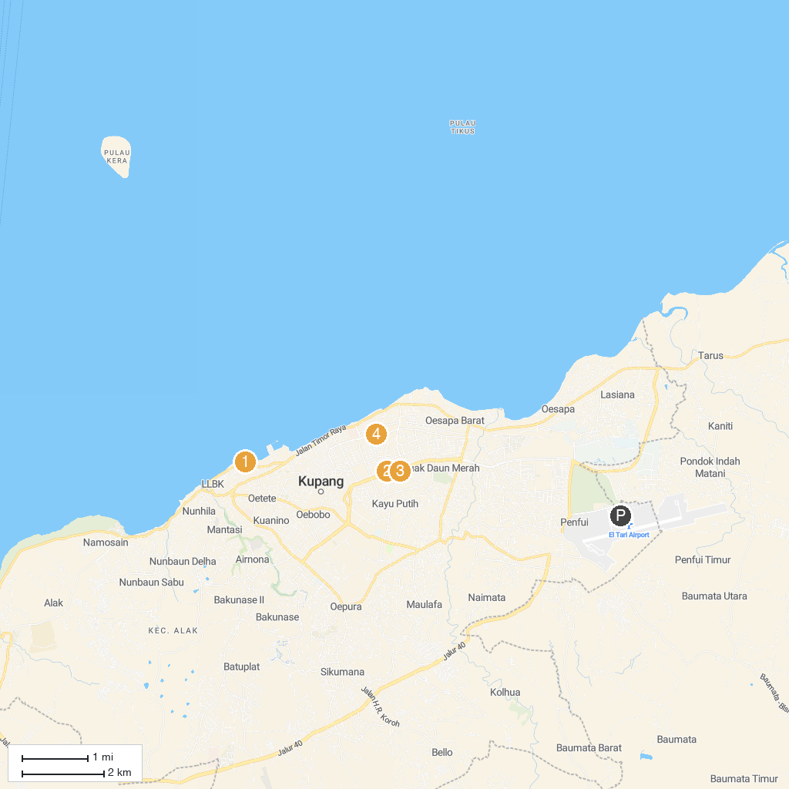
MAP KEY
1. Ketapang Satu Beach | 3. NTT Regional Museum
2. Gong Perdamaian | 4. Goa Tourism Monkey
P. Cruise port / terminal
Map © MapTiler © OpenStreetMap contributors · cruiseports.org

