Kumano, Mie, Japan
On the rugged Kii Peninsula, Kumano guards Japan's most sacred pilgrimage routes — ancient stone paths through cedar forests, volcanic sea cliffs, and shrines that predate their own buildings.
⚓ Pier (Odomari / Shichirihama Port) · 🕒 Typical call: 8-10 hrs · 💴 Currency: Japanese Yen (JPY) · 🗣️ Language: Japanese · 🏯 UNESCO World Heritage site
✍️ MY DAY IN PORT (FILL IN)
Ship / Date
In port | arrive ______ · all aboard ______
Booked excursion
Notes / meeting point
GETTING ASHORE
- Docking: Pier — ships dock at Odomari / Shichirihama port; shuttle buses provided to city center
- Walk to center: ~2.5 km (30-40 min) to Kumanoshi Station; Onigajo cliffs 15-20 min from pier
- Best For: Kumano Kodo hiking, UNESCO shrines, dramatic coastal geology
- Don't Miss: Onigajo volcanic sea cliffs and the Matsumoto-toge Kumano Kodo trail section
GETTING AROUND
- 🚕 Taxi: ¥400–¥750 flag-fall, ~¥3,700 for a 15–20 min ride — Local taxis from Kumano Daiichi Kotsu, Sanko Taxi, and Meiko Taxi are available at the port and train station. Have cash
- 📱 Rideshare: ✅ Uber
TOP THINGS TO DO
- Onigajo Sea Cliffs — A 1.2 km walkway carved into dramatic eroded volcanic rock facing the Pacific — free, walkable from the pier in 15-20 minutes.
- Kumano Kodo: Matsumoto-toge Pass — Walk a beautifully preserved section of the UNESCO-listed Kumano Kodo pilgrimage trail.
- Hana-no-Iwaya Shrine — Japan's oldest Shinto shrine — not a wooden building but a 45-metre sacred rock face worshipped as the mother deity…
- Doro Gorge (Dorokyo) Boat Ride — Ride flat-bottomed wooden boats through the Kumano River gorge past emerald water and sheer rock cliffs — one of Japan's most…
- Maruyama Senmaida Terraced Rice Fields — Over 1,340 hand-sculpted terraced rice paddies climb a steep mountain hillside in a valley west of Kumano.
BEST WALKS
- Pier to Onigajo Sea Cliffs: 2 km · 20 min · flat coastal road — Follow the coastal road north-east from the Odomari pier to the Onigajo entrance.
- Matsumoto-toge Kumano Kodo Section: 3-4 km loop · 1.5-2 hrs · moderate ascent — Walk from near Odomari Station along the ancient stone-paved Matsumoto-toge pass.
WEATHER · DAYLIGHT · MONEY
Month | High °F | Low °F | Rainy days
May | 71 | 58 | 13
Jul | 82 | 73 | 19
Sep | 79 | 70 | 20
Daylight: May 4:54AM–6:49PM · Jul 4:55AM–7:07PM · Sep 5:38AM–6:02PM
cruiseports.org/kumano-mie · Confirm terminal & all-aboard time with your ship

Kumano, Mie, Japan — Port Map
Red = walkable sights · Amber = excursions farther out · P = cruise terminal
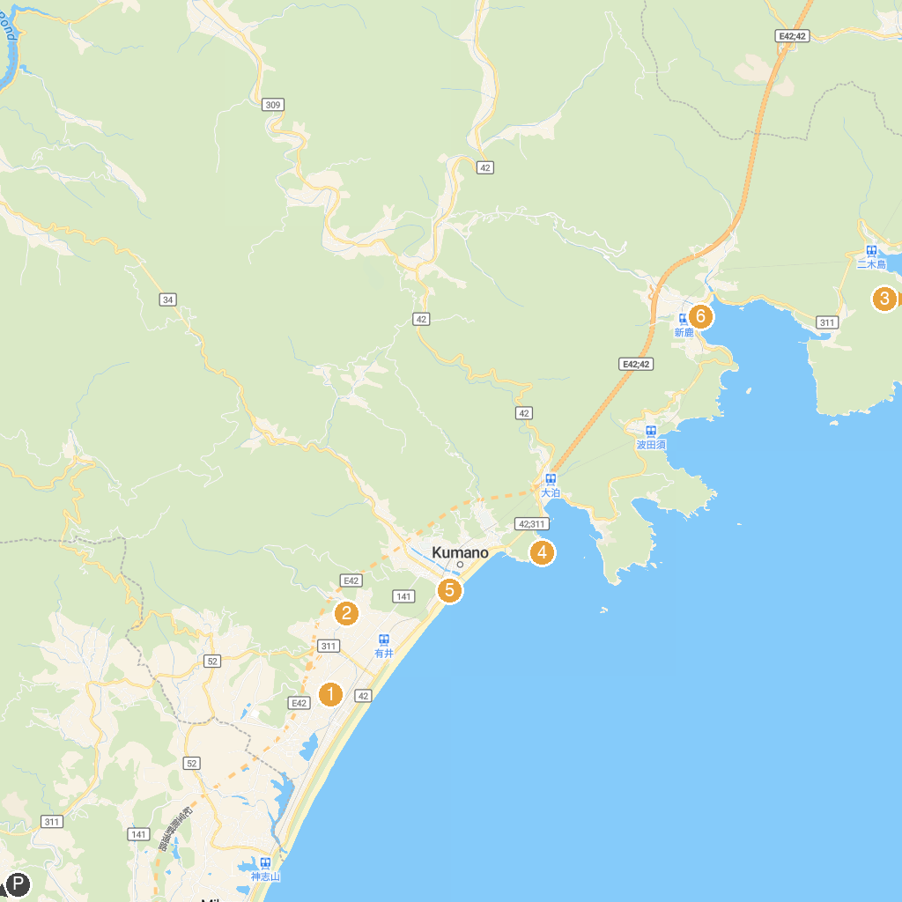
MAP KEY
1. Yamazaki Sports Park | 4. Onigajo Rock Formations
2. Ubuta Shrine | 5. Shishiiwa
3. Tategasaki | 6. Atashika Beach
P. Cruise port / terminal
Map © MapTiler © OpenStreetMap contributors · cruiseports.org

