Kuching, Sarawak, Malaysia
Borneo's most liveable city pairs a handsome colonial waterfront with one-of-a-kind wildlife encounters. It's one of the rare cruise ports where you can watch orangutans roam free in a rainforest reserve, then be back on board in time for dinner.
⚓ Pier dock (Senari or Pending Terminal) · 🕒 Typical call: 8–10 hrs · 💵 Malaysian Ringgit (MYR) · 🗣️ Malay & English widely spoken · 🐾 Borneo wildlife
✍️ MY DAY IN PORT (FILL IN)
Ship / Date
In port | arrive ______ · all aboard ______
Booked excursion
Notes / meeting point
GETTING ASHORE
- Docking: Pier — large ships at Senari Terminal (~20 km from centre); smaller ships at Pending Terminal (~10 km)
- Walk to centre: Not walkable from port — shuttle or Grab required
- Best For: Orangutan encounters, colonial history, Sarawakian food
- Don't Miss: Sarawak Laksa for breakfast and the Borneo Cultures Museum
GETTING AROUND
- 🚕 Taxi: RM 50–70 (~USD 11–16) — Taxis at the port use flat rates to the city center — agree on the fare before departing. Meters are not always used for
- 📱 Rideshare: ✅ Grab
TOP THINGS TO DO
- Semenggoh Orangutan Centre — Semi-wild Bornean orangutans roam a rainforest reserve and return to feeding platforms twice a day.
- Sarawak Cultural Village — A living museum at the foot of Mount Santubong featuring full-scale replica longhouses of Iban, Bidayuh, and Orang Ulu peoples…
- Fort Margherita & Brooke Gallery — Cross the Sarawak River by traditional wooden water taxi (50 sen) to visit the 1879 fort that once guarded Kuching from pirates.
- Bako National Park — Sarawak's oldest park features proboscis monkeys, pitcher plants, and dramatic sea stacks.
- Kuching Waterfront & Borneo Cultures Museum — The landscaped esplanade alongside the Sarawak River is Kuching's heart.
BEST WALKS
- Waterfront to Chinatown Loop: ~2 km · 1–1.5 hrs · Easy — Start at the Kuching Waterfront esplanade and walk east past the Tua Pek Kong Temple (1876) to the…
WEATHER · DAYLIGHT · MONEY
Month | High °F | Low °F | Rainy days
May | 87 | 75 | 28
Jul | 87 | 75 | 21
Sep | 86 | 74 | 26
Daylight: May 6:29AM–6:40PM · Jul 6:38AM–6:50PM · Sep 6:30AM–6:37PM
cruiseports.org/kuching · Confirm terminal & all-aboard time with your ship

Kuching, Sarawak, Malaysia — Port Map
Red = walkable sights · Amber = excursions farther out · P = cruise terminal
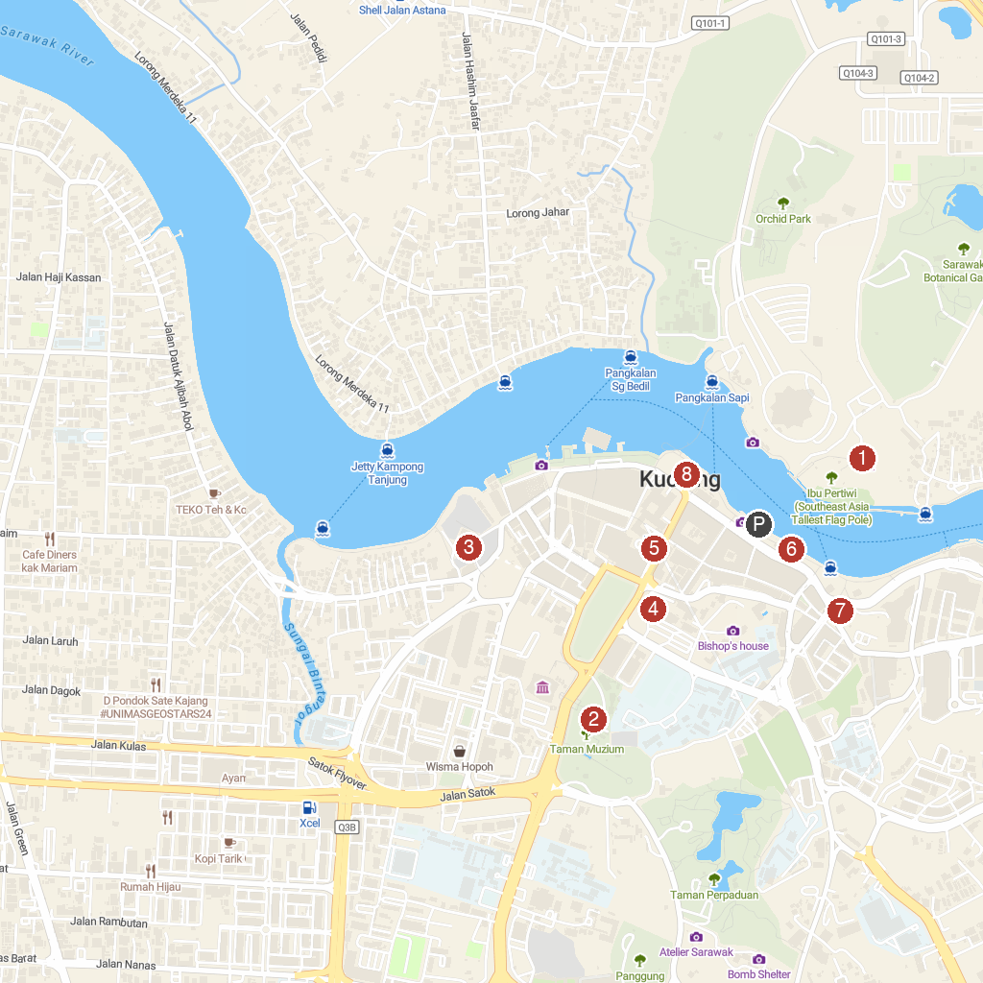
MAP KEY
1. The Brooke Gallery at Fort Margherita | 5. Sarawak Textile Museum
2. Museum Sarawak | 6. Sarawak Traditional Boat Cruise
3. Kuching City Mosque | 7. Tua Pek Kong Temple
4. St Thomas's Cathedral (Anglican Church) | 8. Square Tower & Magenta Restaurant
P. Cruise port / terminal
Map © MapTiler © OpenStreetMap contributors · cruiseports.org

