Krk Island, Kvarner Gulf, Croatia
One of Croatia's largest islands, Krk is the cradle of the Glagolitic script and the 'Golden Island' of the Kvarner Gulf. Tender ashore to a well-preserved medieval walled town, walk to Adriatic beaches, and sip indigenous Žlahtina white wine under the pine trees.
⚓ Tender (no pier) · 🕒 Typical call: 5–8 hrs · 💶 Currency: Euro (€) · 🗣️ Croatian (English widely spoken) · 🏖️ Swimming & history
✍️ MY DAY IN PORT (FILL IN)
Ship / Date
In port | arrive ______ · all aboard ______
Booked excursion
Notes / meeting point
GETTING ASHORE
- Docking: Tender — ships anchor offshore; tenders land on the Riva waterfront directly at Old Town gates
- Walk to center: 0 min — tender drops you at the Old Town entrance
- Best For: Medieval old towns, pebble beaches, local wine, day trips to clifftop Vrbnik
- Don't Miss: Šurlice pasta, Vrbnička Žlahtina wine, Frankopan Castle ramparts
GETTING AROUND
- 🚕 Taxi: €7–16 — Taxis are available near the port. Base fare ~€5–10 plus ~€1.60–1.80/km daytime. Given the port's central location, most
- 📱 Rideshare: ✅ Uber, Bolt
TOP THINGS TO DO
- Krk Old Town & Frankopan Castle — Walk through the Sea Gate into Croatia's third-largest walled town.
- Vrbnik Clifftop Village & Žlahtina Wine Tasting — Taxi 20 minutes northeast to Vrbnik, a medieval village perched 50 m above the sea on sheer cliffs.
- Baška Beach Day — Head to the southern tip of the island for Baška's Vela Plaža — a sweeping 1.8 km pebble beach backed by dramatic mountains.
- Krk Gastronomy: Šurlice & Prosciutto — Sample Krk's signature hand-rolled šurlice pasta (typically served with goulash, scampi, or asparagus and truffle), dried Krčki…
- Kayaking & Snorkeling the Kvarner Coast — Join a guided sea kayak or snorkel trip along Krk's dramatic karst coastline, exploring sea caves, hidden coves, and beaches only…
BEST WALKS
- Old Town Loop: 45 min · Flat to moderate cobblestones · Free — Enter through the Sea Gate (Vrata od Mora), explore the labyrinthine medieval lanes, cross Kamplin…
- Coastal Path to Dražica Beach: 15 min one-way · Flat paved coastal path · Free — From the tender landing, walk east along the pine-shaded coastal promenade to Dražica beach — a…
- West to Ježevac Beach: 15 min one-way · Flat · Free — Head west past the lighthouse and Porporela beach to Blue Flag Ježevac beach, a pebble and pinewood…
WEATHER · DAYLIGHT · MONEY
Month | High °F | Low °F | Rainy days
May | 69 | 57 | 13
Jul | 84 | 70 | 7
Sep | 75 | 63 | 11
Daylight: May 5:32AM–8:23PM · Jul 5:29AM–8:46PM · Sep 6:40AM–7:14PM
cruiseports.org/krk-island-croatia · Confirm terminal & all-aboard time with your ship

Krk Island, Kvarner Gulf, Croatia — Port Map
Red = walkable sights · Amber = excursions farther out · P = cruise terminal
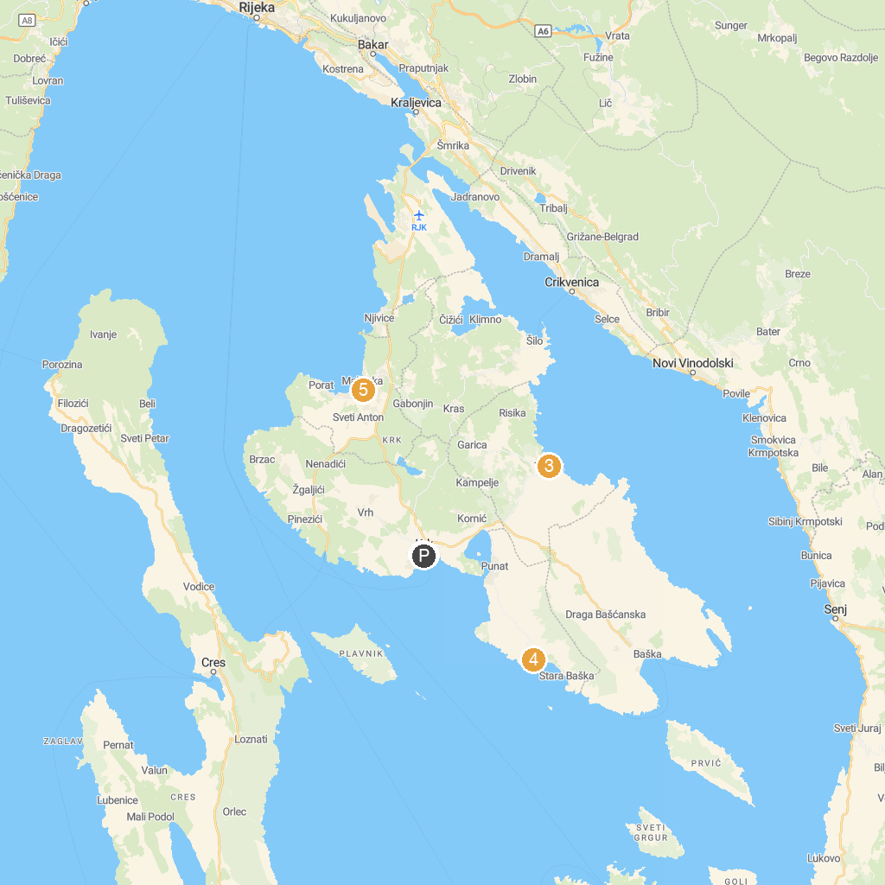
MAP KEY
1. Frankopan Castle | 5. Church of St. Apollinaris
2. Semisubmarine Krk | 6. St. Lucia's Church
3. VRBNIK | 7. Square Tower
4. Zaljev Oprna
P. Cruise port / terminal
Map © MapTiler © OpenStreetMap contributors · cruiseports.org

