Kristiansund, Møre og Romsdal, Norway
Built across four islands after WWII bombing leveled the old town, Kristiansund punches above its size — gateway to the Atlantic Ocean Road, home to the world's oldest continuously running public ferry, and the undisputed clipfish capital of Norway.
⚓ Pier (Storkaia, city center) · 🕒 Typical call: 6-8 hrs · 💵 Norwegian Krone (NOK) — nearly cashless · 🗣️ Norwegian / English widely spoken · 🐟 Clipfish capital of the world
✍️ MY DAY IN PORT (FILL IN)
Ship / Date
In port | arrive ______ · all aboard ______
Booked excursion
Notes / meeting point
GETTING ASHORE
- Docking: Storkaia pier, central Kirkelandet island — 1-5 min walk to town
- Walk to center: 2 min to main square; 20-25 min uphill to Varden viewpoint
- Best For: Atlantic Ocean Road drive, island-hopping by ferry, Norwegian coastal culture
- Don't Miss: Sundbåten ferry (since 1876) and Kirkelandet Church's 320 stained-glass windows
GETTING AROUND
- 🚕 Taxi: 100–200 NOK (short trip) — Local taxis are available near the port. A short in-town ride runs roughly 100–200 NOK; longer trips to outlying areas s
TOP THINGS TO DO
- Atlantic Ocean Road Drive — An 8.3 km ribbon of bridges leaping between islands above the open Atlantic — consistently voted one of the world's most scenic…
- Norwegian Clipfish Museum — Kristiansund made its fortune drying cod on coastal rocks and shipping 'klippfisk' to Spain, Portugal, and Brazil.
- Grip Island Day Trip — A 40-minute boat ride takes you to Grip — a tiny, largely deserted island village with colorful fishermen's houses, a medieval…
- Innlandet Old Town Walk — The only island that survived WWII bombing, Innlandet is a quiet enclave of 18th- and 19th-century wooden buildings, narrow…
- Varden Viewpoint Hike — A brick tower from 1892 crowns the highest point on Kirkelandet — 25 minutes uphill from the pier but rewarded with a 360°…
BEST WALKS
- City Center & Kirkelandet Church: 1.5 km · 30 min · Easy — From Storkaia, walk to the main square (Rådhusplassen), continue to Kirkelandet Church to view 320…
- Varden Viewpoint Loop: 2.5 km · 50 min · Moderate (uphill) — Head inland from the pier, climb the hill to Varden for panoramic views, then descend back to the…
- Sundbåten Island Hop: 3-4 hrs · Easy · Ferry-assisted — Ride the world's oldest public ferry between all four islands: Kirkelandet → Gomalandet (Clipfish…
WEATHER · DAYLIGHT · MONEY
Month | High °F | Low °F | Rainy days
May | 52 | 41 | 15
Jul | 62 | 52 | 17
Sep | 58 | 49 | 18
Daylight: May 4:25AM–10:27PM · Sep 6:54AM–7:52PM
cruiseports.org/kristiansund · Confirm terminal & all-aboard time with your ship

Kristiansund, Møre og Romsdal, Norway — Port Map
Red = walkable sights · Amber = excursions farther out · P = cruise terminal
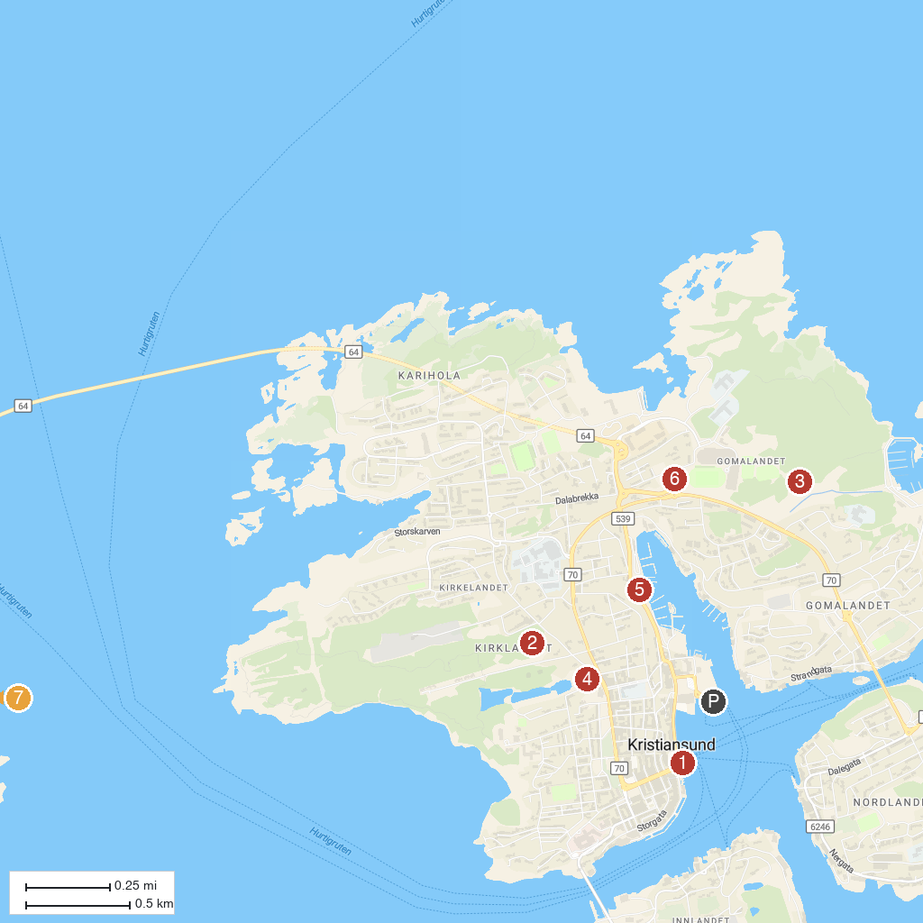
MAP KEY
1. Sundbåten- The harbour ferry | 5. Mellemværftet, Historic Shipyard
2. Varden | 6. Atlanterhavsbadet
3. Folkeparken | 7. Stavnes Lighthouse
4. Svanedammen
P. Cruise port / terminal
Map © MapTiler © OpenStreetMap contributors · cruiseports.org

