Krefeld, North Rhine-Westphalia, Germany
River ships dock in Uerdingen, a quietly charming Rhine-side borough within Krefeld — Germany's historic Velvet and Silk City. Stroll the promenade immediately from the gangway, or hop a short train ride to medieval castles and Bauhaus masterpieces.
⚓ River pier — walk-off docking · 🕒 Typical call: 6–8 hrs · 💶 Currency: Euro (€) · 🗣️ Language: German · 🏰 History & Culture
✍️ MY DAY IN PORT (FILL IN)
Ship / Date
In port | arrive ______ · all aboard ______
Booked excursion
Notes / meeting point
GETTING ASHORE
- Docking: Floating pier in Krefeld-Uerdingen; no tender
- Walk to Uerdingen center: 5–10 min on foot (~600 m)
- Best For: History buffs, textile heritage, quiet Rhine culture
- Don't Miss: Burg Linn medieval castle and the Haus der Seidenkultur
GETTING AROUND
- 🚕 Taxi: €20–25 — Taxis meet ships at the Uerdingen port. The 7–8 km ride to Krefeld city center (Hauptbahnhof) takes about 10–15 minutes.
- 📱 Rideshare: ✅ Uber
TOP THINGS TO DO
- Burg Linn Medieval Castle — A beautifully preserved 12th-century moated castle in the Linn district with an archaeological museum, baroque hunting lodge, and…
- Haus der Seidenkultur (Silk Museum) — Krefeld's famous Velvet and Silk City history comes alive in this former parament weaving workshop.
- Mies van der Rohe: Haus Lange & Haus Esters — Two residential villas designed by Ludwig Mies van der Rohe in the late 1920s — Bauhaus masterpieces now used as contemporary art…
- Rhine Promenade & Uerdingen Stroll — From the gangway, walk the paved Rhine promenade past the landmark Uerdinger Rheinbrücke (1936), then into the historic market…
- Stadtpark Uerdingen & Dujardin Distillery — The historic Dujardin brandy distillery, founded in 1810, produced spirits here until 1983; its preserved Rhine-side buildings…
BEST WALKS
- Uerdingen Riverside & Market Loop: 2.5 km · 35 min · Easy · Free — From the pier head north along the Rhine promenade to the Uerdinger Rheinbrücke suspension bridge…
WEATHER · DAYLIGHT · MONEY
Month | High °F | Low °F | Rainy days
May | 65 | 49 | 12
Jul | 75 | 59 | 13
Sep | 69 | 54 | 10
Daylight: May 5:42AM–9:18PM · Jul 5:35AM–9:43PM · Sep 7:09AM–7:47PM
cruiseports.org/krefeld · Confirm terminal & all-aboard time with your ship

Krefeld, North Rhine-Westphalia, Germany — Port Map
Red = walkable sights · Amber = excursions farther out · P = cruise terminal
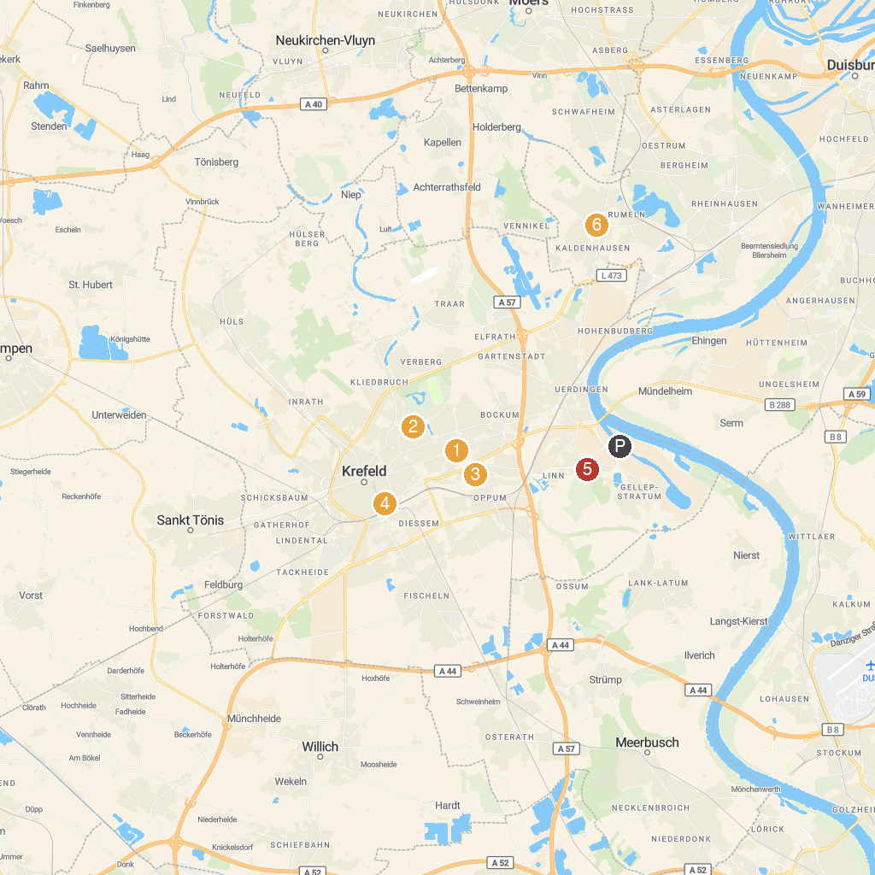
MAP KEY
1. Kaiserpfalz Kaiserswerth | 5. Schönwasser Park
2. Zoo Krefeld | 6. HOUSE OF SILK CULTURE earlier parament weaving H. Gotzes
3. Museums Haus Lange Haus Esters | 7. Haus Greiffenhorst
4. Tiger & Turtle | 8. Bienenmuseum Duisburg
P. Cruise port / terminal
Map © MapTiler © OpenStreetMap contributors · cruiseports.org

