Kratie, Kratie Province, Cambodia
A slow-paced colonial river town on the Mekong, Kratie draws river cruisers for one thing above all — the chance to see critically endangered Irrawaddy dolphins just upstream, while the French-shuttered riverfront and car-free island life fill out a deeply unhurried day.
⚓ Tendered ashore (river cruise only) · 🕒 Typical call: 6-8 hrs · 💵 USD widely accepted · 🗣️ Khmer (English in tourist areas) · 🐬 Irrawaddy dolphin habitat
✍️ MY DAY IN PORT (FILL IN)
Ship / Date
In port | arrive ______ · all aboard ______
Booked excursion
Notes / meeting point
GETTING ASHORE
- Docking: Tender to riverfront promenade steps; river cruise ships only
- Walk to center: Immediate — you land on the promenade in town
- Best For: Irrawaddy dolphin watching, cycling Koh Trong Island, colonial architecture
- Don't Miss: Kampi dolphin boat tour (~$9) and kralan bamboo sticky rice from a roadside stall
GETTING AROUND
- 🚕 Taxi: $0.50–2 — Motodops (moto-taxi drivers) wait near the riverfront and are the cheapest option for solo travelers. Agree on a price b
- 📱 Rideshare: ✅ Grab
TOP THINGS TO DO
- Irrawaddy Dolphin Watching at Kampi — Tuk-tuk 15km north to the Kampi pool, then board a small motorized boat with a local captain who cuts the engine near the…
- Cycling Koh Trong Island — A 5-minute ferry from the promenade ($1) drops you on this car-free river island.
- Kratie Colonial Town Walk — The riverfront promenade and French Quarter behind it preserve yellow-and-blue shuttered colonial buildings largely untouched by…
- Phnom Sambok Temple Hike — An 11km tuk-tuk ride north (often combined with the dolphin tour) brings you to a forested hill topped by a colorful Buddhist…
- Mekong Turtle Conservation Centre (Sambor) — A longer 36km excursion north to Wat Sorsor Muoy Roy (the 100 Pillar Pagoda) — a vast modern temple built on the site of a former…
BEST WALKS
- Riverfront Promenade & French Quarter: 1.5 km · 30 min · Easy — From the tender landing steps, walk south along the Mekong promenade past colonial facades to the…
- Riverfront to Wat Rokakandal: 6 km round trip · 1.5 hrs · Easy (flat road) — Head south on the riverside road from the promenade for 3km to reach one of Cambodia's oldest…
WEATHER · DAYLIGHT · MONEY
Month | High °F | Low °F | Rainy days
May | 91 | 79 | 24
Jul | 87 | 77 | 28
Sep | 86 | 76 | 28
Daylight: May 5:31AM–6:13PM · Jul 5:38AM–6:25PM · Sep 5:45AM–5:56PM
cruiseports.org/kratie · Confirm terminal & all-aboard time with your ship

Kratie, Kratie Province, Cambodia — Port Map
Red = walkable sights · Amber = excursions farther out · P = cruise terminal
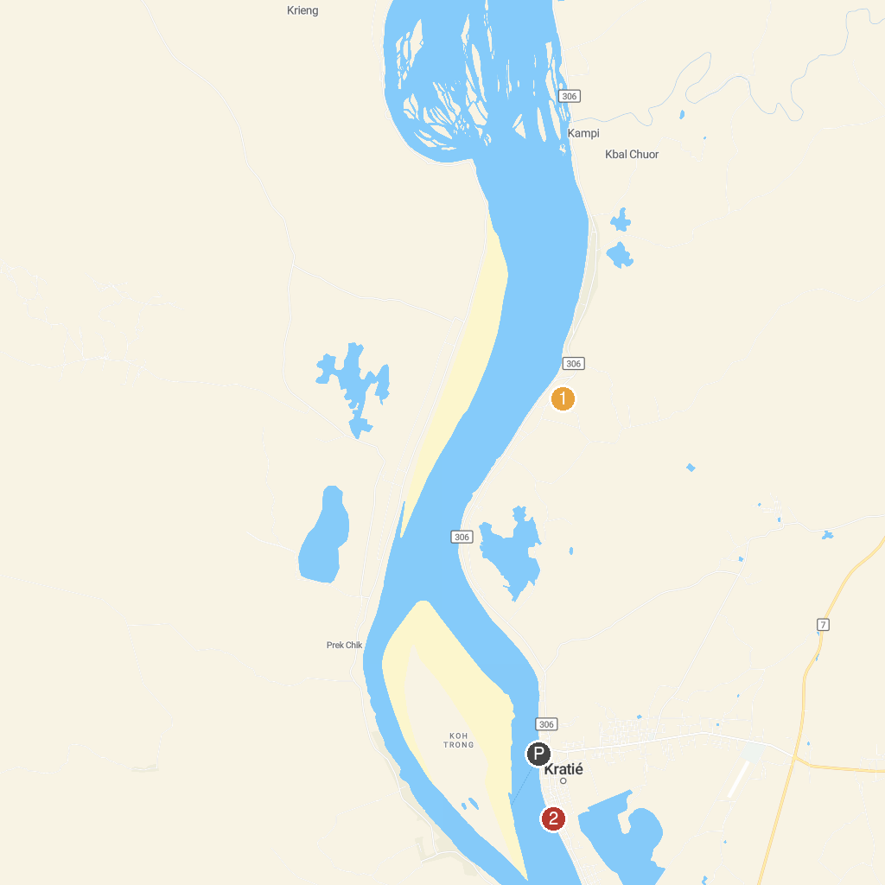
MAP KEY
1. Phnom Sambok Pagoda | 3. Kampi Mega Rapid
2. Mekong Dolphin Pleasance | 4. Silver Dolphin Kayaking
P. Cruise port / terminal
Map © MapTiler © OpenStreetMap contributors · cruiseports.org

