Kralendijk, Bonaire, Caribbean Netherlands
Bonaire is the dive capital of the Caribbean — but even snorkel novices get roped in by No Name Beach, pink flamingo-dotted salt flats, and a reef you can literally wade into from shore. The pier drops you right on the waterfront; the whole island is your playground.
⚓ Docked (no tender) · 🕒 Typical call: 7-9 hrs · 💵 US Dollar (USD) · 🗣️ Papiamentu / Dutch / English widely spoken · 🤿 World-class snorkel & dive destination
✍️ MY DAY IN PORT (FILL IN)
Ship / Date
In port | arrive ______ · all aboard ______
Booked excursion
Notes / meeting point
GETTING ASHORE
- Docking: Two piers (Northern & Southern/New Pier) directly in front of Kralendijk town centre — no tender required
- Walk to centre: Under 5 minutes to Kaya Grandi and Wilhelmina Park
- Best For: Snorkeling, scuba diving, flamingo spotting, Klein Bonaire day trips
- Don't Miss: Klein Bonaire snorkel by water taxi, pink salt flats with flamingos at Pekelmeer
GETTING AROUND
- 🚕 Taxi: $15–$25 to beaches — Taxis wait at both the North and South piers with government-set rates. No meters — agree on a price before you go. Shor
- 📱 Rideshare: ❌ not available
TOP THINGS TO DO
- Klein Bonaire Snorkel by Water Taxi — A short (roughly 15-minute) water taxi from the waterfront reaches this uninhabited islet with No Name Beach and pristine coral…
- Salt Flats & Pekelmeer Flamingo Sanctuary — Drive to the island's south to see the iconic pink salt pyramids and the shallow Pekelmeer lagoon, a major nesting site for…
- Scuba Diving the Bonaire Marine Park — Bonaire pioneered Caribbean marine conservation — the entire coastline is a protected park with shore-accessible dive sites.
- Mangrove Kayak at Lac Bay — Paddle through Bonaire's pristine mangrove forest at Lac Bay, a UNESCO Ramsar wetland site on the eastern coast.
- Tuk-Tuk Island Sightseeing Tour — Hop aboard an eco-friendly tuk-tuk for a guided circuit of Kralendijk, Fort Oranje, the salt flats, slave huts, flamingo spots…
BEST WALKS
- Kralendijk Waterfront & Town Stroll: 1.5 km · Flat · 30–45 min — From the pier, follow the Sea Promenade north past Wilhelmina Park to Fort Oranje, then loop back…
- Southern Coastal Road to Salt Flats: ~25 km round-trip · Flat · Best by bicycle or scooter — Rent a bicycle or scooter and follow the south coastal road past Lac Bay viewpoints, the…
WEATHER · DAYLIGHT · MONEY
Month | High °F | Low °F | Rainy days
May | 84 | 79 | 8
Jul | 84 | 80 | 14
Sep | 87 | 81 | 10
Daylight: May 6:09AM–6:49PM · Jul 6:16AM–7:01PM · Sep 6:22AM–6:33PM
cruiseports.org/kralendijk-bonaire · Confirm terminal & all-aboard time with your ship

Kralendijk, Bonaire, Caribbean Netherlands — Port Map
Red = walkable sights · Amber = excursions farther out · P = cruise terminal
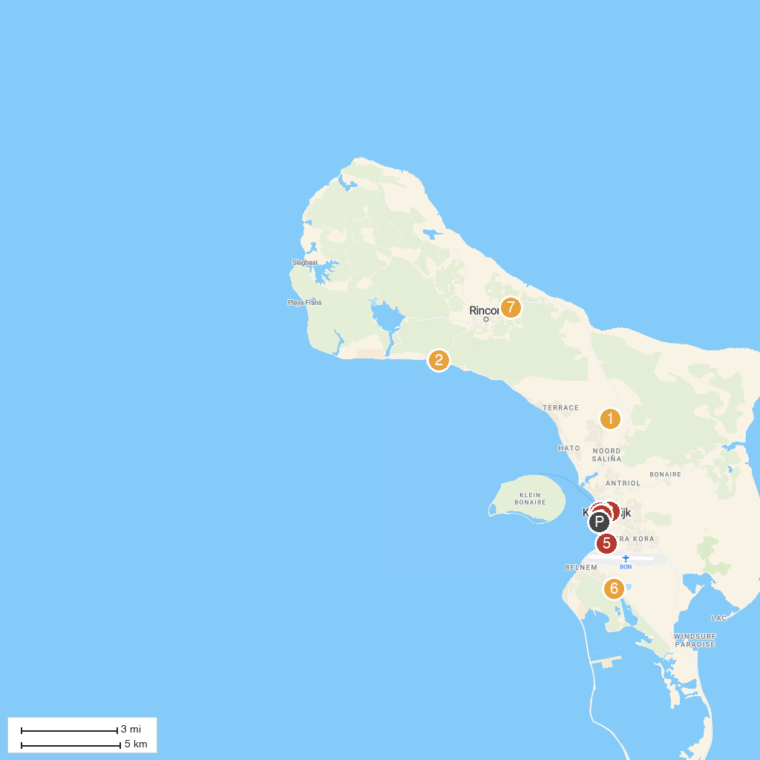
MAP KEY
1. Cruz Seru Largu | 5. Coral Casino Bonaire
2. landhuis Karpata | 6. Donkey Sanctuary Bonaire
3. Bonaire Museum of Natural History | 7. Cultural Park Mangazina di Rei
4. Terramar Museum | 8. Tourism Corporation Bonaire
P. Cruise port / terminal
Map © MapTiler © OpenStreetMap contributors · cruiseports.org

