Krabi, Krabi Province, Thailand
Soaring limestone towers, longtail boats, and beaches only reachable by water — Krabi is southern Thailand at its most dramatic. A half-day here feels like a week's worth of scenery.
⚓ Tender port · 🕒 Typical call: 6–9 hrs · 💵 Thai Baht (THB) · 🗣️ Thai (English in tourist areas) · 🌊 Andaman Sea, Thailand
✍️ MY DAY IN PORT (FILL IN)
Ship / Date
In port | arrive ______ · all aboard ______
Booked excursion
Notes / meeting point
GETTING ASHORE
- Docking: Anchor & tender to Noppharat Thara Pier (~20–30 min)
- Walk to center: ~30-min walk or 5-min tuk-tuk to Ao Nang Beach
- Best For: Island hopping, rock climbing, longtail boats, beach days
- Don't Miss: Railay Beach — only reachable by longtail, 15 min from Ao Nang
GETTING AROUND
- 🚕 Taxi: 400–600 THB (~–17 USD) — Fixed-price taxis are common; negotiate the fare before you board. Covers Krabi Town or Ao Nang from the pier. Agree on
- 📱 Rideshare: ✅ Grab, Bolt
TOP THINGS TO DO
- Railay Beach by Longtail Boat — Accessible only by boat, Railay's west beach is framed by towering limestone cliffs.
- Four Islands Snorkel Tour — A classic: longtail or speedboat to Koh Poda, Koh Tub, Koh Mor, and Chicken Island for snorkeling, sandbar walks at low tide, and…
- Tiger Cave Temple (Wat Tham Suea) — Climb 1,237 steep steps through jungle to a golden Buddha summit with 360° views over limestone forests.
- Emerald Pool & Blue Lagoon — Hike through Khao Phra Bang Khram Nature Reserve to a mineral-spring fed pool of luminous green water.
- Sea Kayaking in Ao Thalane — Paddle through cathedral-like mangrove tunnels and into hidden lagoons carved into the karst cliffs — one of the most peaceful…
BEST WALKS
- Noppharat Thara to Ao Nang Beach: 2.5 km · ~30 min · Flat coastal road — Walk south along the coast road from the tender pier past pine-shaded Noppharat Thara Beach to the…
- Ao Nang Monkey Trail Loop: 1.5 km · ~20 min · Boardwalk — At the southern end of Ao Nang Beach, a cliffside wooden boardwalk winds around karst rocks where…
WEATHER · DAYLIGHT · MONEY
Month | High °F | Low °F | Rainy days
May | 86 | 78 | 28
Jul | 85 | 78 | 24
Sep | 84 | 77 | 24
Daylight: May 6:06AM–6:35PM · Jul 6:14AM–6:46PM · Sep 6:15AM–6:24PM
cruiseports.org/krabi · Confirm terminal & all-aboard time with your ship

Krabi, Krabi Province, Thailand — Port Map
Red = walkable sights · Amber = excursions farther out · P = cruise terminal
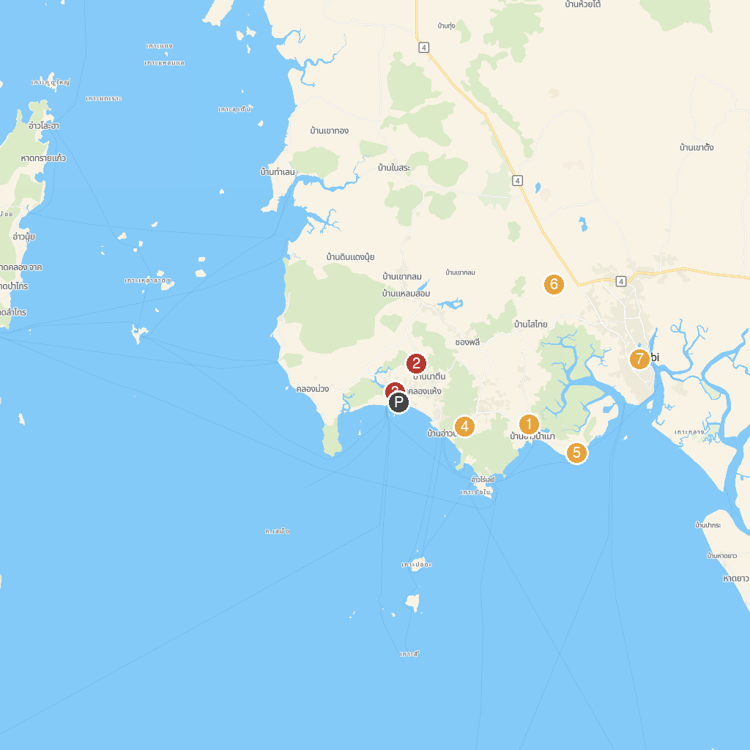
MAP KEY
1. Sa Kaeo | 5. Aonang Al-Munuawarah Mosque
2. Masjid Ban Ao Nam Mao | 6. Shell Cemetery
3. Natin Spicy Garden | 7. THAI'D UP ADVENTURES
4. Koh Phi Phi Tour Pier | 8. Maharaj Market
P. Cruise port / terminal
Map © MapTiler © OpenStreetMap contributors · cruiseports.org

