Kotor, Bay of Kotor, Montenegro
Ringed by medieval walls and cradled by the Adriatic's deepest bay, Kotor delivers a UNESCO Old Town, a vertiginous fortress hike, a famous island church, and more cats per square metre than anywhere in the Mediterranean.
⚓ Dock or tender (larger ships anchor out) · 🕒 Typical call: 8-10 hrs · 💶 Currency: Euro (€) · 🗣️ Language: Montenegrin / English widely spoken · 🏛️ UNESCO World Heritage Site
✍️ MY DAY IN PORT (FILL IN)
Ship / Date
In port | arrive ______ · all aboard ______
Booked excursion
Notes / meeting point
GETTING ASHORE
- Docking: Smaller ships dock alongside the quay by the Old Town walls; larger or overflow ships anchor in the bay and tender 5-20 min to Park Slobode pier
- Walk to center: 2-5 min from the dock/tender pier to the Sea Gate — you can see the walls from where you land
- Best For: History lovers, fortress hikers, photographers, and anyone who likes cats
- Don't Miss: The 1,350-step hike to Fortress of San Giovanni and the boat trip to Our Lady of the Rocks island
GETTING AROUND
- 🚕 Taxi: €4–€12 — Licensed taxis wait outside the port; agree on a price before you get in or confirm the meter is running. Fares rise sig
- 📱 Rideshare: ❌ not available
- 🚌 Hop-on hop-off: ✅
TOP THINGS TO DO
- Kotor Old Town Self-Guided Walk — Wander the marble lanes of the walled Old Town: Arms Square and the 1602 Clock Tower, the Romanesque Cathedral of Saint Tryphon…
- Fortress of San Giovanni Hike — Climb roughly 1,350 uneven stone steps up the ancient city walls to the ruined Fortress of San Giovanni at 280 m, with…
- Perast & Our Lady of the Rocks Boat Tour — A speedboat from City Park (100 m from the tender pier) whisks you 20-30 minutes to the Baroque village of Perast, then a further…
- Lovćen National Park & Njegoš Mausoleum — A winding drive up the Austro-Hungarian serpentine road — 25 hairpin bends above Kotor — leads to Lovćen National Park at 1,660 m.
- Blue Cave Boat Tour — A sea cave on the Lustica Peninsula where sunlight filters through the water and reflects off the white sandy bottom, bathing the…
BEST WALKS
- Old Town Loop: 1-1.5 hrs | Flat marble cobblestones | Easy — A full circuit of the compact Old Town hitting all the main squares, churches, and wall viewpoints.
- Fortress of San Giovanni Climb: 1.5-2 hrs round trip | ~1,350 steps | Strenuous — Follow signage inside the Old Town walls to the staircase entrance and ascend the ancient city wall…
WEATHER · DAYLIGHT · MONEY
Month | High °F | Low °F | Rainy days
May | 71 | 59 | 14
Jul | 85 | 72 | 7
Sep | 78 | 66 | 10
Daylight: May 5:23AM–7:59PM · Jul 5:21AM–8:19PM · Sep 6:25AM–6:54PM
cruiseports.org/kotor · Confirm terminal & all-aboard time with your ship

Kotor, Bay of Kotor, Montenegro — Port Map
Red = walkable sights · Amber = excursions farther out · P = cruise terminal
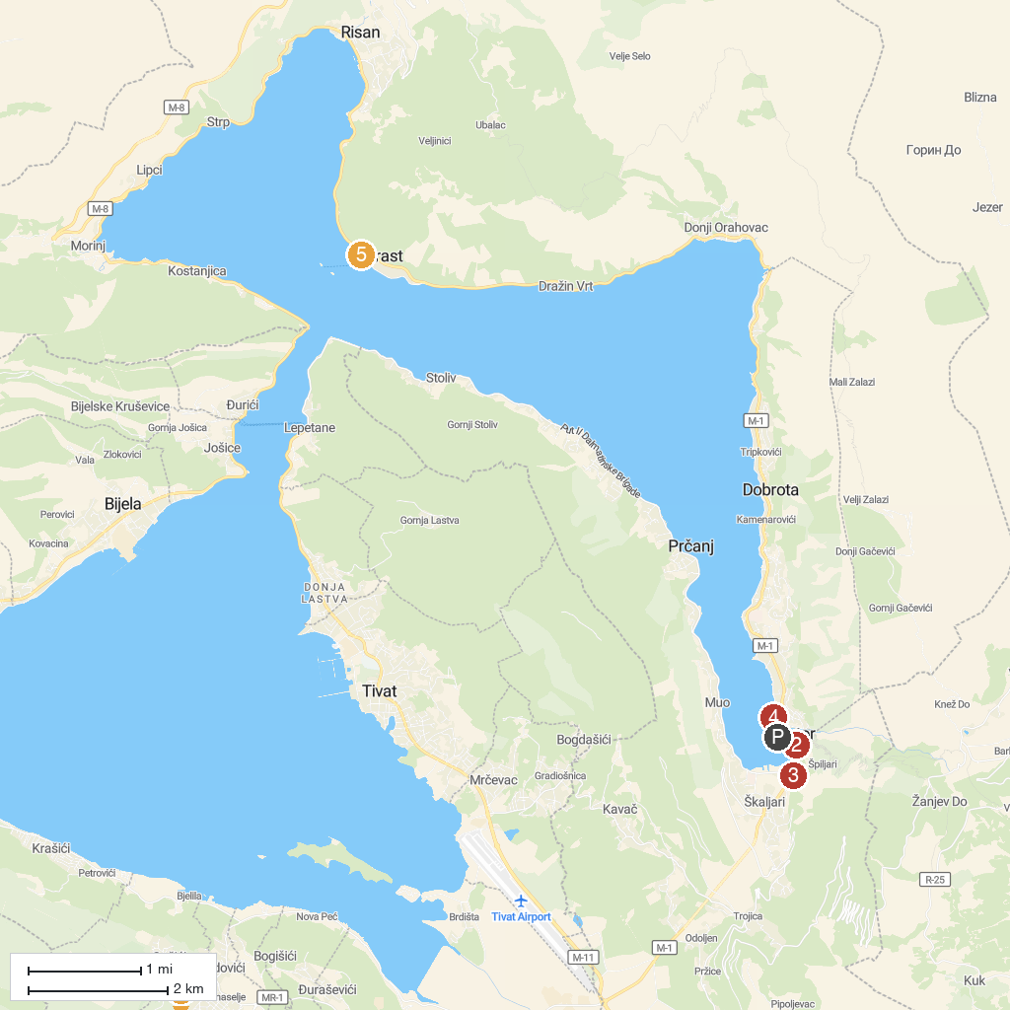
MAP KEY
1. Luštica Bay | 5. Perast Town Museum
2. Maritime Museum | 6. Museum of King Nikola
3. AUTOMAT CLUB ADMIRAL CATTARO | 7. Museum of Money
4. A Day Out on Yacht Monty B
P. Cruise port / terminal
Map © MapTiler © OpenStreetMap contributors · cruiseports.org

