Kotka, South Finland, Finland
Finland's 'City of Parks' sits on its own island in the Gulf of Finland, where award-winning gardens, a world-class maritime museum, and a Tsar's fishing lodge await within easy reach of the pier.
⚓ Pier (Kantasatama or Mussalo) · 🕒 Typical call: 8-10 hrs · 💶 Euro (cards everywhere) · 🗣️ Finnish — English widely spoken
✍️ MY DAY IN PORT (FILL IN)
Ship / Date
In port | arrive ______ · all aboard ______
Booked excursion
Notes / meeting point
GETTING ASHORE
- Docking: Pier — Kantasatama (city center) or Mussalo (shuttle provided)
- Walk to center: 10-15 min from Kantasatama pier; not walkable from Mussalo
- Best For: Parks, maritime history, Finnish cuisine, relaxed strolling
- Don't Miss: Maritime Centre Vellamo, Sapokka Water Garden, a warm Posso pastry
GETTING AROUND
- 🚕 Taxi: €18–€24 — Taxis run from Mussalo commercial port to city center (~5–8 km). Local provider Taksiparoni estimates around €22 for thi
- 📱 Rideshare: ✅ Uber
TOP THINGS TO DO
- Maritime Centre Vellamo — A wave-shaped architectural landmark right at the Kantasatama pier, housing the Maritime Museum of Finland and Museum of…
- Sapokka Water Garden — Consistently ranked among Finland's most beautiful parks, Sapokka features a near-20-meter waterfall, rock sculptures, and masses…
- Langinkoski Imperial Fishing Lodge — Built in 1889 for Tsar Alexander III, this wooden riverside lodge sits among rushing rapids in a nature reserve.
- Maretarium Aquarium — A unique freshwater and Baltic Sea aquarium focused entirely on Finnish fish species.
- Katariina Seaside Park & Beach — A former oil harbor transformed into a sweeping recreational park with ruins of Fort Katarina, a giant labyrinth, and…
BEST WALKS
- City Center & Sculpture Promenade: 1.5 km · 30 min · Easy · Free — Walk from the pier along Keskuskatu — Finland's largest outdoor sculpture gallery — to the Market…
- Vellamo to Sapokka Water Garden: 2 km · 40 min · Easy · Free — Start at the Maritime Centre Vellamo, walk south along the waterfront promenade, and arrive at the…
WEATHER · DAYLIGHT · MONEY
Month | High °F | Low °F | Rainy days
May | 56 | 43 | 10
Jul | 70 | 58 | 12
Sep | 59 | 50 | 10
Daylight: May 4:31AM–9:47PM · Jul 4:12AM–10:22PM · Sep 6:40AM–7:33PM
cruiseports.org/kotka · Confirm terminal & all-aboard time with your ship

Kotka, South Finland, Finland — Port Map
Red = walkable sights · Amber = excursions farther out · P = cruise terminal
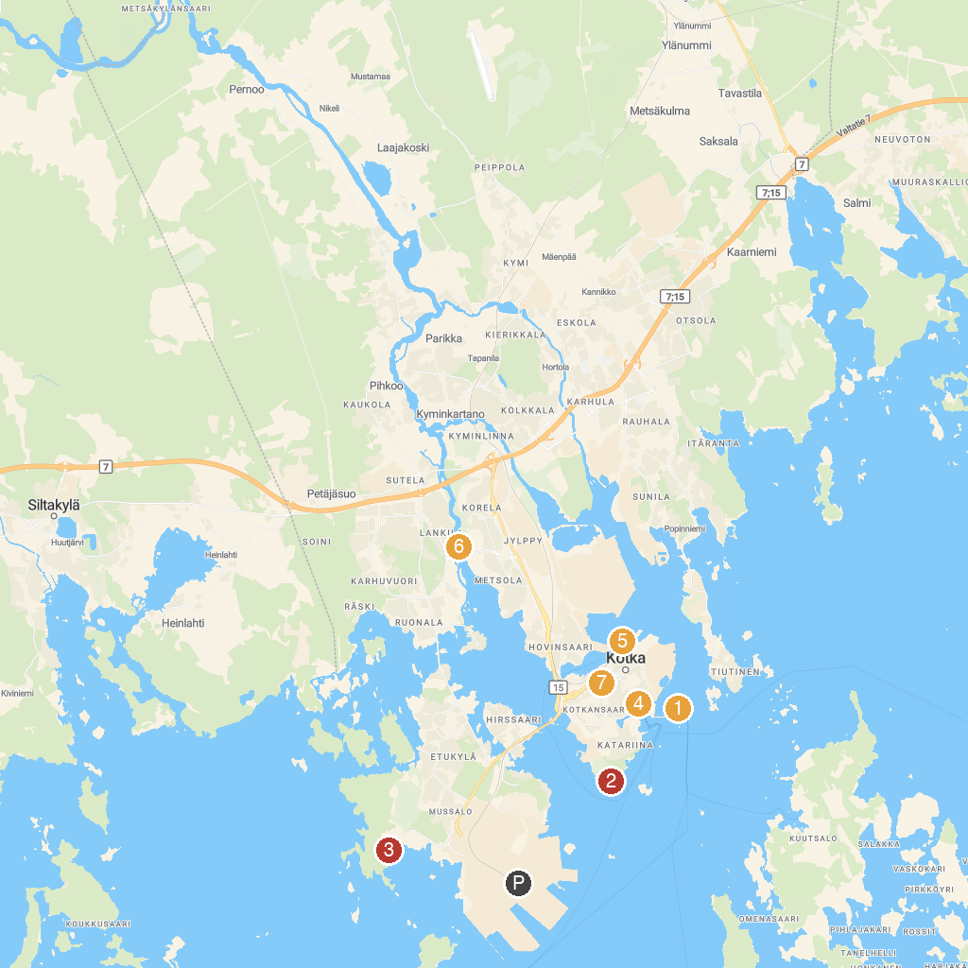
MAP KEY
1. Luotsi-Kuusinen Scenic Spot | 5. Maretarium
2. Katariina Seaside Park | 6. Maritime Museum of Finland
3. Nature trail | 7. Langinkoski Imperial Fishing Lodge
4. Karhulan ilmailukerho Aviation Museum | 8. Church of Kotka
P. Cruise port / terminal
Map © MapTiler © OpenStreetMap contributors · cruiseports.org

