Kota Kinabalu, Sabah, Malaysia
The gateway to Borneo drops you within reach of coral islands, proboscis monkeys, and five indigenous tribes — all in a single port day.
⚓ Pier (Sepanggar Bay Terminal) · 🕒 Typical call: 8-10 hrs · 💵 Malaysian Ringgit (MYR) · 🗣️ Malay & English · 🌿 Wildlife & Island destination
✍️ MY DAY IN PORT (FILL IN)
Ship / Date
In port | arrive ______ · all aboard ______
Booked excursion
Notes / meeting point
GETTING ASHORE
- Docking: Pier at Kota Kinabalu Port, Sepanggar Bay — 15-20 km from city center
- To City Center: 30-45 min by taxi or Grab; no walkable city access from pier
- Best For: Island snorkeling, Bornean tribal culture, wildlife parks
- Don't Miss: DIY island hopping to Tunku Abdul Rahman Marine Park
GETTING AROUND
- 🚕 Taxi: RM 35-45 (~$8-10 USD) — Taxis are available at the pier but often do not use meters — agree on the fare before boarding. Fares from the industri
- 📱 Rideshare: ✅ Grab
- 🚌 Hop-on hop-off: ✅
TOP THINGS TO DO
- Island Hopping — Tunku Abdul Rahman Marine Park — Five tropical islands sit just 15 minutes by boat from shore.
- Lok Kawi Wildlife Park — The best option for seeing Borneo's iconic animals on a port day — proboscis monkeys, pygmy elephants, sun bears, and orangutans…
- Sabah Tribal Cultural Village Experience — Step into the jungle and meet Sabah's five indigenous tribes — Kadazan-Dusun, Bajau, Lundayeh, Murut, and Rungus.
- White-Water Rafting on the Kiulu River — The Kiulu River offers gentle Grade 1-2 rapids through Sabah jungle — accessible and family-friendly for non-experts (the Padas…
- City Walk: Waterfront, Atkinson Clock Tower & Markets — KK's compact center is best on foot once you get there.
BEST WALKS
- KK Waterfront to Atkinson Clock Tower: 1.5 km · 30 min · Flat — Start at the Marlin statue on the waterfront boardwalk, then walk south past the old Jesselton…
- Gaya Street Market Stroll: 0.8 km loop · 20-30 min · Flat — Browse the main shopping street for Bornean pearls, batik sarongs, handicrafts, and local snacks.
WEATHER · DAYLIGHT · MONEY
Month | High °F | Low °F | Rainy days
May | 86 | 77 | 24
Jul | 85 | 76 | 20
Sep | 85 | 76 | 23
Daylight: May 6:00AM–6:23PM · Jul 6:08AM–6:34PM · Sep 6:06AM–6:15PM
cruiseports.org/kota-kinabalu · Confirm terminal & all-aboard time with your ship

Kota Kinabalu, Sabah, Malaysia — Port Map
Red = walkable sights · Amber = excursions farther out · P = cruise terminal
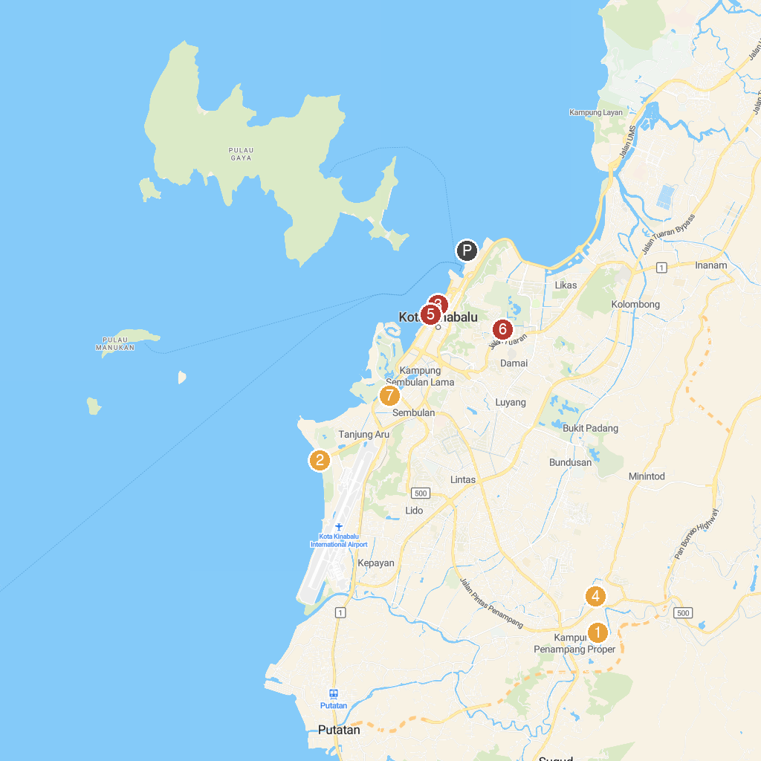
MAP KEY
1. St. Michael's Church | 5. Lok Kawi Wildlife Park
2. Tanjung Aru Beach | 6. Night Food Market
3. Kota Kinabalu Central Market | 7. Aquascape Center
4. Sabah Cultural Centre | 8. Double Six Memorial Park
P. Cruise port / terminal
Map © MapTiler © OpenStreetMap contributors · cruiseports.org

