Korcula Island, Dalmatia, Croatia
A fortified medieval citadel perched on an Adriatic peninsula, Korcula Town's famous fishbone street plan, Venetian-Gothic towers, and native Grk white wine await — all within minutes of the tender dock.
⚓ Mostly tender port · 🕒 Typical call: 5–8 hrs · 💶 Euro (€) · 🗣️ Croatian / English widely spoken · 🏰 UNESCO candidate Old Town
✍️ MY DAY IN PORT (FILL IN)
Ship / Date
In port | arrive ______ · all aboard ______
Booked excursion
Notes / meeting point
GETTING ASHORE
- Docking: Tender for large ships; small ships may dock at town quay
- Walk to Old Town: 1–3 min from tender pier / town dock
- Best For: Medieval history, Dalmatian food & wine, beaches, swordplay show
- Don't Miss: Moreška Sword Dance (Mon & Thu evenings in summer)
GETTING AROUND
- 🚕 Taxi: €6–20 — Taxis queue at the port area. Short in-town rides run ~€6; longer trips like Korcula Town to Lumbarda are around €20. Ne
- 📱 Rideshare: ✅ Uber
TOP THINGS TO DO
- Korcula Old Town Self-Guided Walk — Stroll the fishbone alleys, climb the Cathedral bell tower for rooftop views, peek into Marco Polo's house, and browse the Town…
- Moreška Sword Dance — A centuries-old battle dance performed by two teams of sword fighters re-enacting a clash between the White King and the Black…
- Korcula Wine & Cuisine Tasting — Sample Grk and Pošip white wines — both native to the island — alongside island cheese, local olive oil, and Žrnovski Makaruni…
- Lumbarda Sandy Beaches — A 10-minute taxi or local bus ride east of town, Lumbarda's Vela Pržina and Bilin Žal are among the few natural sandy beaches on…
- Sea Kayaking the Korcula Archipelago — Paddle among the small uninhabited islets east and west of Korcula Town — crystal-clear Adriatic water, hidden coves, and views…
BEST WALKS
- Old Town Fishbone Circuit: 1.5 km · 45–60 min · Easy (some stone steps) — Enter through the Land Gate, wind through the narrow alleys of the medieval core, visit St.
- Promenade to St. Anthony's Hill: 4 km round trip · ~1.5 hrs · Easy — Head east along the waterfront promenade, pass the Banje beach area, and follow the signed path up…
WEATHER · DAYLIGHT · MONEY
Month | High °F | Low °F | Rainy days
May | 72 | 58 | 10
Jul | 88 | 71 | 3
Sep | 79 | 65 | 8
Daylight: May 5:28AM–8:07PM · Jul 5:26AM–8:28PM · Sep 6:31AM–7:01PM
cruiseports.org/korcula-island-croatia · Confirm terminal & all-aboard time with your ship

Korcula Island, Dalmatia, Croatia — Port Map
Red = walkable sights · Amber = excursions farther out · P = cruise terminal
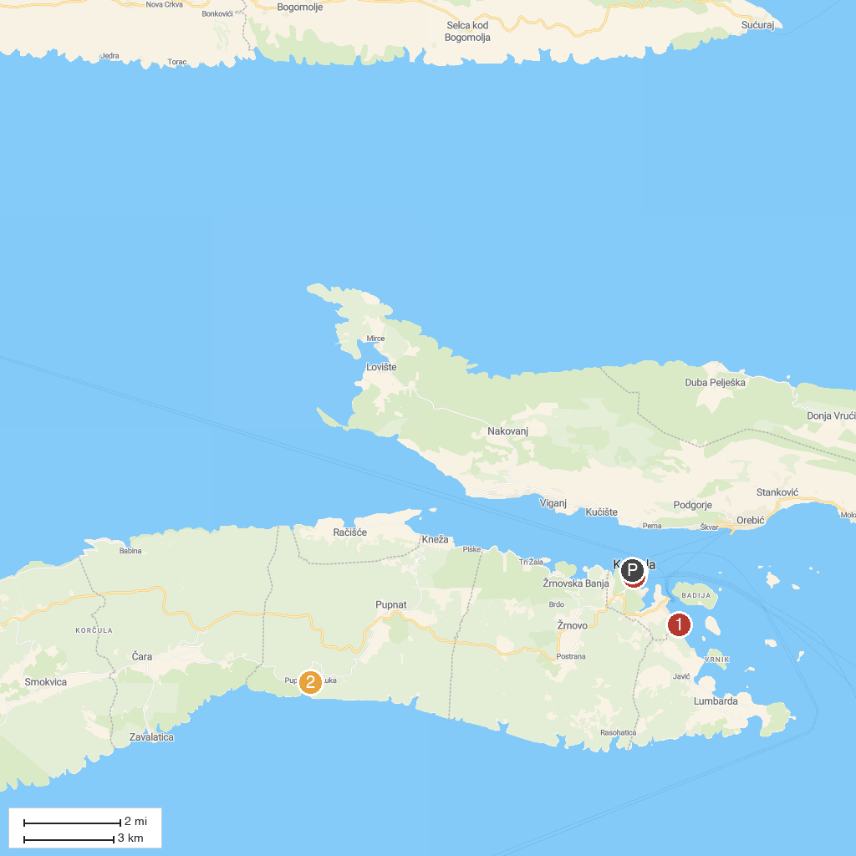
MAP KEY
1. Chiara Apartments | 3. Korcula Town Museum
2. Pupnatska Luka Beach | 4. Marco Polo Museum
P. Cruise port / terminal
Map © MapTiler © OpenStreetMap contributors · cruiseports.org

