Koper, Slovenian Istria, Slovenia
Slovenia's sole cruise gateway packs big punch for a small city — Venetian Gothic squares lead to karst caves, clifftop castles, and the Adriatic's most photogenic coastline.
⚓ Docked (cruise terminal) · 🕒 Typical call: 8-10 hrs · 💶 Euro (€) · 🗣️ Slovenian / Italian
✍️ MY DAY IN PORT (FILL IN)
Ship / Date
In port | arrive ______ · all aboard ______
Booked excursion
Notes / meeting point
GETTING ASHORE
- Docking: Dedicated cruise terminal; ships dock directly — no tender needed
- Walk to center: 5-10 min on foot to Tito Square and Old Town
- Best For: History lovers, cave explorers, foodies, and castle fans
- Don't Miss: Postojna Cave + Predjama Castle combo (45-60 min drive)
GETTING AROUND
- 🚕 Taxi: €3–€6 — Local taxis (e.g. ATX Taxi Koper) operate 24/7. Fares start at €1 base + ~€0.90/km; the very short distance into the old
- 📱 Rideshare: ✅ Bolt
- 🚌 Hop-on hop-off: ✅
TOP THINGS TO DO
- Postojna Cave & Predjama Castle — Ride a miniature electric train through 24 km of stalactite-draped galleries at Postojna, then visit Predjama Castle — a medieval…
- Lake Bled & Ljubljana — Full-day inland sweep: glacier-blue Lake Bled with its island church and clifftop castle, then Ljubljana's baroque Old Town…
- Piran & Slovenian Riviera — Drive 20 minutes to Piran — often called the most beautiful town on the Adriatic — with Tartini Square, Venetian walls, and St…
- Škocjan Caves (UNESCO) — A UNESCO World Heritage karst cave with a thundering underground river canyon — more dramatic than Postojna for visitors who…
- Koper Old Town Walk — Self-guided stroll through the medieval Old Town: Tito Square, the Venetian Gothic Praetorian Palace, Cathedral of the Assumption…
BEST WALKS
- Tito Square & Cathedral Loop: 2-3 hrs · Easy · Free — From the cruise terminal, walk north into the Old Town.
- Waterfront Promenade: 1 hr · Easy — After the Old Town, follow the modern harbour promenade south from the terminal past the marina and…
WEATHER · DAYLIGHT · MONEY
Month | High °F | Low °F | Rainy days
May | 69 | 56 | 15
Jul | 83 | 69 | 9
Sep | 75 | 62 | 10
Daylight: May 5:34AM–8:29PM · Jul 5:31AM–8:50PM · Sep 6:43AM–7:15PM
cruiseports.org/koper · Confirm terminal & all-aboard time with your ship

Koper, Slovenian Istria, Slovenia — Port Map
Red = walkable sights · Amber = excursions farther out · P = cruise terminal
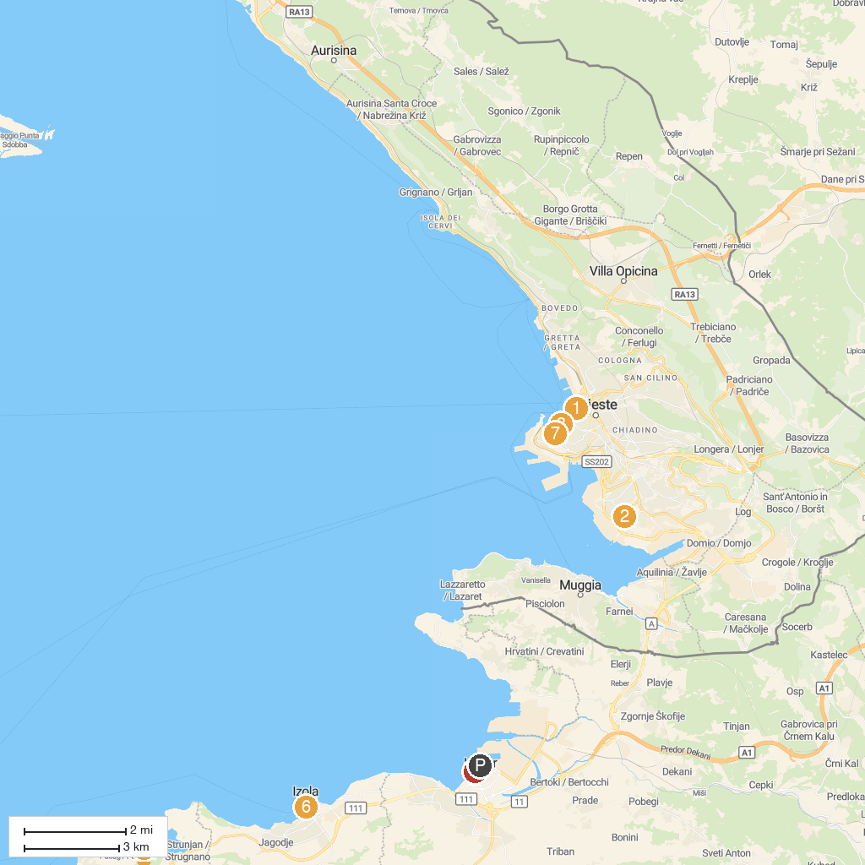
MAP KEY
1. Greek Orthodox Church of Saint Nicholas | 5. Portorož Beach Central
2. San Sabba Rice Mill National Monument & Museum | 6. Koper Regional Museum
3. Revoltella Museum | 7. Muzej Izolana - hiša morja
4. Walls of Piran | 8. Bora Museum
P. Cruise port / terminal
Map © MapTiler © OpenStreetMap contributors · cruiseports.org

