Königswinter, North Rhine-Westphalia, Germany
Where Rhine Romanticism was born — Königswinter packs a fairy-tale castle, a medieval hilltop ruin, and Germany's oldest rack railway into one compact, walkable river town.
⚓ Docked (riverside pier) · 🕒 Typical call: 4–6 hrs · 💶 Euro (€) · 🗣️ German (English widely spoken) · 🏔️ Best: Drachenfels hike or railway
✍️ MY DAY IN PORT (FILL IN)
Ship / Date
In port | arrive ______ · all aboard ______
Booked excursion
Notes / meeting point
GETTING ASHORE
- Docking: Tied up at floating pontoons on the Rheinallee; step straight ashore
- Walk to Center: 2–5 min to Altstadt; 10–12 min to rack-railway station
- Best For: History lovers, walkers, Rhine scenery, fairy-tale architecture
- Don't Miss: Schloss Drachenburg & the panoramic summit ruins at Drachenfels
GETTING AROUND
- 🚕 Taxi: €8–€15 (local trips) — Taxis operate under the Rhein-Sieg district tariff: €4.80 base fare plus €2.70/km during the day. Short rides within Kön
- 📱 Rideshare: ✅ Uber
TOP THINGS TO DO
- Drachenfelsbahn & Drachenfels Summit — Board Germany's oldest surviving rack railway (1883) for the roughly 8-minute ride up the Drachenfels.
- Schloss Drachenburg — This turret-spired neo-Gothic villa (1882–84) sits halfway up the Drachenfels hill.
- Siebengebirge Nature Park Hike — Germany's oldest nature reserve fans out behind Königswinter.
- Altstadt & Rheinallee Stroll — Königswinter's compact old town rewards a slow wander: half-timbered houses, the Baroque Rathaus, St.
- Drachenblut Wine & Rhineland Lunch — Try 'Dragon's Blood' — the local dry red wine grown on the Drachenfels vineyards — paired with Sauerbraten or Himmel un Äd…
BEST WALKS
- Rheinallee Promenade to Old Town: 0.5 km · 10 min · flat · free — A gentle waterfront walk from the ship along the tree-lined Rheinallee into the Altstadt, then duck…
- Old Town to Drachenfelsbahn & Up the Eselsweg: 1.5 km to summit · 45 min uphill · paved but steep — Walk from the Altstadt south along Drachenfelsstraße to the rack-railway station, then take the…
WEATHER · DAYLIGHT · MONEY
Month | High °F | Low °F | Rainy days
May | 65 | 48 | 12
Jul | 75 | 59 | 12
Sep | 69 | 53 | 10
Daylight: May 5:42AM–9:13PM · Jul 5:36AM–9:37PM · Sep 7:07AM–7:44PM
cruiseports.org/konigswinter · Confirm terminal & all-aboard time with your ship

Königswinter, North Rhine-Westphalia, Germany — Port Map
Red = walkable sights · Amber = excursions farther out · P = cruise terminal
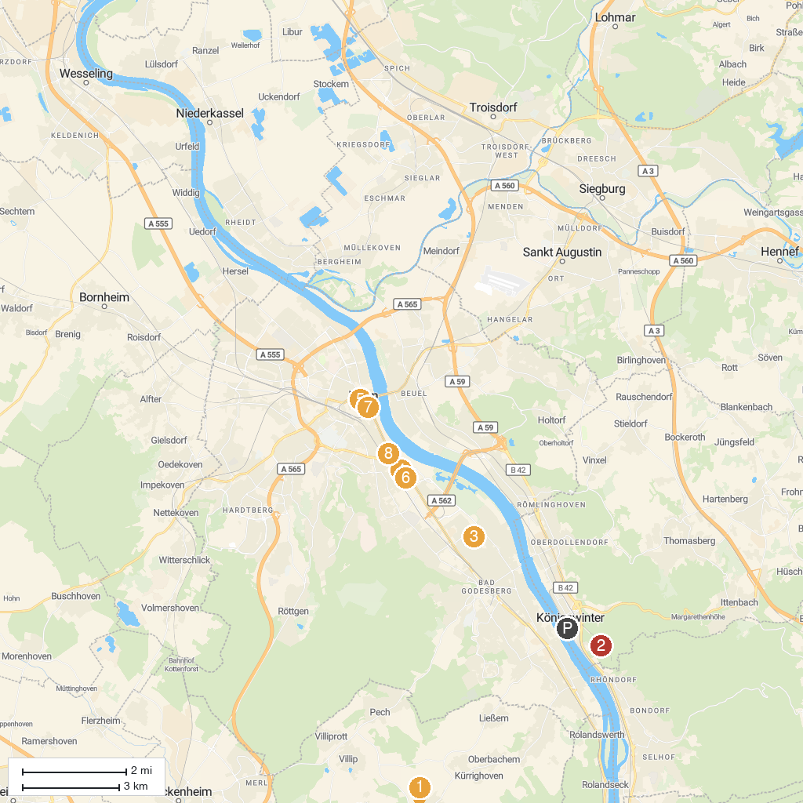
MAP KEY
1. Burg Odenhausen | 5. Beethoven-Haus Bonn
2. Schloss Drachenburg | 6. Art museum
3. German Museum Bonn | 7. StadtMuseum Bonn
4. House of the History of the Federal Republic of Germany | 8. Museum Koenig Bonn
P. Cruise port / terminal
Map © MapTiler © OpenStreetMap contributors · cruiseports.org

