Kom Ombo, Upper Egypt, Egypt
Perched on a dramatic bend of the Nile 48 km north of Aswan, Kom Ombo is one of Egypt's most photogenic temple stops — and your ship ties up close enough to walk straight to the ancient stones.
⚓ Moored (Nile riverbank pier) · 🕒 Typical call: 2–3 hrs · 💵 Egyptian Pound (EGP); temple ticket cashless card only · 🗣️ Arabic; English widely spoken at sites · 🏛️ UNESCO-listed Ptolemaic temple
✍️ MY DAY IN PORT (FILL IN)
Ship / Date
In port | arrive ______ · all aboard ______
Booked excursion
Notes / meeting point
GETTING ASHORE
- Docking: Ships moor alongside the Nile promenade; gangway direct to shore
- Walk to Temple: 2–5 min up a paved incline from the gangway
- Best For: Ancient history, Egyptology, sunset photography
- Don't Miss: The Crocodile Museum and the surgical-instrument reliefs on the rear temple wall
GETTING AROUND
- 🚕 Taxi: ~LE 20–50 (~/bin/zsh.40–) — Informal taxis operate in Kom Ombo for short trips in and around town. Negotiate the fare before you get in — meters are
- 📱 Rideshare: ❌ not available
TOP THINGS TO DO
- Temple of Kom Ombo — The only double temple in Egypt, built by Ptolemaic pharaohs between 180–47 BC.
- Crocodile Museum — Housed inside the temple complex and included with your entry ticket.
- Ancient Nilometer & Medical Reliefs — Inside the temple precinct, spot the ancient Nilometer — a stone-lined well priests used to measure the Nile flood and calculate…
- Nile Sunset from the Temple Terrace — Many ships dock in the late afternoon.
- Kom Ombo Souk — The bazaar between the temple and the pier sells alabaster statues, papyrus, scarabs, and spices.
BEST WALKS
- Promenade to Temple Loop: 0.3 km · 5 min one-way · Easy — Walk off the gangway, cross the promenade, and follow the paved incline up to the temple entrance.
WEATHER · DAYLIGHT · MONEY
Month | High °F | Low °F | Rainy days
May | 104 | 75 | 0
Jul | 107 | 81 | 0
Sep | 105 | 79 | 0
Daylight: May 6:04AM–7:24PM · Jul 6:09AM–7:39PM · Sep 6:34AM–6:51PM
cruiseports.org/kom-ombo · Confirm terminal & all-aboard time with your ship

Kom Ombo, Upper Egypt, Egypt — Port Map
Red = walkable sights · Amber = excursions farther out · P = cruise terminal
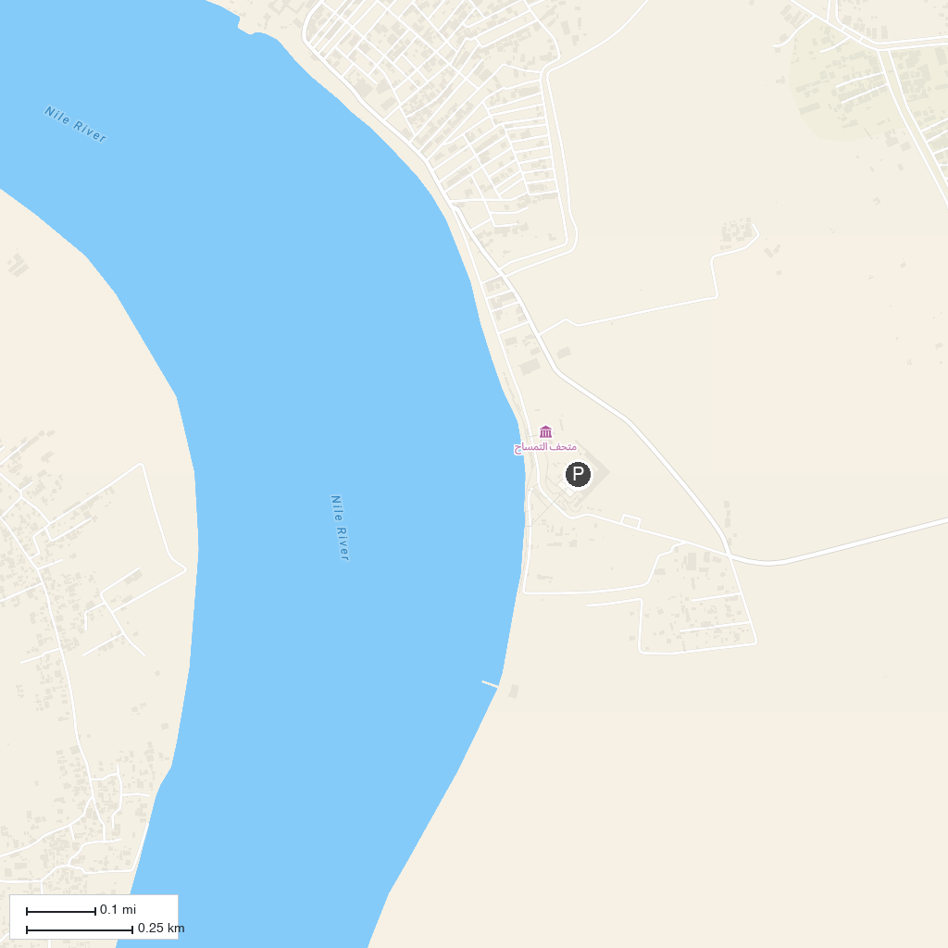
MAP KEY
1. Kom Ombo Temple | 2. Gezeret Elshbeka
P. Cruise port / terminal
Map © MapTiler © OpenStreetMap contributors · cruiseports.org

