Kolkata, West Bengal, India
The former capital of British India, Kolkata is a raw, vivid city of crumbling colonial grandeur, sacred river ghats, and legendary street food. Arriving by ship on the Hooghly is an experience in itself.
⚓ Docked at Kidderpore / river jetty · 🕒 Typical call: 8-12 hrs · 💵 Indian Rupee (INR) · 🗣️ Bengali, English, Hindi
✍️ MY DAY IN PORT (FILL IN)
Ship / Date
In port | arrive ______ · all aboard ______
Booked excursion
Notes / meeting point
GETTING ASHORE
- Docking: Ocean ships berth at Kidderpore Docks; river cruises dock at Millennium Park or Man-of-War Jetty
- Walk to center: Kidderpore: not walkable — take Uber/Ola or tour bus. River jetty: steps from BBD Bagh
- Best For: Colonial history, temple hopping, street food, and sensory immersion
- Don't Miss: Victoria Memorial, Mullick Ghat Flower Market at dawn, Kumartuli potters' quarter
GETTING AROUND
- 🚕 Taxi: ₹200–400 (~$2–5) — Prepaid taxi stands are located at the port entrance (Syama Prasad Mookerjee Port). Fixed rates to city center ~6 km awa
- 📱 Rideshare: ✅ Uber, Ola
- 🚌 Hop-on hop-off: ✅
TOP THINGS TO DO
- Victoria Memorial & Gardens — The crown jewel of Raj-era architecture — a vast white marble palace-museum built to honor Queen Victoria, set in lush gardens.
- Kumartuli Potters' Quarter — A 300-year-old riverside neighbourhood where artisans hand-sculpt enormous clay idols of Hindu deities — especially the goddess…
- Colonial Dalhousie Square (BBD Bagh) — The heart of British Calcutta, ringed by monumental Victorian and Edwardian public buildings — the Writers' Building, GPO, High…
- Mother House & Mother Teresa's Tomb — The global headquarters of the Missionaries of Charity is a quiet, contemplative space open to all visitors.
- Mullick Ghat Flower Market at Dawn — Asia's largest wholesale flower market operates under the Howrah Bridge from around 4 AM.
BEST WALKS
- River Jetty to BBD Bagh Colonial Circuit: 1.5 km | 20 min | Easy | River cruise passengers only — From Millennium Park Jetty, stroll north along the Strand riverfront, passing the Man-of-War Jetty…
- Victoria Memorial to Park Street: 1.5 km | 20 min walk | Easy | All passengers (after transport to area) — From the Victoria Memorial gardens, walk north along Jawaharlal Nehru Road (Chowringhee) to Park…
WEATHER · DAYLIGHT · MONEY
Month | High °F | Low °F | Rainy days
May | 94 | 80 | 14
Jul | 88 | 79 | 30
Sep | 88 | 78 | 26
Daylight: May 4:56AM–6:09PM · Jul 5:01AM–6:23PM · Sep 5:23AM–5:39PM
cruiseports.org/kolkata · Confirm terminal & all-aboard time with your ship

Kolkata, West Bengal, India — Port Map
Red = walkable sights · Amber = excursions farther out · P = cruise terminal
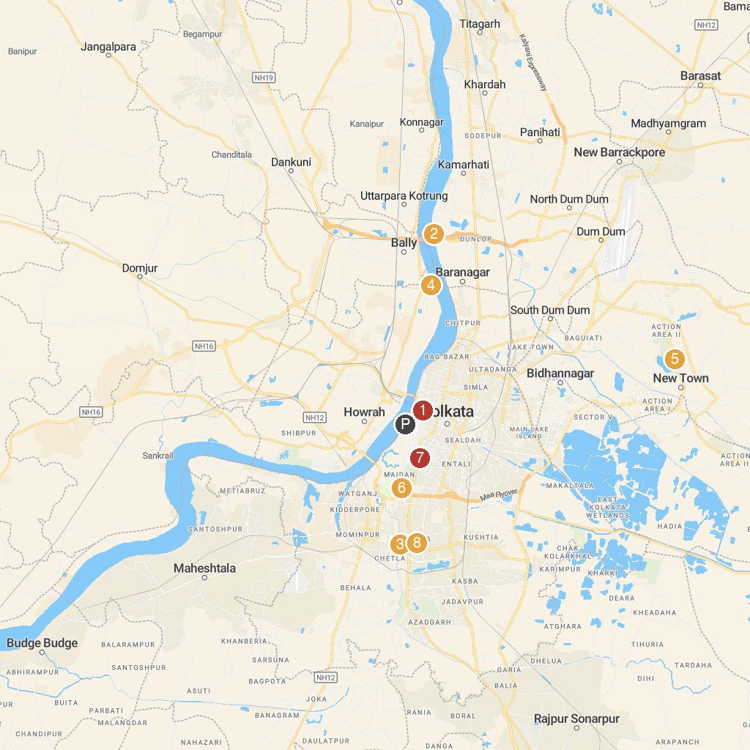
MAP KEY
1. CATHEDRAL OF THE MOST HOLY ROSARY | 5. Eco Park
2. Dakshineswar Kali Temple | 6. Victoria Memorial
3. Kalighat Kali Mata Temple | 7. Indian Museum
4. Belur Math | 8. SREE GURUVAYURAPPAN TEMPLE
P. Cruise port / terminal
Map © MapTiler © OpenStreetMap contributors · cruiseports.org

