Koh Lanta, Krabi, Thailand
Koh Lanta moves on island time — long sandy beaches, century-old stilt-house villages, and a rare Buddhist-Muslim-Sea Gypsy culture that makes it unlike any other Thai island.
⚓ Tender port · 🕒 Typical call: 7-9 hrs · 💵 Thai Baht (THB) · 🗣️ Thai · 🏖️ Beach day
✍️ MY DAY IN PORT (FILL IN)
Ship / Date
In port | arrive ______ · all aboard ______
Booked excursion
Notes / meeting point
GETTING ASHORE
- Docking: Tender to Saladan Pier (north tip of island)
- Walk to center: Saladan village is steps from the pier; beaches need a tuk-tuk
- Best For: Beaches, local culture, cave adventures, animal rescue sanctuary
- Don't Miss: Lanta Old Town stilt houses and Long Beach sunset
GETTING AROUND
- 🚕 Taxi: ฿40–฿450 depending on distance — The primary way to get around. Fares are unmetered — negotiate before you ride. Short hops near Saladan run ฿40–฿80; tri
- 📱 Rideshare: ❌ not available
TOP THINGS TO DO
- Long Beach (Phra Ae) — Best Swimming Beach — A roughly 3 km stretch of golden sand lined with casuarina trees and casual beach bars — one of the island's longest beaches and…
- Lanta Old Town (Ban Si Raya) — A beautifully preserved village of century-old Sino-Thai shophouses built on stilts over the eastern sea — once the island's main…
- Mu Ko Lanta National Park & Lighthouse — The southern tip of the island is protected parkland with a clifftop lighthouse, a secluded beach, and a short rainforest trail.
- Khao Mai Kaew Cave — A genuine adventure cave requiring a local guide — squeeze through tight passages, climb bamboo ladders, and see impressive…
- Lanta Animal Welfare Sanctuary — A globally respected non-profit rescue centre for stray dogs and cats, founded in 2005.
BEST WALKS
- Saladan Village Waterfront Wander: 30–45 min · Flat · Starts at pier — From the tender dock, walk the main strip of Saladan village past dive shops, handicraft stalls…
- Lanta Old Town Heritage Walk: 1–1.5 hrs · Flat · Start: Ban Si Raya — Stroll the single main street of Ban Si Raya (Lanta Old Town) on the east coast, passing Sino-Thai…
WEATHER · DAYLIGHT · MONEY
Month | High °F | Low °F | Rainy days
May | 88 | 77 | 27
Jul | 85 | 77 | 24
Sep | 85 | 76 | 25
Daylight: May 6:06AM–6:35PM · Jul 6:14AM–6:46PM · Sep 6:14AM–6:24PM
cruiseports.org/koh-lanta-island-thailand · Confirm terminal & all-aboard time with your ship

Koh Lanta, Krabi, Thailand — Port Map
Red = walkable sights · Amber = excursions farther out · P = cruise terminal
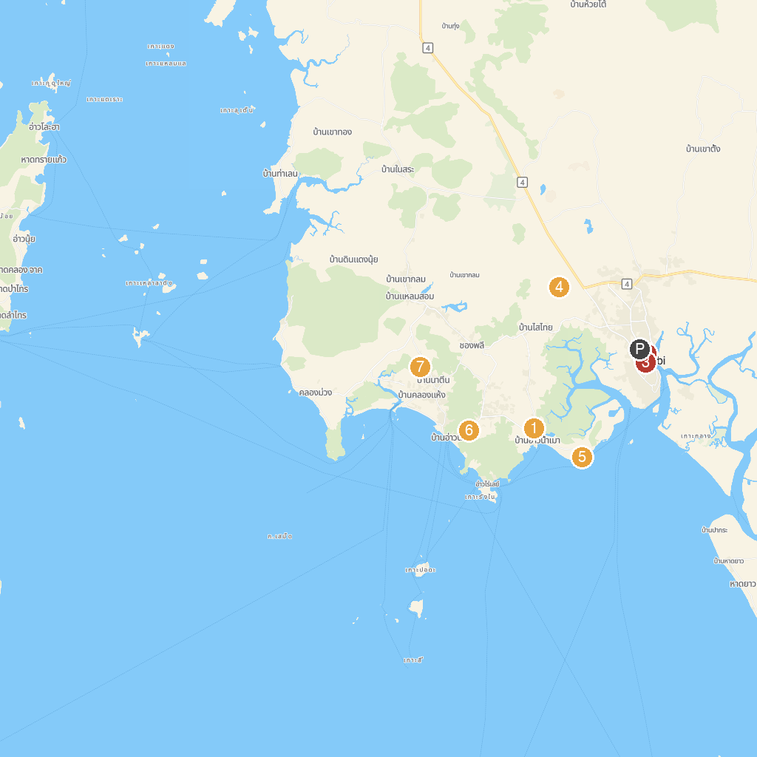
MAP KEY
1. Masjid Ban Ao Nam Mao | 5. Shell Cemetery
2. Andaman Cultural Study Center | 6. Aonang Al-Munuawarah Mosque
3. Maharaj Market | 7. Natin Spicy Garden
4. THAI'D UP ADVENTURES | 8. Koh Phi Phi Tour Pier
P. Cruise port / terminal
Map © MapTiler © OpenStreetMap contributors · cruiseports.org

